**Tutor Hub**

### Final Year Project Report

### 2022-2023

A project submitted in partial fulfilment of the COMSATS University Degree

of

BS in Computer Science / Software Engineering (CUI)



Department of Computer Science COMSATS University Islamabad, Lahore Campus

Project Detail

|  |  |  |  |  |  |
| --- | --- | --- | --- | --- | --- |
| Type (Nature of project) | | | [ ] **D**evelopment [ ] **R**esearch [ ] **R**&**D** | | |
| Area of specialization | | | Web Application | | |
| **Project Group Members** | | | | | |
| Sr.# | Reg. # | Student Name | | Email ID | *Signature |
| (i) | FA19-BCS- 097 | Muhammad Faizan Shahid | | [Fa19-bcs-097@cuilahore.edu.pk](mailto:Fa19-bcs-097@cuilahore.edu.pk) |  |
| (ii) | FA19-BCS- 069 | Moazzam Ali | | [Fa19-bcs-069@cuilahore.edu.pk](mailto:Fa19-bcs-069@cuilahore.edu.pk) |  |
| (iii) | FA19-BCS- 155 | Syed Muhammad Saad | | [Fa19-bcs-155@cuilahore.edu.pk](mailto:Fa19-bcs-155@cuilahore.edu.pk) |  |

*The candidates confirm that the work submitted is their own and appropriate credit has been given where reference has been made to work of others

Plagiarism Free Certificate

This is to certify that, I am **Muhammad Faizan Shahid** S/D/o **Shahid Iqbal**, group leader of FYP under registration no **CIIT/FA19-BCS-097/LHR** at Computer Science Department, COMSATS University Islamabad, Lahore Campus. I declare that my FYP proposal is checked by my supervisor and the similarity index is **18**% that is less than 20%, an acceptable limit by HEC. Report is attached herewith as Appendix A.

Date: Name of Group Leader: **Muhammad Faizan Shahid** Signature:

Name of Supervisor: Abdul Karim Shahid Co-Supervisor (if any):_

|  |  |  |  |
| --- | --- | --- | --- |
| Designation: | Associate Professor | Designation: |  |
| Signature: |  | Signature: |  |

**Abstract**

Access to quality education now a days is a big concern for students as well as for their parents. With increasing competition students tend to join after school academies or their parents hire tutor for their assistance. Now the problem faced by majority of students and their parents is that in today’s busy world it is very difficult to find good and trustworthy tutor who knows his subject and also poses the art of teaching.

Another problem faced by the teachers/tutors is that sometimes they have to travel a long distance to reach a student’s house or an academy. Now a days every second counts and this process cause a lot of time and resource wastage as well. Also, sometimes parent’s busy schedule cause them to miss out PTMs. Due to this they could not keep track of their child’s performance and results.

The above problem will be solved in our project as we will build a web application on which students will have access to certify subject expert tutors available nearby them. Students will be able to hire a tutor according to their subject of interest. Students will also be able to choose a tutor according to their own timetable. It will also be beneficial for tutors as they will not have to travel a long distance to reach their students. Also, parents will have access to their child’s progress and tutor’s remarks as well as they can schedule a face to face or an online meeting with the teacher according to mutual convenience. The hustle of finding a good tutor will be no more and tutors will also earn easily with the help of this system.

## Table of Contents

Abstract 2

1. Introduction 6

1.1 Scope and Objective 6

1.1.1 Scope 6

1.1.2 Objective 7

1.2 Problem Statement 7

1.3 Assumptions and Constraint 8

1. Requirement Analysis 9

2.1 Literature Review 10

2.1.1 Stakeholders list 10

2.2 Product Functions 11

2.3 Requirements 12

2.3.1 Functional Requirement 12

2.3.2 Non-Functional Requirements 21

2.4 Use Case Description 23

2.5 Use Case 42

1. System Design 45

3.1 Work Break Down Structure 46

* 1. Activity Diagram 47
  2. Sequence Diagram 65
  3. Software Architecture 78
  4. Class Diagram 79
  5. Gantt Chart 80
  6. Collaboration Diagram………….........................................................................................81

1. System testing……………………………………………………………………………….........97
2. Conclusion……………………………………………………………………………………….154
   1. Problem faced…………………………………………………………………………….155

5.2 Project Summary…………………………………………………………………………155

5.3 Future work………………………………………………………………………............155

6 References……………………………………………………………………………………….156

**List of Tables**

Table 1 Usescase1: Signup 24

Table 2 Usescase2: Login 25

Table 3 Usescase3: View list of teacher 26

Table 4 Usescase4: View Profile 27

Table 5 Usescase5: View Schedule 28

Table 6 Usescase6: View Appointment 29

Table 7 Usescase7: Register Student and teacher 30

Table 8 Usescase8: view Feedback 31

Table 9 Usescase9: Add Appointment 32

Table 10 Usescase10: Add Feedback 33

Table 11 Usescase11: Choose Service 34

Table 12 Usescase12: Update Appointment 35

Table 13 Usescase13: Update Feedback 36

Table 14 Usescase14: Delete Appointment 37

Table 15 Usescase15: Notification and Email 38

Table 16 Usescase16: Add teacher 39

Table 17 Usescase17: Update teacher list 40

Table 18 Usescase18: Delete teacher 41

Table 19 Usescase19: Logout 42

Table 20 Gantt Chart 80

Table 21 Testcase 1: Sign Up 98

Table 22 Testcase 2: Login 99

Table 23 Testcase 3: View List of teachers 100

Table 24 Testcase 4: View Profile 101

Table 25 Testcase 5: View Schedule 102

Table 26 Testcase 6: View Appointment 103

Table 27 Testcase 7: View Feedback 104

Table 28 Testcase 8: Add Feedback 105

Table 29 Testcase 9: Choose Service 106

Table 30 Testcase 10: Update Appointment 107

Table 31 Testcase 11: Update Feedback 108

Table 32 Testcase 12: Notification and Email 109

Table 33 Testcase 13: Logout 110

**List of Figures**

Figure 1 use case diagram for User 44

Figure 2 use case diagram for admin portal 45

Figure 3 WBS 48

Figure 4 Activity Diagram 1: Signup 49

Figure 5 Activity Diagram 2: Login 50

Figure 6 Activity Diagram 3: View list of tutors 51

Figure 7 Activity Diagram 4: View profile 52

Figure 8 Activity Diagram 5: View Schedule 53

Figure 9 Activity Diagram 6: View Appointment 54

Figure 10 Activity Diagram 7: View Feedback 55

Figure 11 Activity Diagram 8: Add Appointment 56

Figure 12 Activity Diagram 9: Add Feedback 57

Figure 13 Activity Diagram 10: Update feedback 58

Figure 14 Activity Diagram 15: Delete Appointment 59

Figure 15 Activity Diagram 16: Update Appointment 60

Figure 16 Activity Diagram 17: Notification 61

Figure 17 Activity Diagram 18: Add teacher list 62

Figure 18 Activity Diagram 19: Update teacher list 63

Figure 19: Activity Diagram 20: Delete teacher list 64

Figure 20 Activity Diagram 21: Logout 65

Figure 21 Sequence diagram 1: Signup 67

Figure 22 Sequence diagram 2: View List of teachers 68

Figure 23 Sequence diagram 3: View Schedule 69

Figure 24 Sequence diagram 4: Delete Appointment 70

Figure 25 Sequence diagram 5: Delete Feedback 71

Figure 26 Sequence diagram 6: Update Appointment 72

Figure 27 Sequence diagram 7: Update Profile 73

Figure 28 Sequence diagram 8: View Profile 74

Figure 29 Sequence diagram 9: Add list of teacher 75

Figure 30 Sequence diagram 10: Delete list of teacher 76

Figure 3 Sequence diagram 11: Update list of teacher 77

Figure 32 Sequence diagram 12: Logout 78

Figure 33 Class Diagram 79

Figure 34 Collaboration Diagram 1: Sign Up 82

Figure 35 Collaboration Diagram 2: Login 83

Figure 36 Collaboration Diagram 3: View List of Teacher 84

Figure 37 Collaboration Diagram 4: View Schedule 85

Figure 38 Collaboration Diagram 5: Add Feedback 86

Figure 39 Collaboration Diagram 6: Update Feedback 87

Figure 40 Collaboration Diagram 7: Delete Feedback 88

Figure 41 Collaboration Diagram 8: View Feedback 89

Figure 42 Collaboration Diagram 9: Add Appointment 90

Figure 43 Collaboration Diagram 10: Delete Appointment 91

Figure 44 Collaboration Diagram 11: View Appointment 92

Figure 45 Collaboration Diagram 12: View Profile 93

Figure 46 Collaboration Diagram 13: Add List of Teacher Admin 94

Figure 47 Collaboration Diagram 14: Update List of Teacher 95

Figure 48 Collaboration Diagram 15: Delete List of Teacher Admin 96

Figure 49 Collaboration Diagram 16: Logout 97

# CHAPTER 1 INTRODUCTION

## Introduction

Now a days to excel in society one must have a good academic record and because of the day by day increasing competition in the field of education it getting difficult for students to keep up with society standards and market demands. Students tend to join after school coaching or they hire a tutor which helps them to understand their subjects better and eventually they score better in exams. For their ease we will build a platform which will help the students/parents as well as tutors.

As mentioned above, our platform will provide students an opportunity to select a tutor of their own choice available nearby their location. Students and tutors will register themselves on the system and a list of tutors available in the area will be displayed to students from which they can hire one or more tutors based on their area of interest and expertise of tutors.

Students will also have the facility to make a timetable with the tutor they have hired. Tutors will be able to take online quizzes and assignments as well. Parents will also have access to the platform and they will be able to check their child’s performance as well as his grades in quizzes and assignments. Parents will also have the facility to arrange a meeting with the tutor to discuss their child’s situation.

To facilitate the hiring process the platform will also provide a chat box and online meeting option so both parents/students and tutors will be able to know more about each other before they start working together.

This system will also provide ease of work for tutors as they will only be suggested to those students who are nearby their location. In this way their travel expense and time will be saved. The built-in functionalities in the system like chat box and online meeting option, online quizzes and assignments, timetable management and ease to connect with parents will prove to be very helpful for both parties i.e., tutors and parents/students.

### Scope and Objectives

### Scope

The scope of the Project is as following:

* Access teacher through location
* Verify teacher through degree
* Rank and experience of a teacher
  + Attendance Record
  + Fees Record
  + Feedback report
  + Trial based class
  + Chat box for parents
  + Quiz system
  + Time table management
  + Online course
  + Monthly report card
  + Quran classes
  + Monthly meeting schedule
  + Assessment plan

## Objective

* The major role of tutoring app is to build a virtual tutoring environment for student’s that produce a face-to-face experience which can assist a student to achieve success in a given class.
* The main purpose of the application is to overcome and reduce the challenges faced by student and provide them flexibility in time.
* Student who uses on demand tutoring app are not far away to gather the help when it is required. This is vital in pandemic as well as when a person is sick or ill it can cover through application.
* Tutoring application will accommodate student by using different strategies and techniques to prepare for exams.
* Tutoring app helps both parents and teacher to be on one platform where they can discuss and can-do regular meetings regarding the student.
* The main objective of application is that there will be a trial base class of two days in which a relevant teacher will visit to students’ home and if a student satisfies the teacher will carry there will be no charges of a trial-based class.

## Problem Statement

The main problem with online tutoring for these providers relates to **scalability**: one of the main benefits of online tutoring for students is that it offers one-to-one attention. Unfortunately, that dynamic simply doesn’t allow for growth on a large scale.

## Assumptions and Constraint

* User must have internet connectivity
* User must have a device to use the web application i.e., smart phone, laptop/Pc, tablet
* Make sure that location access in switched on
* User must be aware of basic functionality
* There are geographic boundaries
* System will work in Pakistan only
* For signup user should have valid Gmail account or have to put valid credentials for signup

# CHAPTER 2 REQUIREMENT ANALYSIS

### Literature Review

Deployment of tutoring application has been done before via online mode such as Khan Academy

Udemy and Coursera etc. Model of all these applications is based on online module in which location of student and teacher does not matter. But in Pakistan it was proved during Corona Virus outbreak that online mode of study is not so beneficial and fair. During online mode of students showed an irresponsible behavior towards studies beside it was very difficult and challenging for teachers as well to teach remotely. Due to all of this many parents and students were unsatisfied from online learning and some even left schools and colleges because according to them it was just a waste of time and money.

Now keeping the perspective of thinking process especially of Pakistani students and parents were working to develop a platform which will satisfy their learning expectations as well as it will be beneficial for both tutors and students. Parents also will be satisfied by this system. Some new things that we will be including in our system are:

* Tutor will be physically available for assistance.
* Our system will work on location-oriented module i.e. only those tutors will be shown to students in the availability list who live nearby.
* With respect to the location service our platform will also provide tutors, students and parents with online helping tools.
* If the student has hired more than one tutors, he will be able to make a timetable for his ease.
* Monthly report card will be generated based on student’s performance in quizzes and assignments which will be sent to their parents.
* Parents and tutors will have ease of online or physical PTMs.
* Students will be able to specify their class and subjects to get most suitable results.
* Educational institutes will also be able to look and hire good teachers after viewing their profiles.

### Stake Holders:

* + - User
    - Admin
    - Development team
    - Testing and QA Team

#### Requirement Elicitation

##### Functional Requirements Student and Teacher

**FR01: Sign Up:**

|  |  |
| --- | --- |
| **Req. No.** | **Functional Requirements** |
| **FR01-01** | System will allow the student and teacher to sign up a system and get registered using his/her name, Gmail, email and password. |
| **FR01-02** | A system must allow the student and teacher to sign Up with Google. |
| **FR01-03** | The system must display the message to the user that he/she has been registered. |

##### FR02: Log In

|  |  |
| --- | --- |
| **Req. No.** | **Functional Requirements** |
| **FR02-01** | System must allow the student and teacher to login by password and username. |
| **FR02-02** | System must allow the user to log in on more than one system by the same username and password. |
| **FR02-03** | by clicking on the login button system must allow the student and teacher to log In. |
| **FR02-04** | System must display a message of successfully log in to the user. |
| **FR02-05** | The system must provide the option of forgetting a password. |
| **FR02-06** | The system shall provide the option of the Email in case of forgetting the password to send a reset password code on it. |

**FR03: View List of Teachers**

|  |  |
| --- | --- |
| **Req. No.** | **Functional Requirements** |
| **FR03-01** | System must provide an interface of different teacher so the student can easily view the teacher. |
| **FR03-02** | System will only show the relevant subject teachers. |
| **FR03-04** | System must allow the student to read information and the profile of teacher. |
| **FR03-06** | System must not allow the student to add, less the rate or any update. |
| **FR03-07** | System must allow the student to view subject, fee and experience. |

**FR04: View Profile**

|  |  |
| --- | --- |
| **Req. No.** | **Functional Requirements** |
| **FR04-01** | A system will allow the user to view his/her profile as well as teacher’s profile. |
| **FR04-02** | System will display all the information about the teacher’s profile. |
| **FR04-03** | System will only allow the registered students and teachers to view the profile of the other teachers. |
| **FR04-04** | System will allow the student and teacher to update his/her profile. |
| **FR04-05** | System will not allow the user (teacher and student) to update the profile of other users. |

|  |  |
| --- | --- |
| **Req. No.** | **Functional Requirements** |
| **FR05-01** | A system will allow the student to check the availability of teacher. |
| **FR05-02** | The system will display the schedule so that the student can easily fix his/her time for learning. |
| **FR05-04** | The system will display the updated schedule after the appointment has been added. |

##### FR06: View Appointment

|  |  |
| --- | --- |
| **Req. No.** | **Functional Requirements** |
| **FR06-01** | System will provide an interface so that the student and teacher can view their appointment. |
| **FR06-02** | The system shall display student, teacher name, subjects, date and time. |
| **FR06-03** | System will display only that student information who have made an appointment. |

**FR07: Register Student and Teacher**

|  |  |
| --- | --- |
| **Req. No.** | **Functional Requirements** |
| **FR07-01** | The system will register new students and teacher |
| **FR07-02** | The system must show the message of successfully registered to students and teacher after registering. |

**FR08: View Feedback:**

|  |  |
| --- | --- |
| **Req. No.** | **Functional Requirements** |
| **FR08-01** | A system will allow the student teacher and admin to view feedback. |
| **FR08-02** | The system will display feedback so that student can easily decide about choosing a tutor. |
| **FR08-03** | The system will allow student to view feedback provided by his/herself and by another student about the tutors. |

##### FR09: Add Appointment:

|  |  |
| --- | --- |
| **Req. No.** | **Functional Requirements** |
| **FR09-01** | The system must provide an interface to the student to add an appointment. |
| **FR09-02** | The system must allow the student to add appointments by using credentials to choose a teacher, choose subject, student id, contact no, age, time and date. |

**FR010: Add Feedback:**

|  |  |
| --- | --- |
| **Req. No.** | **Functional Requirements** |
| **FR010-01** | The system will provide an interface to the student to add feedback. |
| **FR010-02** | The system will allow the student to add feedback by commenting or by rating through stars. |
| **FR010-03** | The system will display the feedback to the student and will show on teacher’s profile. |

**FR011: Choose service**

|  |  |
| --- | --- |
| **Req. No.** | **Functional Requirements** |
| **FR011-01** | The system will provide an interface to the student to easily select subjects and services. |
| **FR011-02** | The system will show the distance between the tutor and home destination to student and teacher as well. |
| **FR011-03** | The system will show the time required to arrive at the home destination to student of teacher |

##### FR012: Update Appointment:

|  |  |
| --- | --- |
| **Req. No.** | **Functional Requirements** |
| **FR012-01** | The system must provide an interface to update the appointment. |
| **FR012-02** | The system must display the updated appointment. |
| **FR012-03** | The system must provide the confirmation message before update the appointment. |

**FR013: Update Feedback:**

|  |  |
| --- | --- |
| **FR013-01** | The system must provide an interface to update feedback. |
| **FR013-02** | The system must display the updated feedback. |
| **FR013-03** | The system must enable the user to view this updated feedback. |

##### FR014: Delete an appointment

|  |  |
| --- | --- |
| **Req. No.** | **Functional Requirements** |
| **FR014-01** | The system will provide an option on the interface so that the student deletes an appointment after making it. |
| **FR014-02** | The system will allow a student to view appointments before deleting it. |
| **FR014-03** | The system will allow the student to delete an appointment by clicking on the delete button. |
| **FR014-04** | The system will display a confirmation message to ensure about deleting the appointment |
| **FR014-05** | The system will display an alert message after deleting the specific appointment. |

**FR015: Notification and Email**

|  |  |
| --- | --- |
| **Req. No.** | **Functional Requirements** |
| **FR015-01** | The system must allow the admin to send the confirmed appointment notification to the student and teacher via SMS or Email. |
| **FR015-02** | The system must allow the admin to notify the student and teacher about appointment cancelation via SMS or Email. |
| **FR015-03** | The system must allow the admin to notify the student and teacher about any kind of update of the teacher or student via SMS or Email. |

**FR016: Experience**

|  |  |
| --- | --- |
| **Req. No.** | **Functional Requirements** |
| **FR016-01** | A system must allow the admin to display experience of tutors by showing their CV and educational details. |
| **FR016-03** | A system must allow admin to display the list of previously taught students. |

##### FR017: Logout

|  |  |
| --- | --- |
| **Req. No.** | **Functional Requirements** |
| **FR017-01** | The system must provide an option on the interface so that the student, teacher and can logout after sign in. |
| **FR017-02** | The system must display a message about successfully log out to all |
| **FR017-03** | The system must allow the student, teacher and admin to log out by clicking Logout Button. |

**FR018: View List of Teacher (Admin):**

|  |  |
| --- | --- |
| **Req. No.** | **Functional Requirements** |
| **FR018-01** | The system must provide an interface of different teachers so the admin can easily view tutor. |
| **FR018-02** | The system must allow the admin to see different tutors’ profiles. |
| **FR018-03** | The system must allow the admin to read information about the specific service of a teacher. |
| **FR018-04** | The system must display information about a particular teacher, mobile number, location, timing, and the fee per subject. |
| **FR018-06** | The system must not allow the admin to add service, less the fee, or any updating. |
| **FR018-07** | The system must allow the admin to view service, the fee and teaching methodology. |

##### FR019: View Schedule (Admin):

|  |  |
| --- | --- |
| **Req. No.** | **Functional Requirements** |
| **FR019-01** | The system will provide an interface to view the schedule of the teachers and students. |
| **FR019-02** | A system will allow the admin to view the schedule. |
| **FR019-03** | A system will allow the admin to view the schedule of the teachers and student and fix appointments. |
| **FR019-04** | The system will display the schedule so that the admin can easily fix the appointments of the students. |
| **FR019-05** | The system will display the updated schedule after the appointment has been added |

**FR020: Add List of Teachers**

|  |  |
| --- | --- |
| **Req. No.** | **Functional Requirements** |
| **FR020-01** | The system will allow Admin to add a tutor. |
| **FR020-02** | The system will ensure that the added tutor is not already present in the list. |
| **FR020-03** | The system will allow admin to view the list before adding a new tutor. |

##### FR021: Update teacher list

|  |  |
| --- | --- |
| **Req. No.** | **Functional Requirements** |
| **FR021-01** | The system must enable Admin to update a list of the added tutor. |
| **FR021-02** | The system must display the updated list after updating it. |
| **FR021-03** | The system must provide the confirmation message before update the list. |
| **FR021-04** | The system must enable the student and teacher to view this updated list. |

**FR022: Delete teacher list**

|  |  |
| --- | --- |
| **Req. No.** | **Functional Requirements** |
| **FR022-01** | The system will enable admin to delete the list of the teacher. |
| **FR022-02** | The system will display a confirmation message before deleting the specific teacher. |
| **FR022-03** | The system will display a message after deleted the teacher. |
| **FR022-04** | The system will ensure that the teacher that required to be deleted must be added to the list. |

##### Non-Functional Requirements Performance:

|  |  |
| --- | --- |
| **Req. No.** | **Functional Requirements** |
| **NFR 1.1:** | The system shall not crash while adding feedback and make an appointment because it frustrates the user. |
| **NFR 1.2:** | The system must notify the student and teacher about his/her appointment before time. |
| **NFR1.3:** | The system shall give a quick response about finding the nearest teachers. |

**Maintainability**

|  |  |
| --- | --- |
| **Req. No.** | **Functional Requirements** |
| **NFR 2.3:** | The system should have a backup of data. |

##### Reliability

|  |  |
| --- | --- |
| **Req. No.** | **Functional Requirements** |
| **NFR 3.1:** | The design of the system must be easy to use. |
| **NFR 3.2:** | The design of the system must be easy to understand. |
| **NFR 3.3:** | The system should have a quick exit for the user. |
| **NFR 3.4:** | The failure rate of the system will be less. |
| **NFR 3.5:** | The system shall not require a high amount of internet. |
| **NFR 3.6:** | Notifications will be sent on accurate time. |
| **NFR 3.7:** | Multiple users can use the system at a time. |

|  |  |
| --- | --- |
| **NFR 3.8:** | The system shall provide some action control in the user's hand. |
| **NFR 3.9:** | The load time of images and page should be less than 5 seconds |

**Integrity**

|  |  |
| --- | --- |
| **Req. No.** | **Functional Requirements** |
| **NFR 4.1:** | The system must confirm the user that your information is protected from unauthorized access. |
| **NFR 4.2:** | Unregistered users will not allow giving feedback. |
| **NFR4.3:** | Unregistered users shall not allow for viewing the schedule of appointments. |

##### Usability

|  |  |
| --- | --- |
| **Req. No.** | **Functional Requirements** |
| **NFR 5.1:** | The users will easily make their appointment. |
| **NFR 5.2:** | The users will easily add feedback. |
| **NFR 5.3** | The users will easily update their appointment. |
| **NFR5.4:** | The users have also provided ease in viewing the schedule. |

**Portability**

|  |  |
| --- | --- |
| **Req. No.** | **Functional Requirements** |
| **NFR 6.1:** | The website can be used on any service engine like Chrome, Mozilla Firefox, etc. |
| **NFR 6.2:** | The Responsive design of the website allows user to use the website on tablets mobile and many other portable devices. |

**Security**

|  |  |
| --- | --- |
| **Req. No.** | **Functional Requirements** |
| **NFR 7.1:** | The only user can add feedback. |
| **NFR 7.2:** | The unauthorized users will not allow for viewing the schedule. |
| **NFR 7.3:** | Data will secure with multiple back-ups. |
| **NFR 7.4:** | Unauthorized user does not make an appointment. |

#### 2.4 Use Case Description

##### Signup

|  |  |
| --- | --- |
| **Use case name:** | **Sign Up** |
| **Use case id:** | 1 |
| **Actors:** | Student and Teacher |
| **Use Case Summary** | User visits the website open Signup form give his/her credentials and get registered. The user can also Signup using Google. |
| **Pre-conditions:** | user shall not be registered |
| **Normal Course of Event:** | |
| **Steps#** | **Description** |
| **1.** | User visit the web site |
| **2.** | User click on sign up button to get registered |
| **3.** | User fill the sign up form using credentials Name, Contact Number, Email, Address and Password |
| **4.** | User click on ok button and submit the form |
| **4.** | The system will display a confirmation message to submit the form. |
| **Alternate Scenario:** | |
| a. If the user will not provide at least one information the system will generate an error | |
| b. If the user will not provide valid email the system will generate an error message | |
| c. If the user is already registered the system will generate an error | |
| d. If the user enters wrong password during signing up with Google the system will generate an error | |
| e. If the user will add the username which is already exist the system will generate an error | |
| **Post-conditions:** | User is registered. |
| **Exceptions:** Nil | |

Table 1 Usescase1: Signup

|  |  |
| --- | --- |
| **Use case name:** | **Log In** |
| **Use case id:** | 2 |
| **Actors:** | Student, Teacher and Admin |
| **Use Case Summary** | Users visit the site and open login form and fill it by entering username, password and Email. User then click on the login button. System will save details and send the confirmation request. |
| **Pre-conditions:** | Users must be registered. |
| **Normal Course of event:** | |
| **Steps#** | **Description** |
| **1.** | Users visit the web site and open form to login. |
| **2.** | Users enter his/her username password. |
| **3.** | Users press login button after form filling. |
| **4.** | System will verify and validate the entered information is either correct or not. If given information are correct then user will be shown the successfully logged in message. |
| **Alternative Course of event:** | |
| 2a. If information entered is wrong system will not let anyone to fill the next field. | |
| 3a. If the entered password doesn’t match the system will show an error and provide an option of forget password. | |
| 4a. User will have to correct the information and again press the login button. | |
| 5a. If user will be missing the field the form will not be submitted and “fill all the fields” error will be showed. | |
| 5b. User will have to fill the missing field and then try again for login. | |
| **Post-conditions:** | User will receive the Successfully logged in confirmation email. |
| **Exceptions:**  If user cancel the page. He/she has to fill all the fields again previous information will not be saved. | |

Table 2 Usescase2: Login

|  |  |
| --- | --- |
| **Use case name:** | **View list of teachers** |
| **Use case id:** | 3 |
| **Actors:** | Student, teachers and admin |
| **Use Case Summary** | This use case helps the user to view the teacher. |
| **Pre-conditions:** | The list of the tutors should exist. |
| **Normal Course of Event:** | |
| **Steps#** | **Description** |
| **1.** | The use case starts when the user visits the Home Page. |
| **2.** | The student selects the subject option and further click on the list of a teachers. |
| **3.** | The system will display the list of a teachers that further open a list of names with experience. |
| **4.** | The student selects the specific teacher. |
| **5.** | The system will display the specific teacher page on a screen. |
| **6.** | The tutor page contains information about tutor experience, rating, feedback, number, address, location, their services and prices correspond to service. |
| **7.** | The student views the tutor’s page. |
| **8.** | This use case ends. |
| **Alternative course of event:** | |
| **1a**: The user fails to visit the Home Page. | |
| **2a:** Users click on another option. | |
| **3a:** The user hovers the list of the tutors so the list appears and disappears. | |
| **4a:** The user doesn't select any tutor.  **4b:** The user only visits the tutors list. | |
| **5a:** Page doesn't appear.  **5b:** Cancel action | |

Table 3 Usescase3: View List of Teachers

|  |  |
| --- | --- |
| **Use case name:** | **View Profile** |
| **Use case id:** | 4 |
| **Actors:** | Student, teacher and admin |
| **Use Case Summary** | User visits the website, open profile page and view his/her profile or the other users, update his/her profile but not others |
| **Pre-conditions:** | User shall be registered |
| **Normal Course of Event:** | |
| **Steps#** | **Description** |
| **1.** | User visit the web site |
| **2.** | User click on profile button |
| **3.** | User open his/her profile, view his/her profile or the other users |
| **4.** | User selects the option to update his/her profile |
| **5.** | User click on the submit button or home button to go back |
| **Alternate Scenario:** | |
| a. If the user is not registered and want to view profile of other user the system will generate an error | |
| **Post-conditions:** | Profile is viewed or updated |
| **Exceptions:** Nil | |

Table 4 Usescase4: View Profile

|  |  |
| --- | --- |
| **Use case name:** | **View Schedule** |
| **Use case id:** | 05 |
| **Actors:** | Student, teacher and admin |
| **Use Case Summary** | User visits the website, open schedule page, view schedule of the teachers and fix his/her appointment |
| **Pre-conditions:** | User shall be registered |
| **Normal Course of Event:** | |
| **Steps#** | **Description** |
| **1.** | User visit the web site |
| **2.** | User click on schedule button to view the schedule of the teachers |
| **3.** | User click on particular teacher to view the schedule of that specific tutor and fix his/her appointment |
| **4.** | User click on the home button after viewing the schedule |
| **Alternate Scenario:** | |
| a. If the user will not choose any teacher the system will generate an error | |
| **Post-conditions:** | Schedule is shown to the user according to the option selected by him/her. |
| **Exceptions:**  Nil | |

Table 5 Usescase5: View Schedule

|  |  |
| --- | --- |
| **Use case name:** | **View Appointment** |
| **Use case id:** | 6 |
| **Actors:** | Student, teacher |
| **Use Case Summary** | This use case helps the user to view an appointment. |
| **Pre-conditions:** | The appointment must be made. |
| **Normal Course of Event:** | |
| **Steps#** | **Description** |
| **1.** | The use case starts when the user wants to view the system. |
| **2.** | User select the schedule option |
| **3.** | The system will display the form of appointment along with the delete, view and add option. |
| **4.** | The user selects the View option corresponds to the appointment that he  Wants to view. |
| **5.** | The system will display that appointment from the form. |
| **6.** | The appointment contains the user’s name, subject, date, time and teacher  Name. |
| **7.** | Admin views the appointment. |
| **8.** | This use case ends. |
| **Alternative course of event:** | |
| **1a:** Admin fails to login account | |
| **2a:** Admin selects another option. | |
| **3a:** The system will display a blank page.  **3b:** The system will display a message that “page is not found” | |
| **4a:** Admin selects another option.  **4b:** Admin doesn't want to make any changes. | |
| **5a:** Cancel action | |
| **6a:** The system display nothing. | |

Table 6 Usescase6: View Appointment

|  |  |  |
| --- | --- | --- |
| **Use case name:** | **Register Student & Teacher** | |
| **Use case id:** | 7 | |
| **Actors:** | Admin | |
| **Use Case Summary** | “Admin will register the student and teachers by checking their credentials. | |
| **Pre- conditions:** | Admin must be login | |
| **Normal Course of Event:** | | |
| **Steps#** | **Description** | |
| **1.** | User visits the web site. | |
| **2.** | Admin will be show portal. | |
| **3.** | User will click on register option. | |
| **4.** | User selects the services from his/her device that either he is teacher or student. | |
| **5.** | User press the confirm register button. | |
| **Alternative Course of event:** | | |
| 2 Admins fails to register | | |
| **Post-conditions:** | | Confirmation message will be delivered via email or SMS. |
| **Exceptions:**  1-NiL | | |

Table 7 Usescase7: Register Student & teacher

|  |  |
| --- | --- |
| **Use case name:** | **View Feedback** |
| **Use case id:** | 8 |
| **Actors:** | Student, teacher and Admin |
| **Use Case Summary** | User visits the website, open feedback page and view feedback about the teacher given by him/herself or by other users |
| **Pre-conditions:** | User may or may not be registered User may not already given feedback |
| **Normal Course of Event:** | |
| **Steps#** | **Description** |
| **1.** | User visit the web site |
| **2.** | User click on feedback button to view feedback of the website |
| **3.** | User click on particular teacher to view the feedback of that specific teacher |
| **4.** | User click on feedback button to view feedback of that teacher |
| **5.** | User click on the home button after viewing the feedback |
| **Alternate Scenario:** | |
| a. If the user will not choose any teacher the system will generate an error | |
| **Post-conditions:** | Feedback is shown to the user according to the option selected by him/her. |
| **Exceptions:** Nil | |

Table 8 Usescase8: view Feedback

|  |  |
| --- | --- |
| **Use case name:** | **Add appointment** |
| **Use case id** | 9 |
| **Actors:** | Student |
| **Use Case Summary y** | “Student login to the system. He/she can add appointments from the portal/dashboard.” |
| **Pre-conditions:** | Student must login. |
| **Normal Course of Event:** | |
| **Steps#** | **Description** |
| **1.** | Student visit the web site and login to his/her account. |
| **2.** | He/she selects the appointment. |
| **3.** | He/she clicks submit button. |
| **Alternate Scenario:** | |
| NIL | |
| **Post-conditions:** | Appointment added will be posted. |
| **Exceptions:**  Nil | |

Table 9 Usescase9: Add Appointment

|  |  |
| --- | --- |
| **Use case name:** | **Add Feedback** |
| **Use case id:** | 10 |
| **Actors:** | Student |
| **Use Case Summary** | Student visits the website, open feedback page and add feedback about this teachers through commenting or by rating through stars |
| **Pre-conditions:** | Student may or may not be registered |
| **Normal Course of Event:** | |
| **Steps#** | **Description** |
| **1.** | Student visit the web site |
| **2.** | Student click on services button |
| **3.** | Student click on feedback button to add feedback |
| **4.** | Student add feedback by commenting or by rating through stars |
| **5.** | Student click on the submit button |
| **Alternate Scenario:** | |
| a. If the student will not write anything in the commenting box the system will generate an error | |
| b. If the student double clicks on the star the star will be unfilled, the feedback will not submit and the system will generate an error | |
| **Post-conditions:** | Feedback is added |
| **Exceptions:** Nil | |

Table 10 Usescase10: Add Feedback

|  |  |  |
| --- | --- | --- |
| **Use case name:** | **Choose Services** | |
| **Use case id:** | 11 | |
| **Actors:** | Student | |
| **Use Case Summary** | “Student visit the site and will be shown teachers available near the location click on the services button to view which services are available”. | |
| **Pre- conditions:** | Student must be register. Student must be login. | |
| **Normal Course of Event:** | | |
| **Steps#** | **Description** | |
| **1.** | Student visits the web site and login to account. | |
| **2.** | Student will be showed tutors available near to student location and can  Select the teacher. Where there is an option to view services. | |
| **3.** | Student will click on view services option. | |
| **4.** | Student selects the service from his/her device. | |
| **Alternative Course of event:** | | |
| 7a. The system will show error message if selected service will not be available on the location. | | |
| **Post-conditions:** | | Confirmation message or email will be received. |
| **Exceptions:** Nil | | |

Table 11 Usescase11: Choose Service

|  |  |
| --- | --- |
| **Use case name:** | **Update Appointment** |
| **Use case id:** | 12 |
| **Actors:** | Student, teacher |
| **Use Case Summary** | User visits the website, open make an appointment page and update his/her appointment |
| **Pre-conditions:** | User shall be registered  User had already made an appointment |
| **Normal Course of Event:** | |
| **Steps#** | **Description** |
| **1.** | User visit the web site |
| **2.** | User click on make an appointment button |
| **3.** | User open his/her appointment |
| **4.** | User selects the option to update his/her appointment |
| **5.** | User update his appointment |
| **6.** | The system will display a confirmation message to the user to update his/her appointment |
| **7.** | User click on the ok button and then save his/her appointment |
| **Alternate Scenario:** | |
| a. If the user will not fill at least one section the system will generate an error | |
| b. If the user will mistakenly add wrong information the system will generate an error | |
| c. If the user will add the service which is not available the system will generate an error | |
| **Post-conditions:** | Appointment is updated |
| **Exceptions:** Nil | |

Table 15 Usescase12: Update Appointment

|  |  |
| --- | --- |
| **Use case name:** | **Update feedback** |
| **Use case id:** | 13 |
| **Actors:** | Student |
| **Use Case Summary** | “Student will login. He/she can edit comment the admin will update the feedback on the portal/dashboard of the tutor” |
| **Pre-conditions:** | Student must login and add comment. |
| **Normal Course of Event:** | |
| **Steps#** | **Description** |
| **1.** | Student visit the web site and login to his/her account. |
| **2.** | He/she selects the edit comment button. |
| **3.** | He/she click submit button. |
| **4.** | Admin/system update the feedback |
| **Alternate Scenario:** NIL | |
| **Post-conditions:** | Edited comment will be posted. |
| **Exceptions:** Nil | |

Table 13 Usescase13: Update Feedback

|  |  |  |
| --- | --- | --- |
| **Use case name:** | **Delete Appointment** | |
| **Use case id:** | 14 | |
| **Actors:** | Student, teacher | |
| **Use Case Summary** | This use case helps the user to delete an appointment that he has made. | |
| **Pre-conditions:** | A specific appointment should exist in the appointment form. | |
| **Normal Course of Event:** | | |
| **Steps#** | **Description** | |
| **1.** | The use case starts when the user wants to delete an appointment. | |
| **2.** | user selects the schedule option | |
| **3.** | The system will display the form of appointment along with the update, delete, view and add option. | |
| **4.** | The user selects the delete option that corresponds to the appointment that he  wants to delete. | |
| **5.** | The system will remove that appointment from the form. | |
| **6.** | The form after deleting an appointment will be shown by the system. | |
| **Alternative course of event:** | | |
| **1a:** The user selects another option. | | |
| **2a:** The system will display a blank page.  **2b:** The system will display a message that “page is not found” | | |
| **3a:** The user selects another option.  **3b:** The user doesn't want to make any changes. | | |
| **4a:** Cancel action | | |
| **Post-conditions:** | | The selected appointment has been deleted. The appointment form is updated. |

Table 14 Usescase14: Delete Appointment

|  |  |
| --- | --- |
| **Use case name:** | **Notifications And Email** |
| **Use case id:** | 15 |
| **Actors:** | Student, teacher |
| **Use Case Summary** | “User can receive notifications of any type example menu update  , cancelation appointment and confirmation appointment etc.by SMS or Email. |
| **Pre-conditions:** | User must login. |
| **Normal Course of Event:** | |
| **Steps#** | **Description** |
| **1.** | User visit the web site and login his/her account. |
| **2.** | When a notification arrives, it will be informed via a SMS or Email. |
| **3.** | User clicks updates/notification button. |
| **4.** | After clicking the updates/notification button all latest notifications will be shown. |
| **Alternate Scenario:** Nil | |
| Post-conditions: | User will get all updates. |
| **Exceptions:** Nil | |

Table 15 Usescase15: Notification and Email

|  |  |
| --- | --- |
| **Use case name:** | **Add list of teachers** |
| **Use case id:** | 16 |
| **Actors:** | Admin |
| **Use Case Summary** | This use case helps the admin to add a list of tutors. |
| **Pre-conditions:** | The list of the tutors should not exist already. |
| **Normal Course of Event:** | |
| **Steps#** | **Description** |
| **1.** | The use case starts with the admin wanting to make changes in the list of teachers. |
| **2.** | The admin wants to add a tutor that does not exist on the list. |
| **3.** | The admin wants to delete the name of the tutor from the existing list of a teachers. |
| **4.** | The admin wants to make changes in the description of a tutor. |
| **5.** | The admin after doing changes select the update option or save option. |
| **6.** | This use-case ends. |
| **Alternative course of event:** | |
| **1a:** admin does not want to do any changing. | |
| **2a:** cancel the action. | |
| **3a:** The Admin does not want to add a tutor that does not exist on the list. | |
| **4a:** The Admin wants to do a task other than deleting the teacher that exists in the list. | |
| **5a**: Admin just visits the tutor’s page. | |
| **6a:** Admin selects another option.  **6b:** Admin doesn't want to make any changes. | |

Table 16 Usescase16: Add Teacher

|  |  |
| --- | --- |
| **Use case name:** | **Update teachers list** |
| **Use case id:** | 17 |
| **Actors:** | Admin |
| **Use Case Summary** | This use case helps the admin to update a list of tutors |
| **Pre-conditions:** | The list of tutors should exist. |
| **Normal Course of Event:** | |
| **Steps#** | **Description** |
| **1.** | The use case starts with the admin wanting to make changes in the list of a teacher. |
| **2.** | The list of tutors contains the name of a teacher which mapped to  the corresponding page |
| **3.** | The admin wants to add a tutor that does not exist on the list. |
| **4.** | The admin wants to delete the name of the tutor from the existing list of a teacher. |
| **5.** | The admin wants to make changes in the description of a tutor. |
| **6.** | The admin after doing changes select the update option or save option. |
| **7.** | This use-case ends. |
| **Alternative course of event:** | |
| **1a:** admin does not want to do any changing. | |
| **2a:** cancel the action. | |
| **3a:** The Admin does not want to add a tutor that does not exist on the list. | |
| **4a:** The Admin wants to do a task other than deleting the tutor that exists in the list. | |
| **5a**: Admin just visits the tutor page. | |
| **6a:** Admin selects another option.  **6b:** Admin doesn't want to make any changes. | |

Table 17 Usescase17: Update tutor list

|  |  |
| --- | --- |
| **Use case name:** | **Delete tutors list** |
| **Use case id:** | 18 |
| **Actors:** | Admin |
| **Use Case Summary** | This use case helps the admin to delete a specific tutor in the list of tutors |
| **Pre-conditions:** | The specific name of a tutor should exist in the list. |
| **Normal Course of Event:** | |
| **Steps#** | **Description** |
| **1.** | The use case starts with the admin wanting to make delete teacher from the list of a tutors. |
| **2.** | The admin visits the list of a tutors. |
| **3.** | The admin views the tutor’s name. |
| **4.** | The admin selects the delete option. |
| **5.** | The system will display a confirmation message. |
| **6.** | The admin will select either yes or no |
| **7.** | The Particular tutor is deleted |
| **8.** | The system will display changes. |
| **Alternative course of event:** | |
| **1a:** Amin does not want to do any change. | |
| **2a:** cancel the action. | |
| **3a:** The Admin is doing tasks other than this. | |
| **4a**: Admin selects another option.  **4b:** Admin doesn't want to make any changes. | |
| **6a:** The System will display nothing. | |
| **7a:** Cancel action | |
| **8a:** The System will display an error message. | |

Table 18 Usescase18: Delete tutor

|  |  |
| --- | --- |
| **Use case name:** | **Logout** |
| **Use case id:** | 19 |
| **Actors:** | User (including admin) |
| **Use Case Summary** | This use case helps the admin and user to logout the system. |
| **Pre-conditions:** | The admin and user must be logging into the system. |
| **Normal Course of Event:** | |
| **Steps#** | **Description** |
| **1.** | The use case starts when the user and admin want to exit the website page. |
| **2.** | The admin and user click on the logout option. |
| **3.** | The system will display a confirmation message that “Are you sure you want to exit”. |
| **4.** | This use case ends by logging out of the system. |
| **Alternative course of event:** | |
| **1a:** The page doesn’t open. | |
| **2a:** The admin and user don’t want to logout. | |
| **3a:** Cancel action. | |
| **1a:** The page doesn’t open. | |

Table 19 Usescase19: Logout

##### Use Case Diagrams

* + 1. **Student and Tutor Portal**

If the user is a student, then user will have an option to signup/login and logout, user will be able to choose a service, give feedback, set/view the schedule,

add an appointment, will get emails and notifications, will be able to view and edit profile and get/edit and delete an appointment.

If the user is a teacher, then user will be able to signup/login and logout, user will get notifications and emails, will be able to view and edit profile, update and delete an appointment.

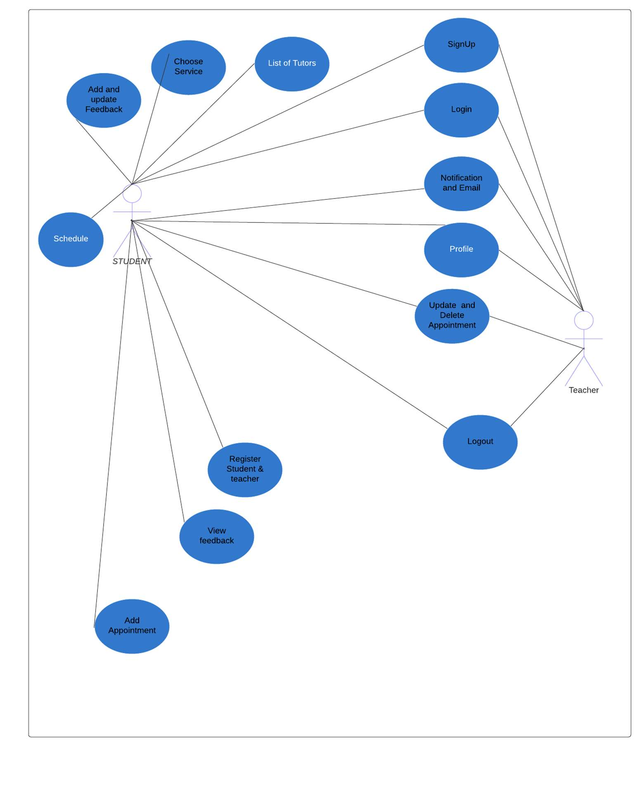

Figure 1 Use Case diagram for User

* + 1. **Admin Portal**

Admin will be able to login, view schedule, add a teacher, view profile, delete/update teacher list, view feedback, register students and teachers, and logout.

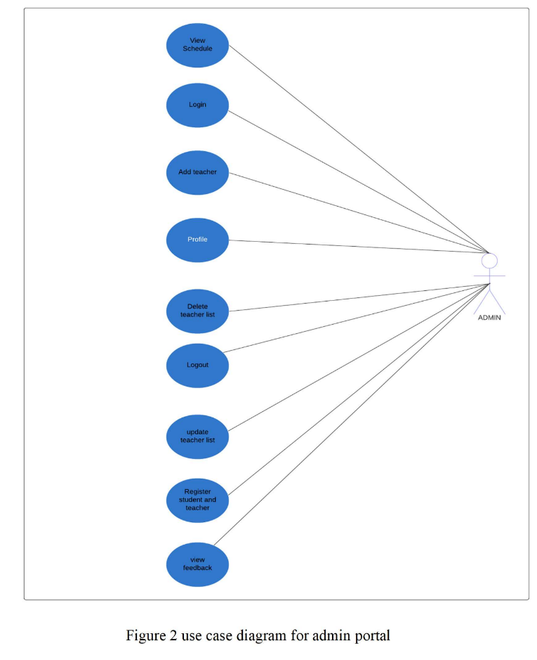

Figure 2 use case diagram for admin portal

#### Software Development Life Cycle Model

In our project the software development model we are using is **Agile Methodology**

This model refers to agile software methodologies focused round the possibility of programming advancement, where prerequisites and arrangements develop through coordinated effort between self- organizing cross-functional teams. The most important in this method is that it allows teams to deliver things quickly with highest quality, and predictability, and higher aptitude to respond to change. **Scrum** and **Kanban** are two of the most generally utilized Agile Methodologies.

##### Key Principles of Agile Methodology

* Active client inclusion is basic
* The group must be engaged to decide
* Requirements develop yet the timescale is fixed
* The most noteworthy need is to fulfill the client through right on time and constant conveyance of important programming.
* Develop little, steady discharges and emphasize
* Focus on visit conveyance of items
* Complete each component before proceeding onward to the following
* Apply the 80/20 rule
* Testing is coordinated all through the undertaking lifecycle – test early and frequently
* A synergistic and helpful methodology between all partners is fundamental

The reason of using the agile methodology in our project is that it predicts changes and enables for much more flexibility than traditional methods. Clients can avoid of the large changes in the budget or schedule by making small changes. The procedure includes separating each task into organized requirements and conveying each independently inside an iterative cycle. A cycle is the daily schedule of growing little portions of the tasks at once. Every cycle is checked on and surveyed by the development team and user. The bits of knowledge picked up from the evaluation are utilized to decide the subsequent stage being developed. Clients visit to rearrange the meetings for the work finished by the past cycle and for the next cycle. Definite objectives are set in every meeting, for example, anticipated changes, time assessments, needs and financial plans.

# CHAPTER 3 SYSTEM DESIGN

##### Work Breakdown Structure (WBS)

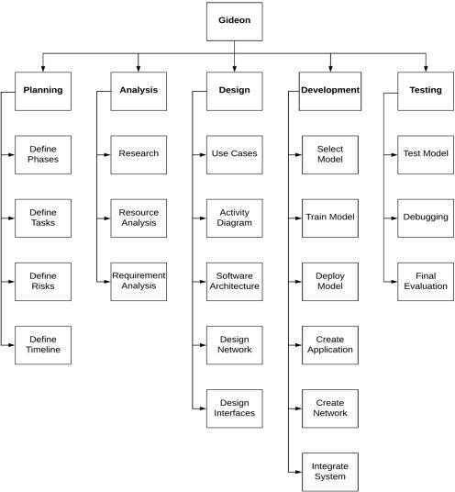

Figure 3 WBS

##### Activity Diagrams

**User signup**

A user who wants to register will have two options for signup i.e., enter his credentials or he can sign up

from his google account. Once user submit the credentials and they are invalid or already in use then the

user will be asked to enter again otherwise he will be shown the home page.

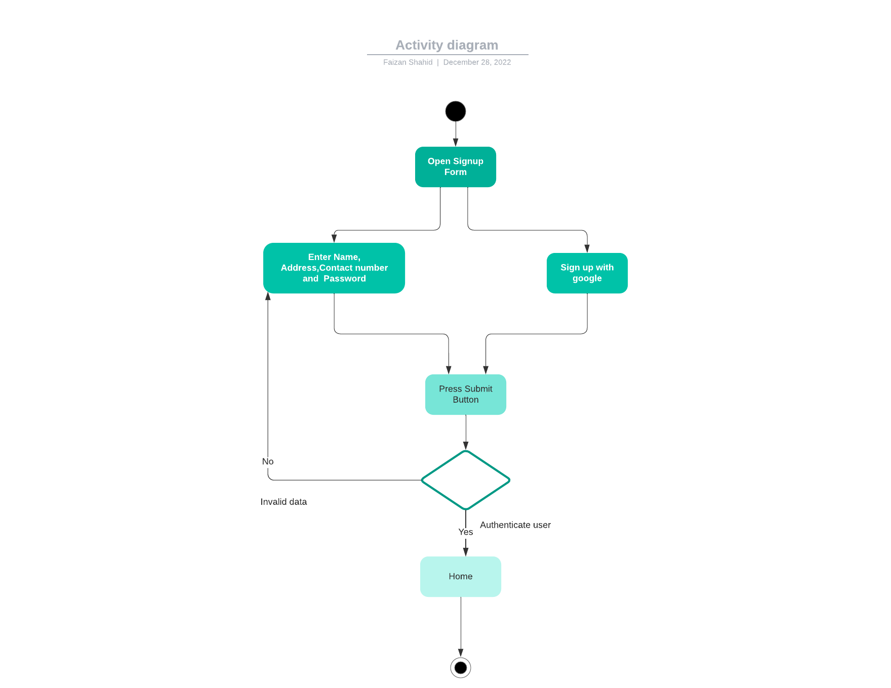

Figure 4 Activity diagram 1: Signup

**Login**

If the user is already registered then he will open login form and enter his username and password. If the

credentials are correct then the user will be led to user dashboard after pressing login button and the

credentials are wrong then user will be asked to reenter the credentials.

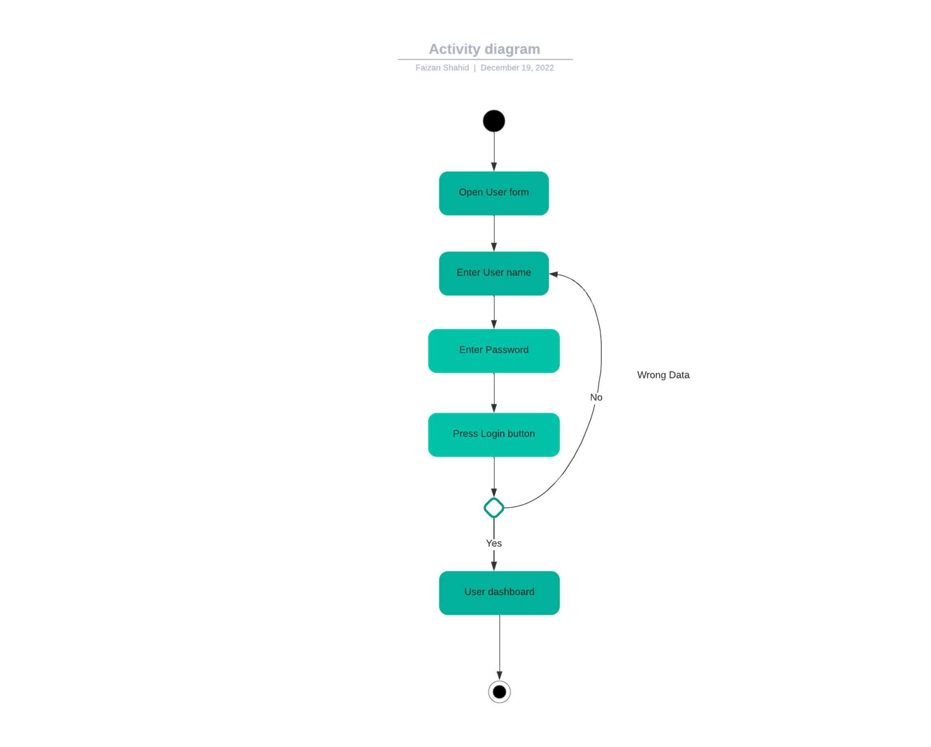

Figure 5 Activity diagram 2: login

**View List of Teachers**

Registered students will login through user login portal and will be directed to the user dashboard from

where they will search or select their subject. After this they will be shown list of available teachers from

which they will select a specific teacher and will view teacher’s profile.

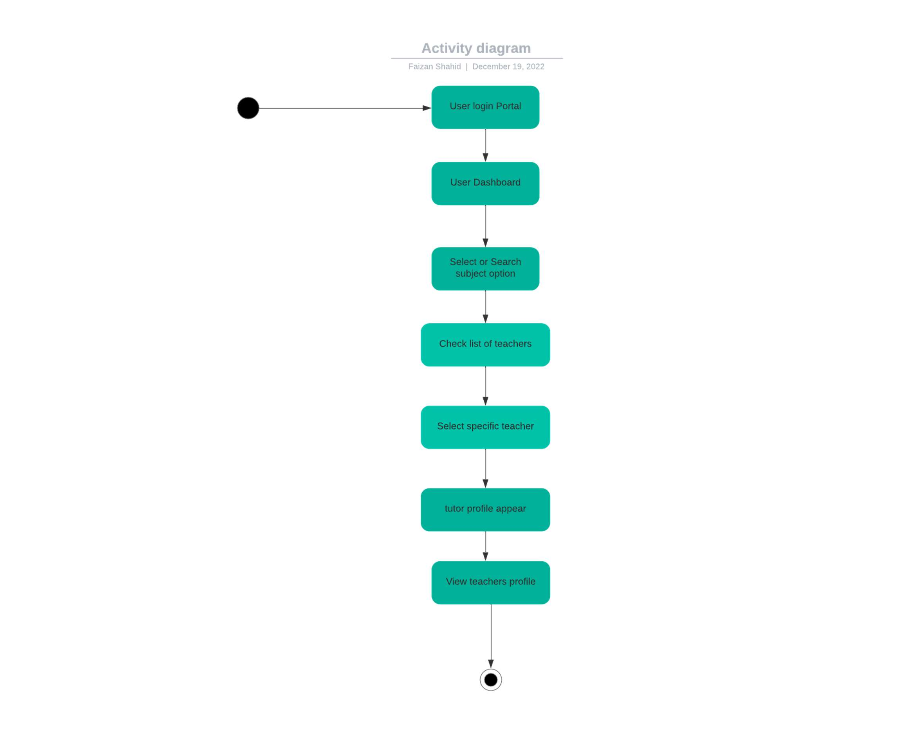

Figure 6 Activity diagram 3: View list of teachers

**View Profile**

User will first login and will be led to home page from which user will click on my profile and user’s

profile will appear.

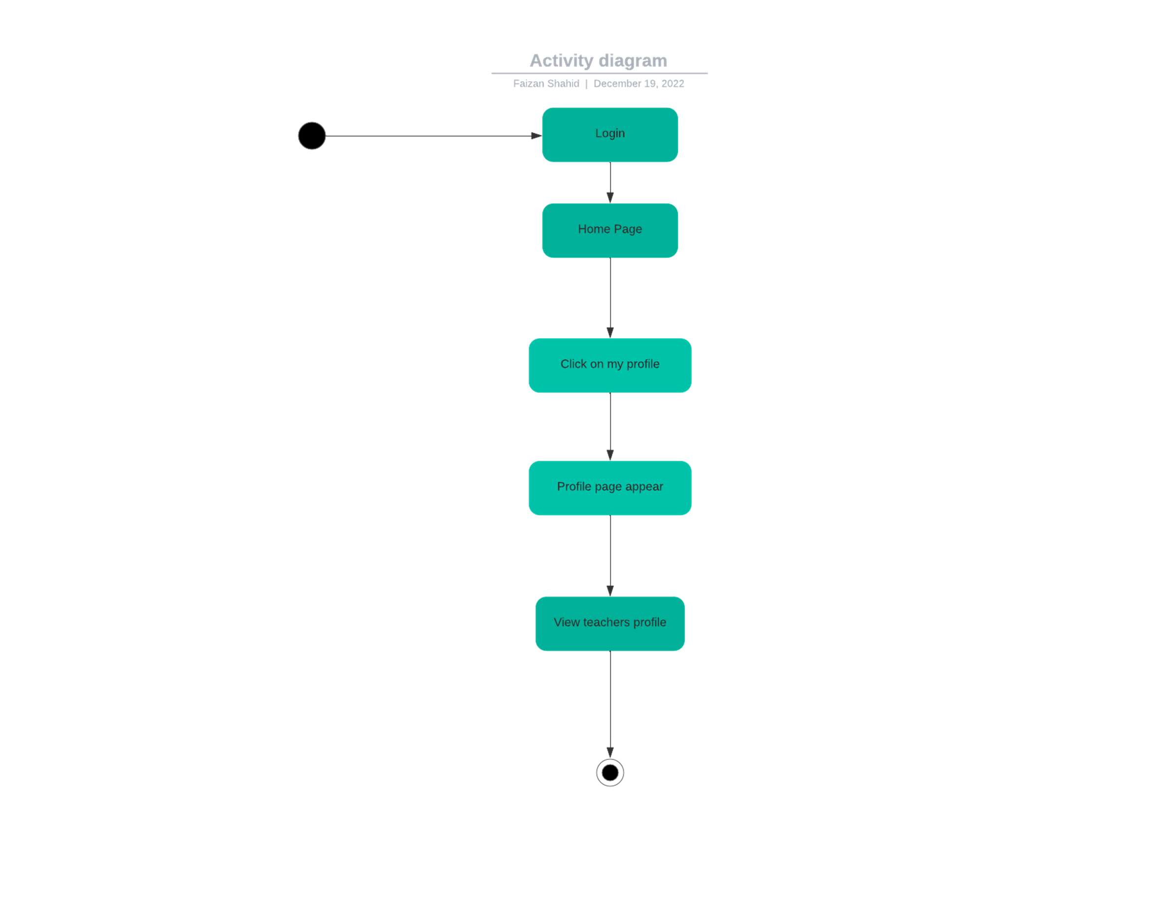

Figure 7 Activity diagram 4: Signup

**View Schedule**

User will first login and will be led to dashboard from where user will click on schedule and will view

the schedule.

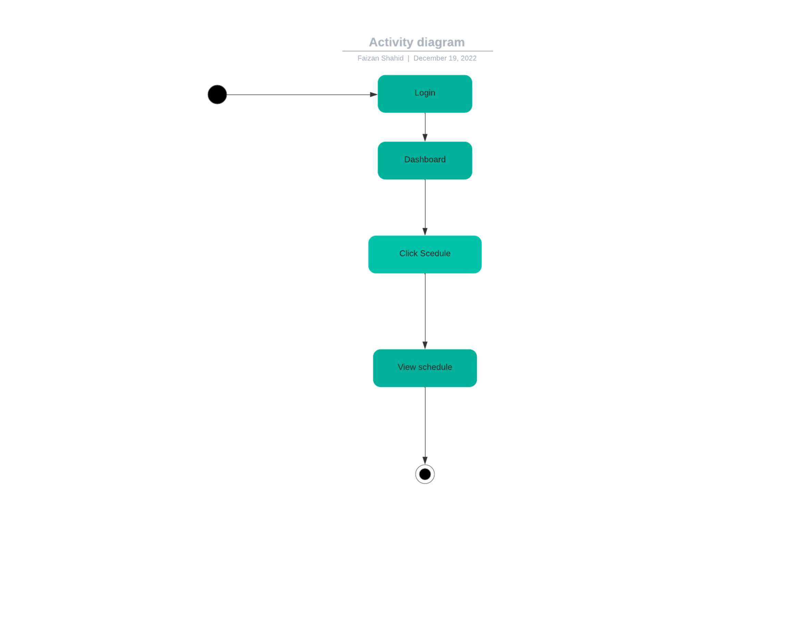

Figure 8 Activity diagram 5: View schedule

**View Appointment**

User will first login and will be led to dashboard from where he will click on appointment and view

the appointments and their details.

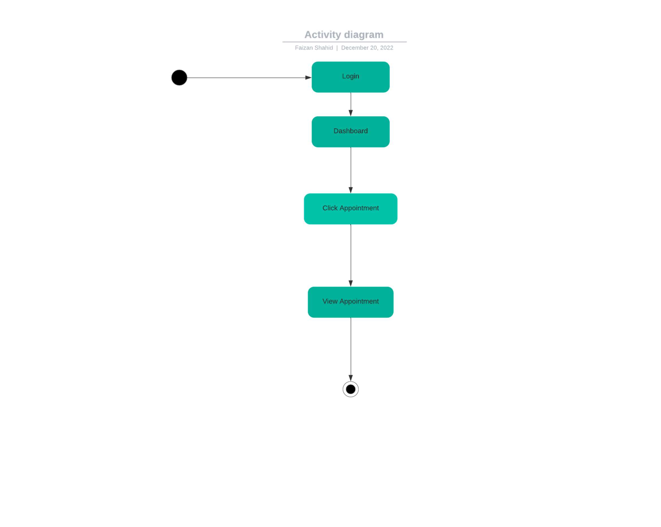

Figure 9 Activity diagram 6: View Appointment

**View Feedback**

From homepage user will click service option and after selecting a specific service, list of tutors will appear

from where user can select a specific tutor and view tutors’ profile in which user will click feedback button

and view the feedback of that tutor.

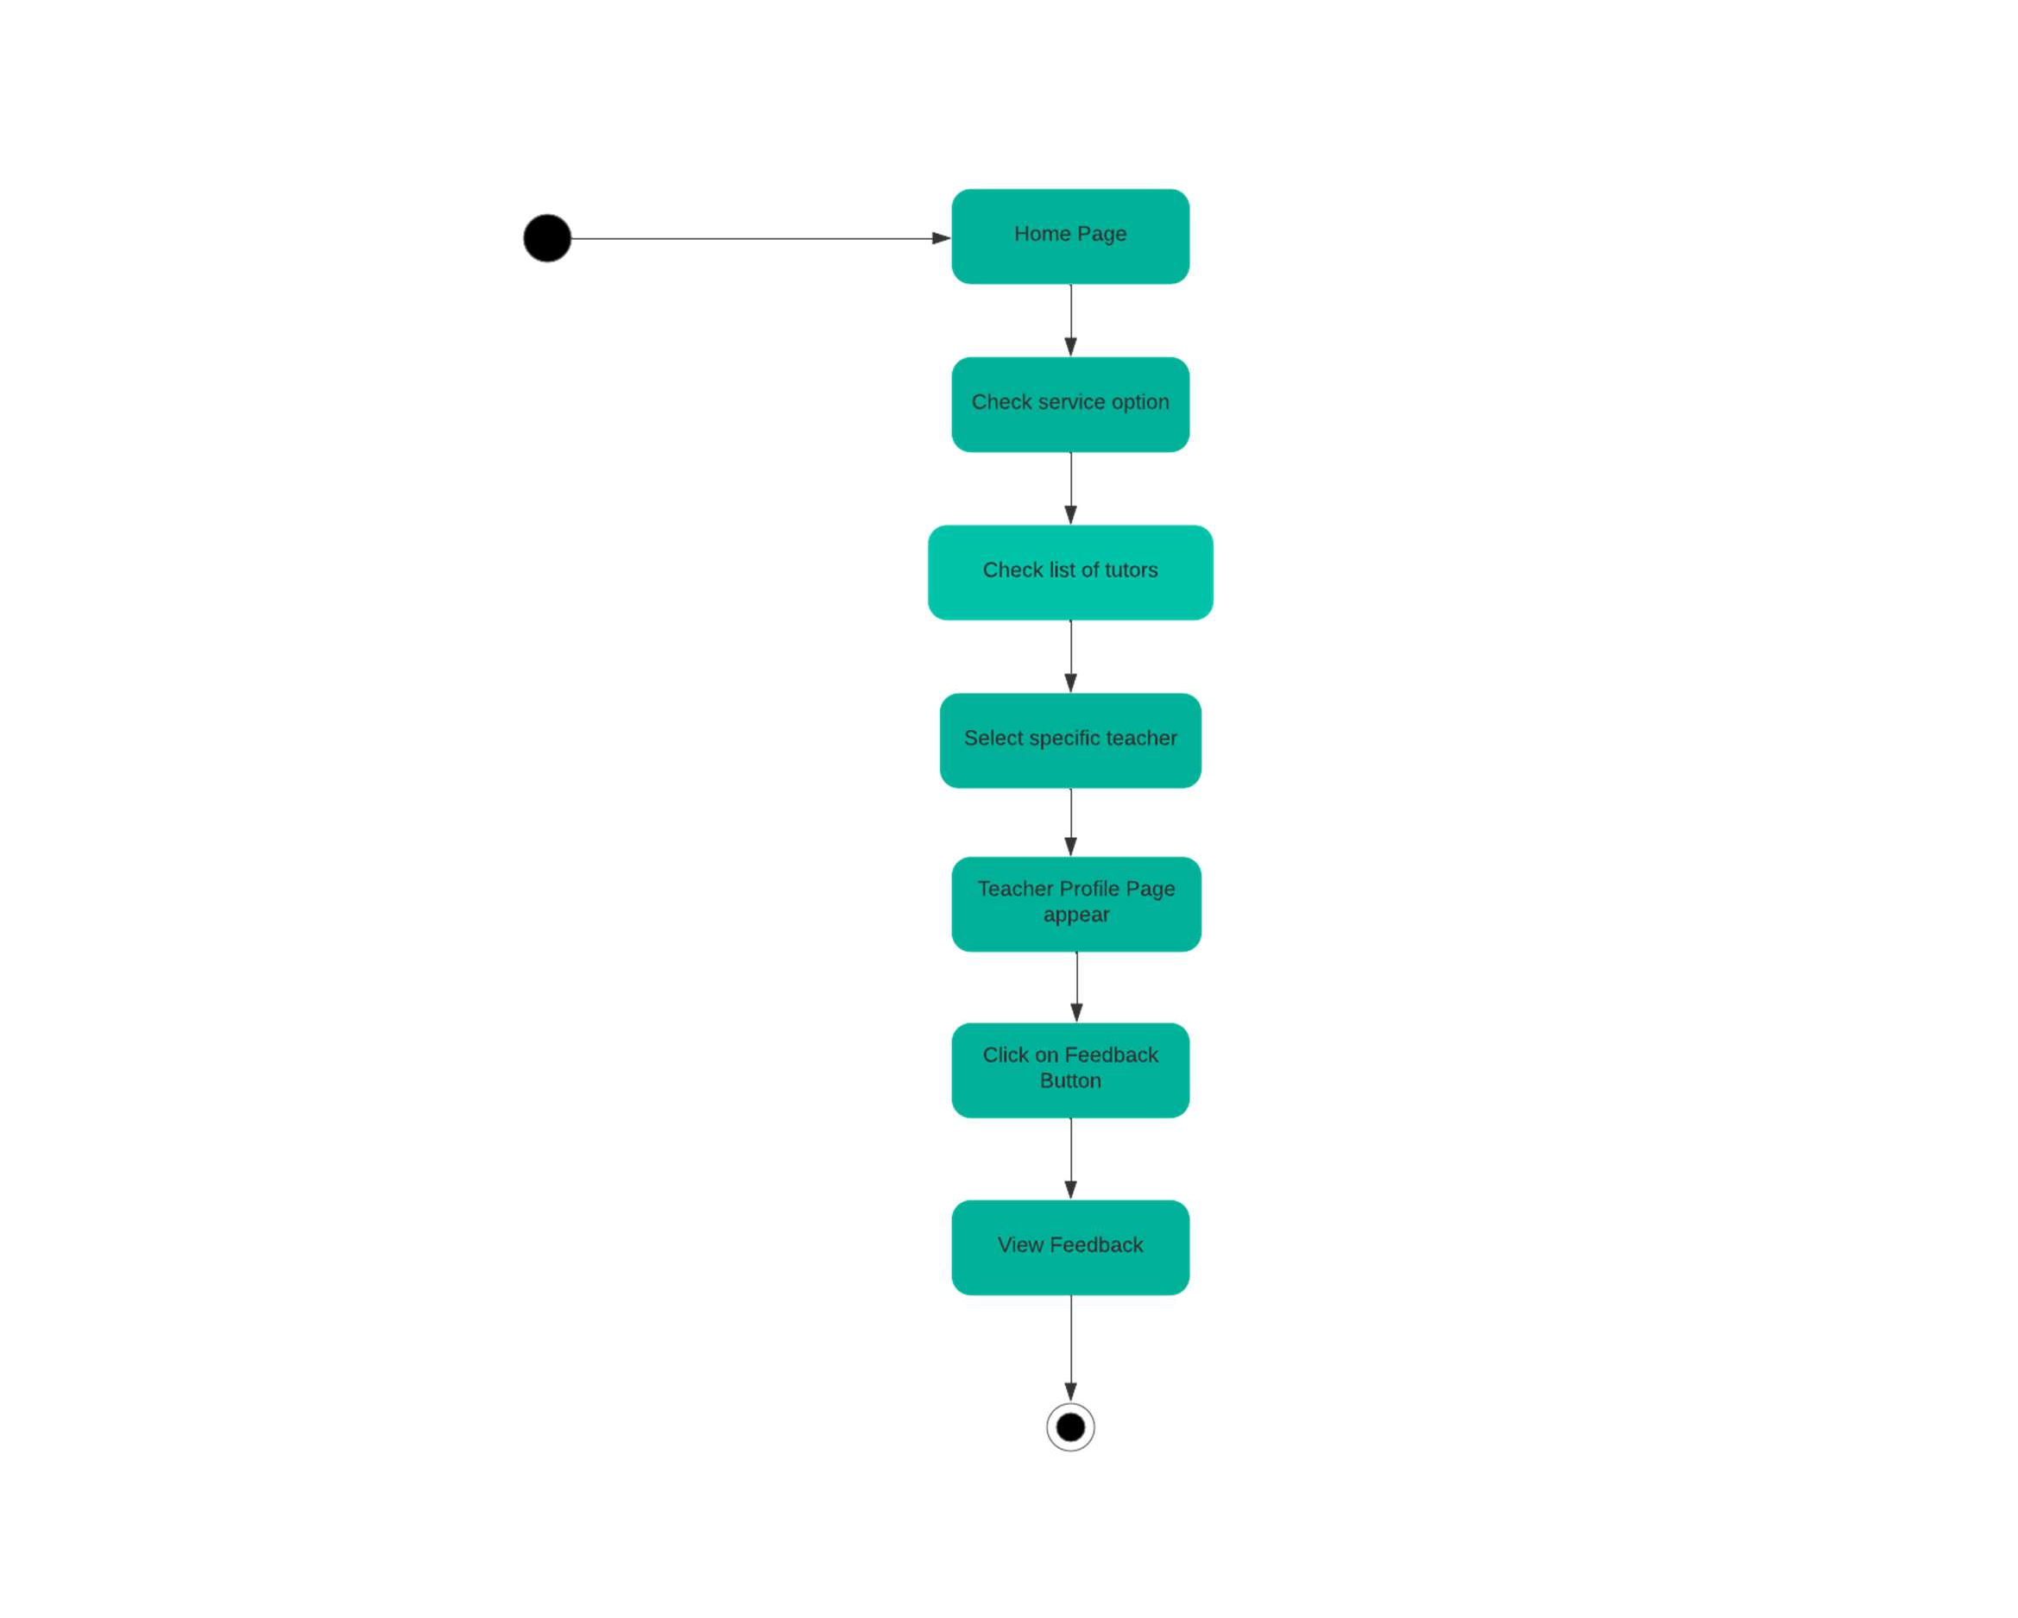

Figure 10 Activity diagram 7: View feedback

**Add Appointment**

First user will login and will be led to dashboard from which user will open add appointment page and then

user will enter appointment details and then will press add appointment button. The system will add an

appointment and notify the user.

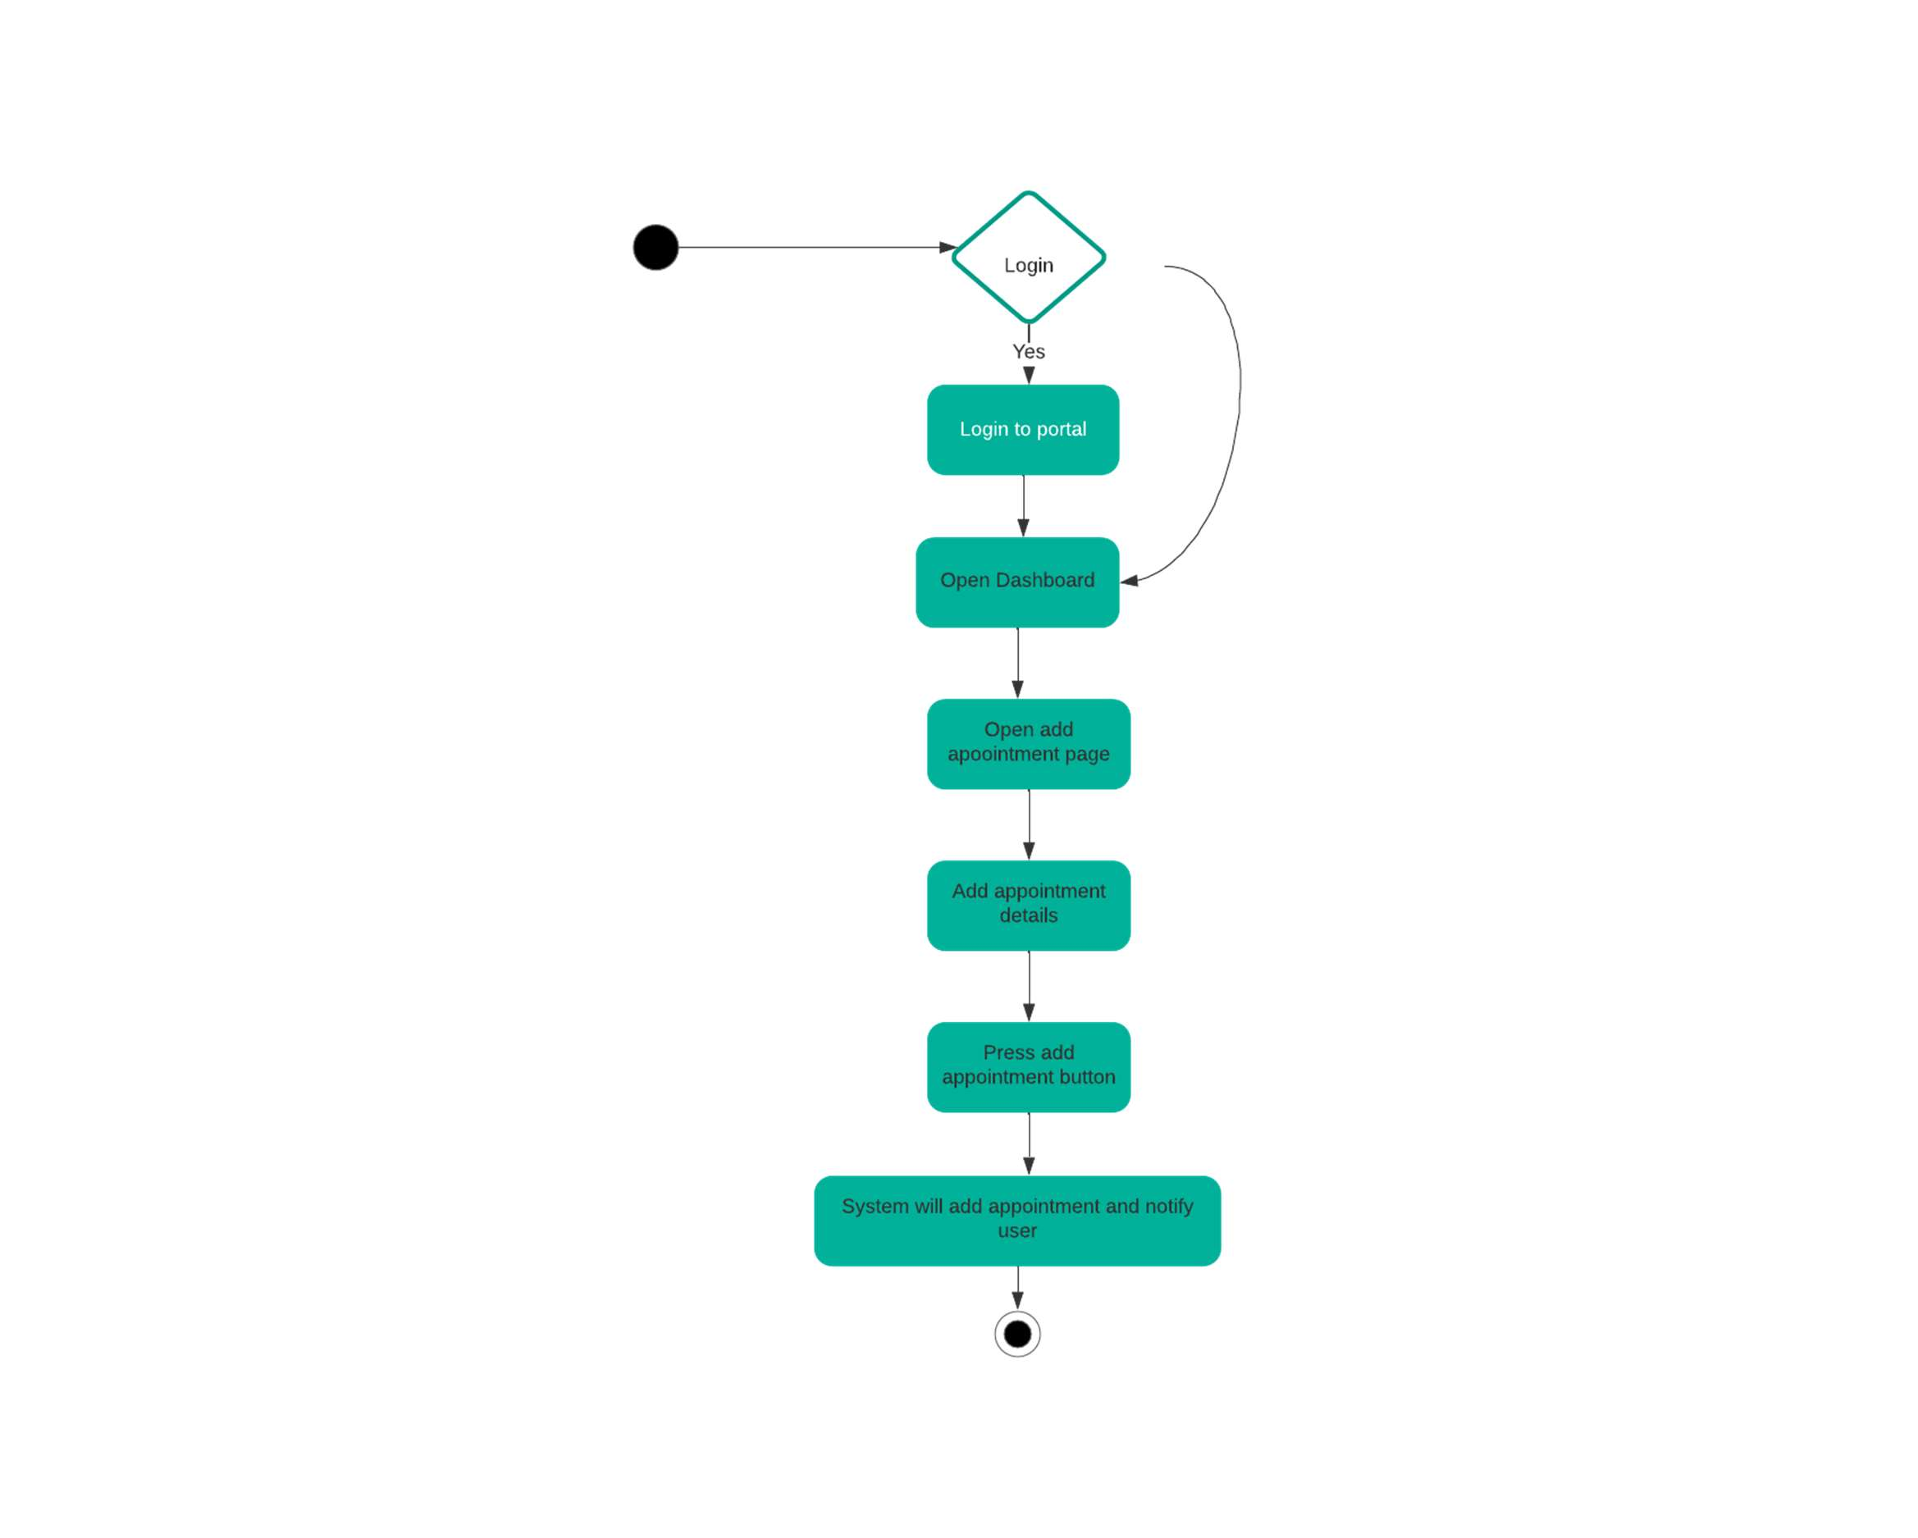

Figure 11 Activity diagram 7: Add Appointment

**Add Feedback**

From home page user will open feedback page which will have two options i.e., enter feedback through

stars or enter a comment. User can also choose both and after entering feedback and clicking submit button

the message will be shown and the feedback will be submitted. If the message is not shown then the entered

feedback is invalid or the user has not entered any kind of feedback and in this case, user will be asked to

enter feedback again.

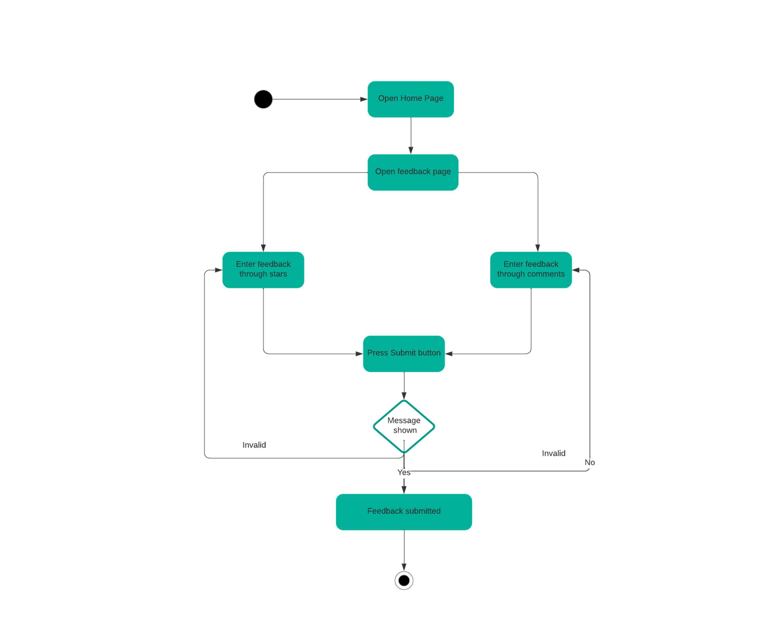

Figure 12 Activity diagram 8: Signup

**Update Feedback**

From the user dashboard the user will click on edit comment then after editing the user will press submit

comment. After this the comment/feedback will be updated and the message will be shown.

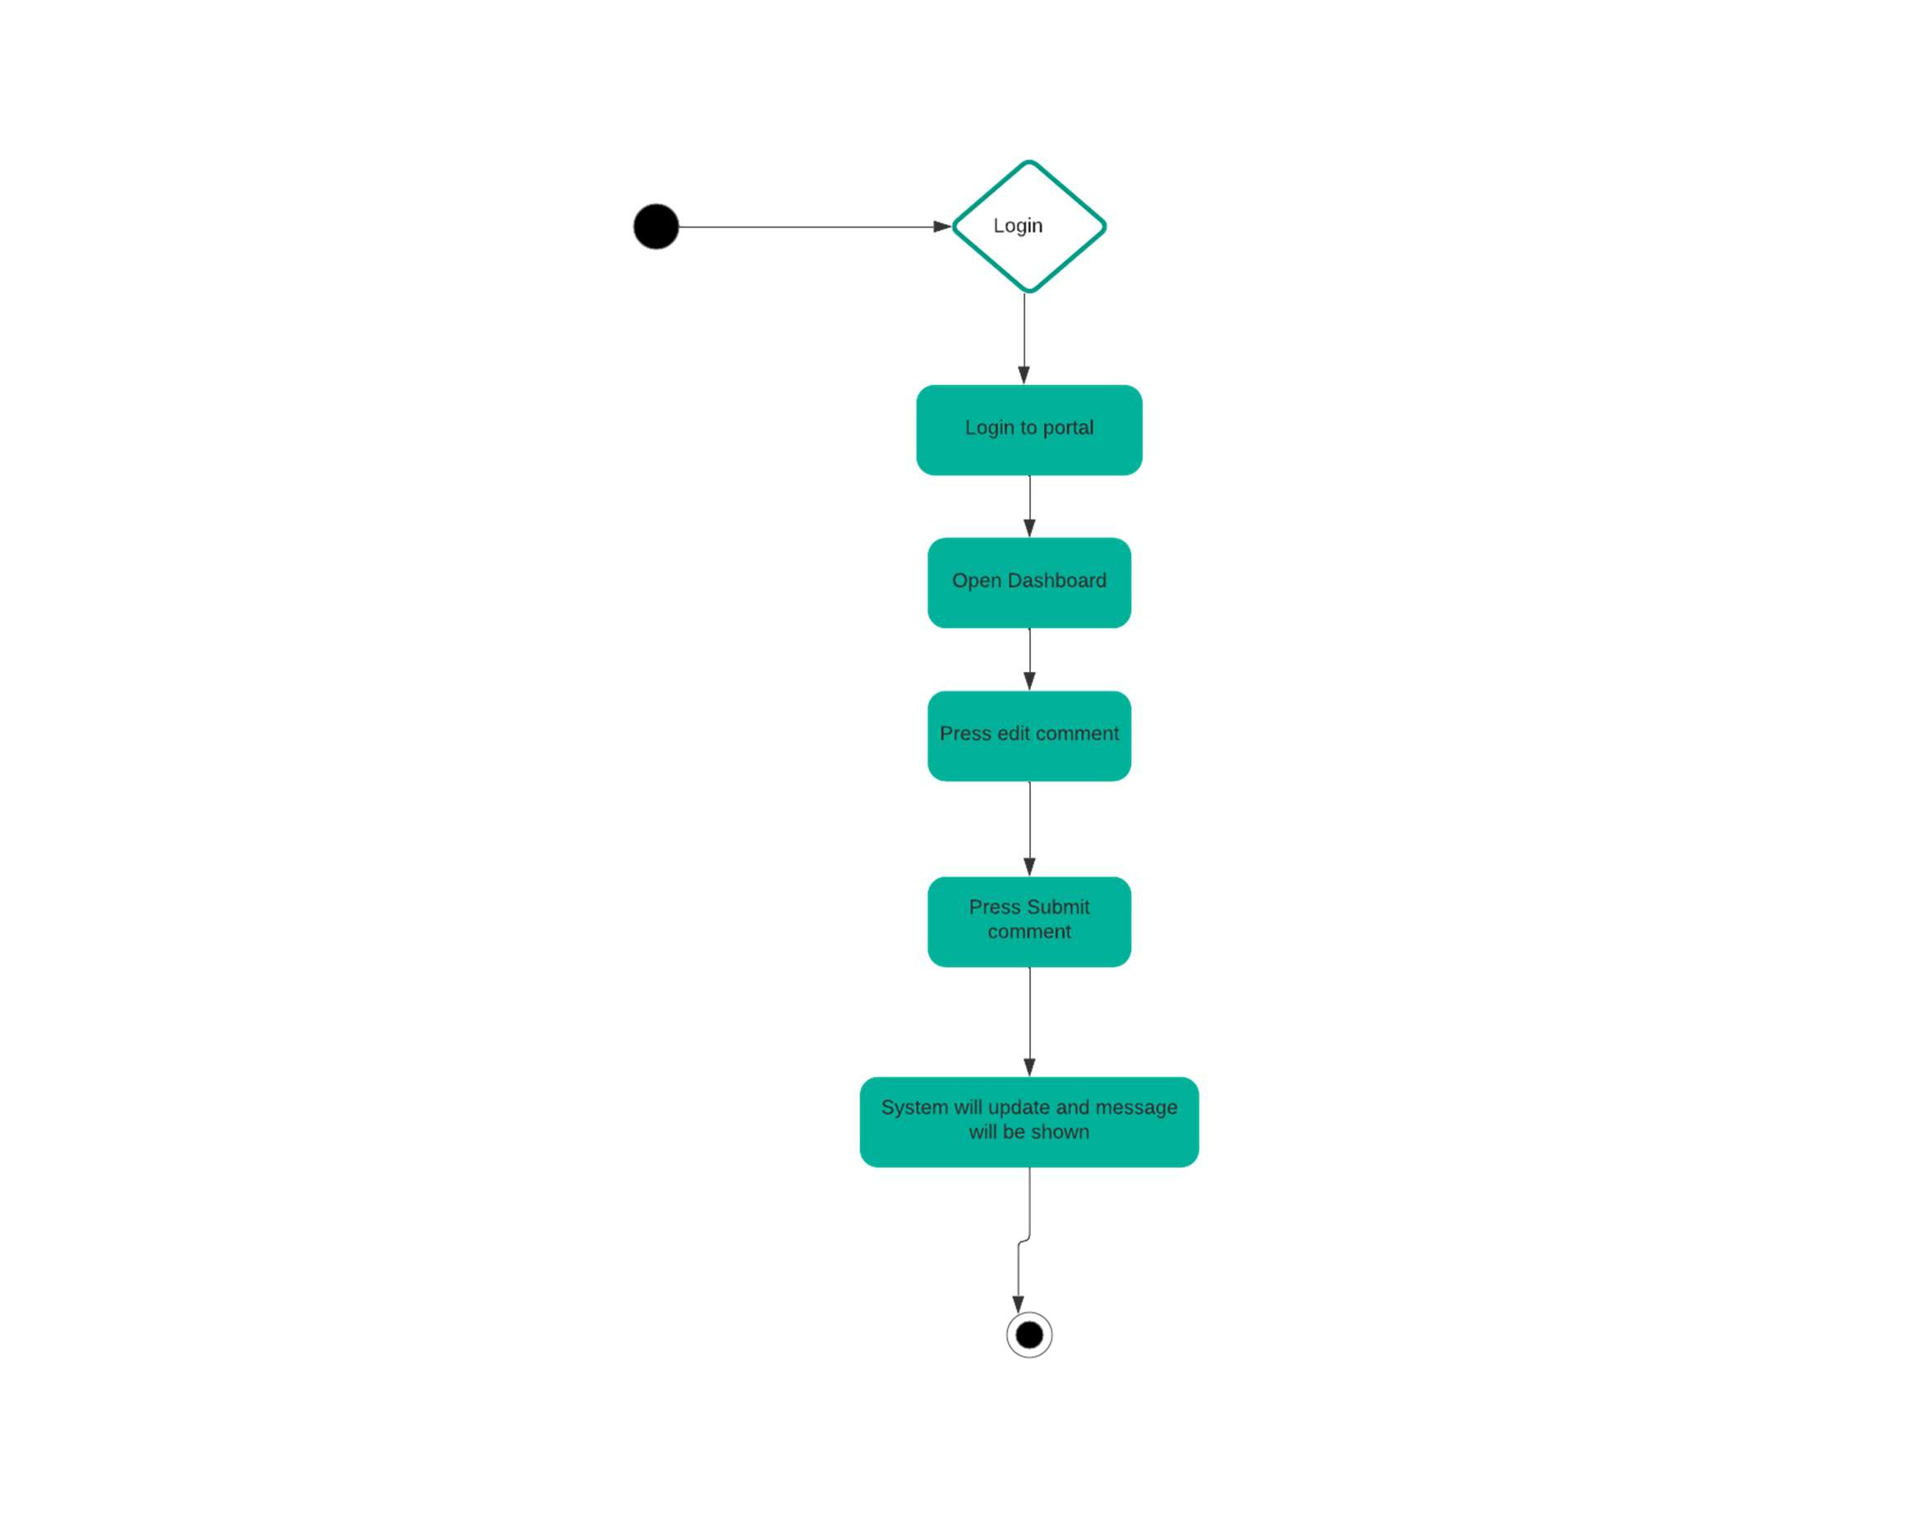

Figure 13 Activity diagram 9: Update feedback

**Delete Appointment**

From user dashboard user will select appointments and if there are no appointments, he will make an

appointment and submit it. If the message is shown then the appointment is added and user will click on

schedule to check the appointments otherwise if the user already has an appointment, he will check the

schedule and see the appointment list from where he will delete an appointment and the message will

be shown.

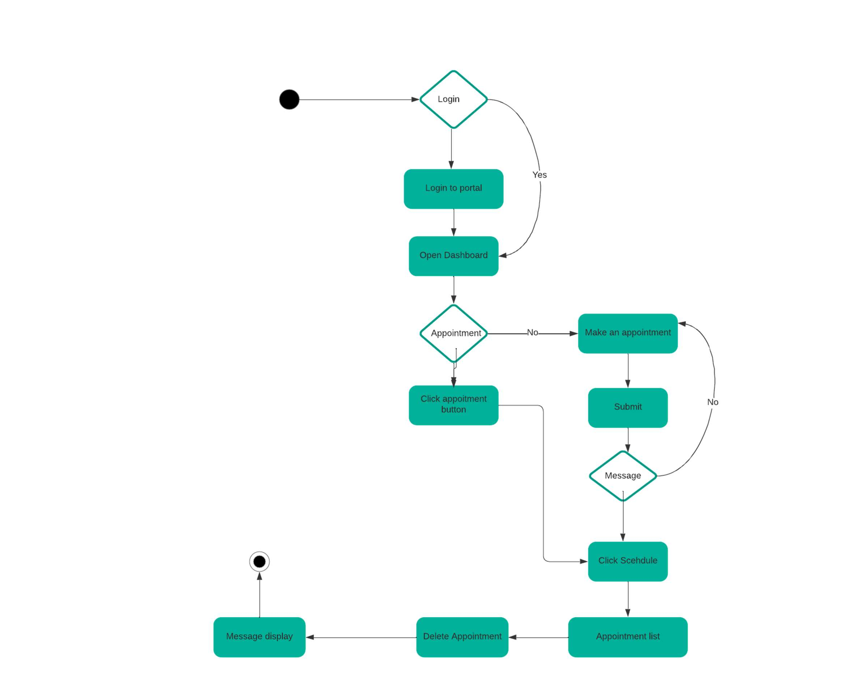

Figure 14 Activity diagram 10: Delete Appointment

**Update Appointment**

After logging in user will go to make an appointment page from the homepage and then user will select

update appointment option. After updating user will press update button and if the conformation message

is shown then the appointment will be updated otherwise user will be redirected to update appointment option.

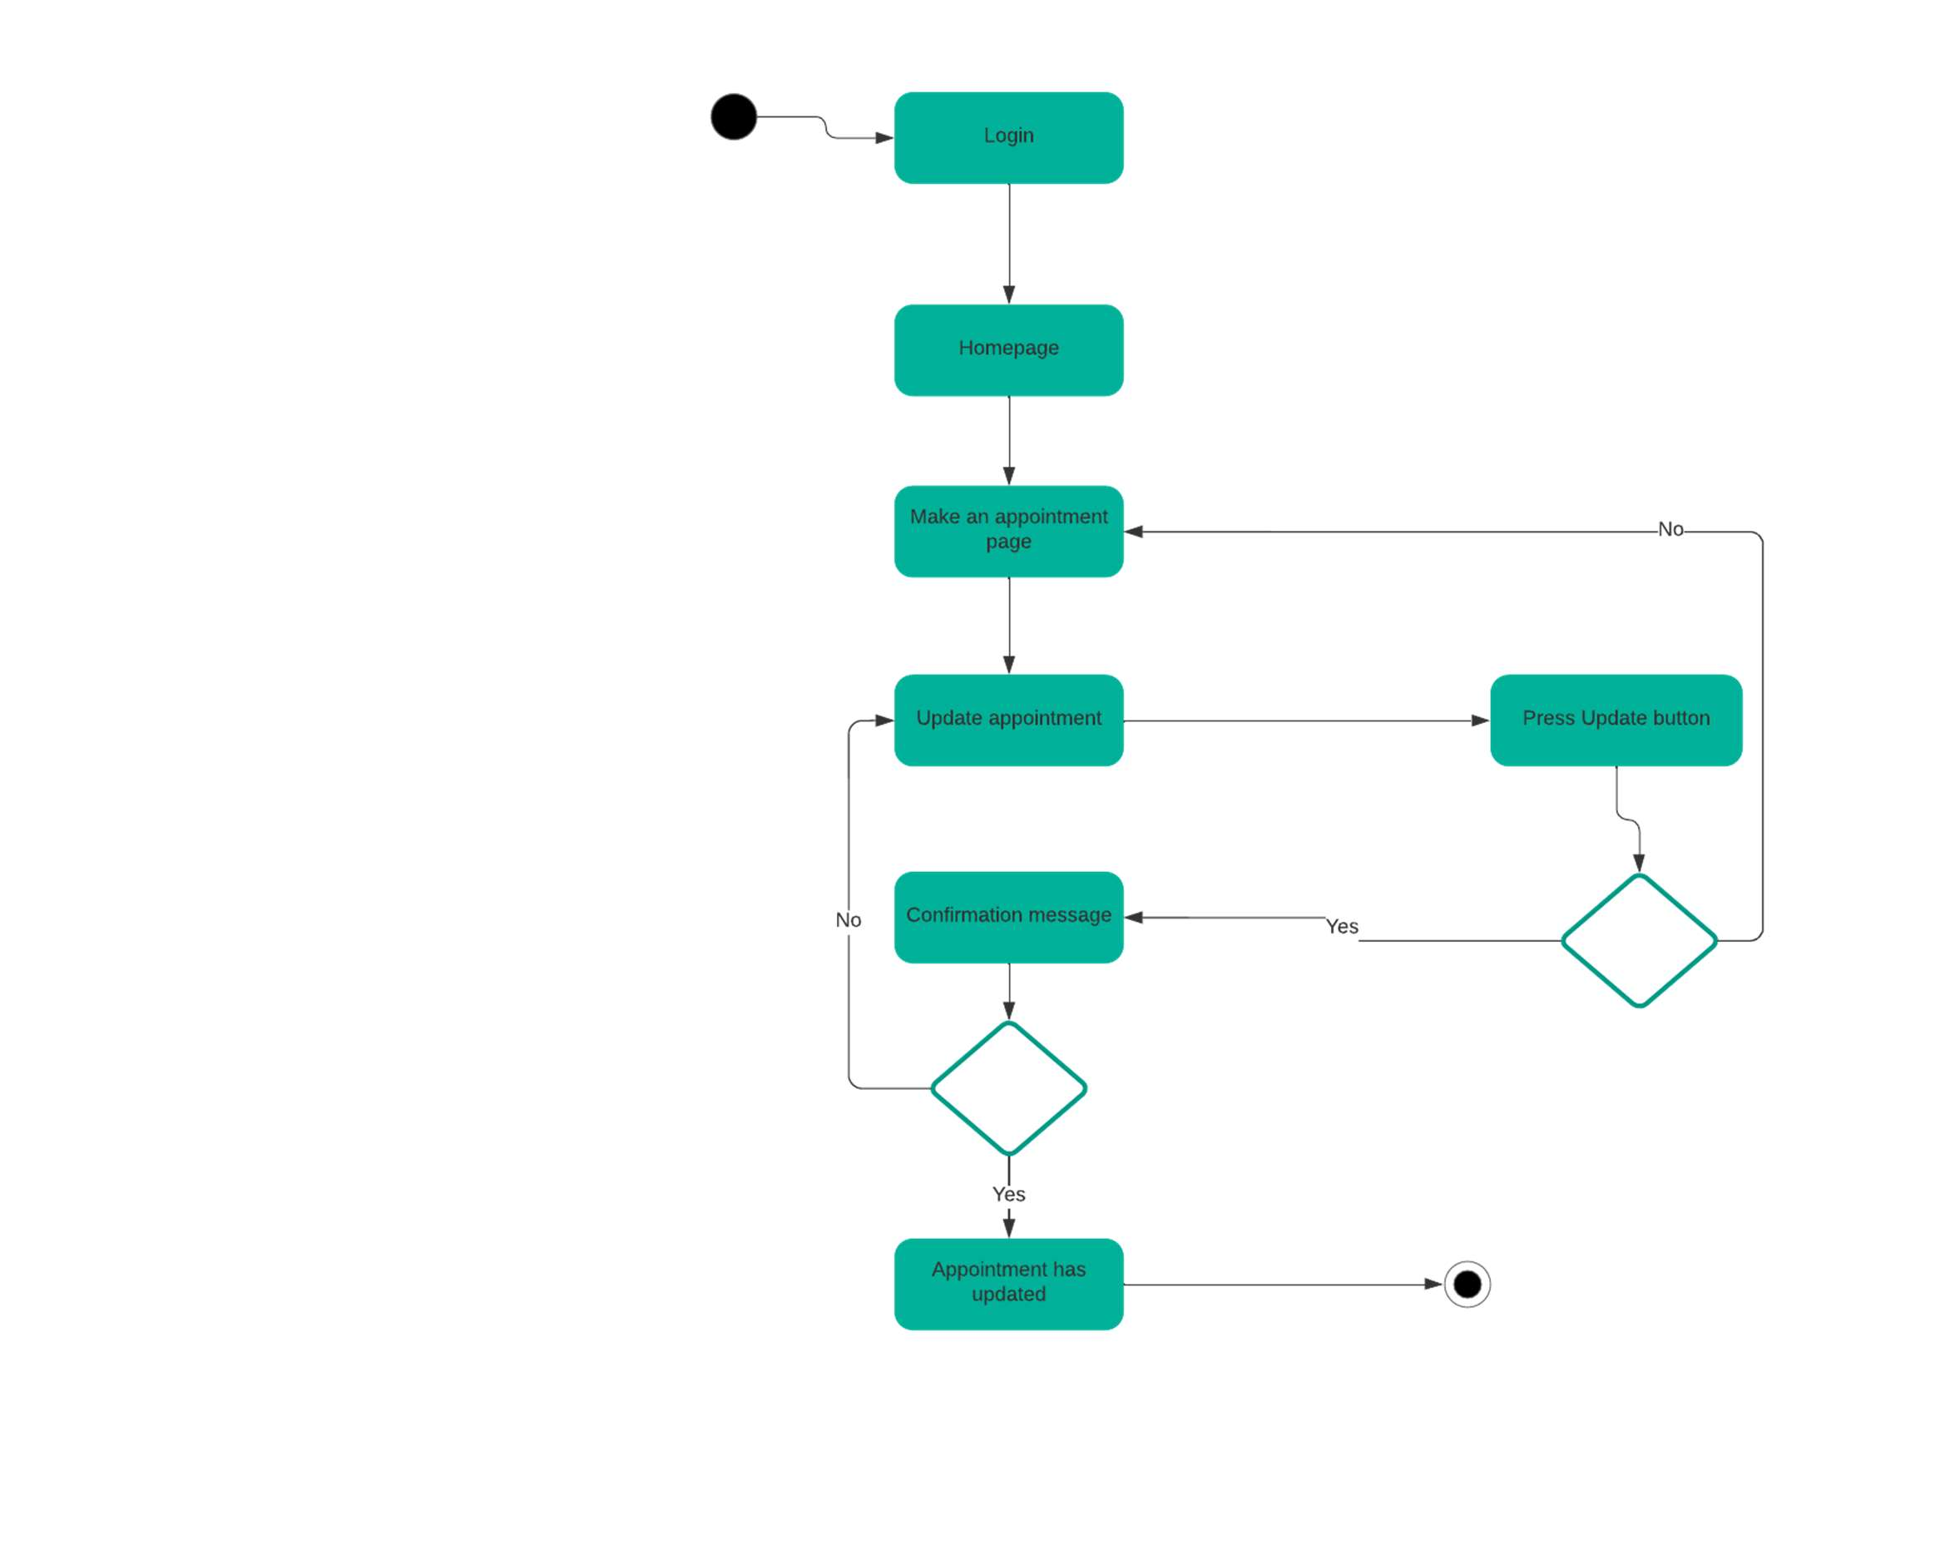

Figure 15 Activity diagram 11: Update appointment

**Notifications**

After logging in user will open dashboard from where he will click on the notifications button and the latest

notifications will be shown.

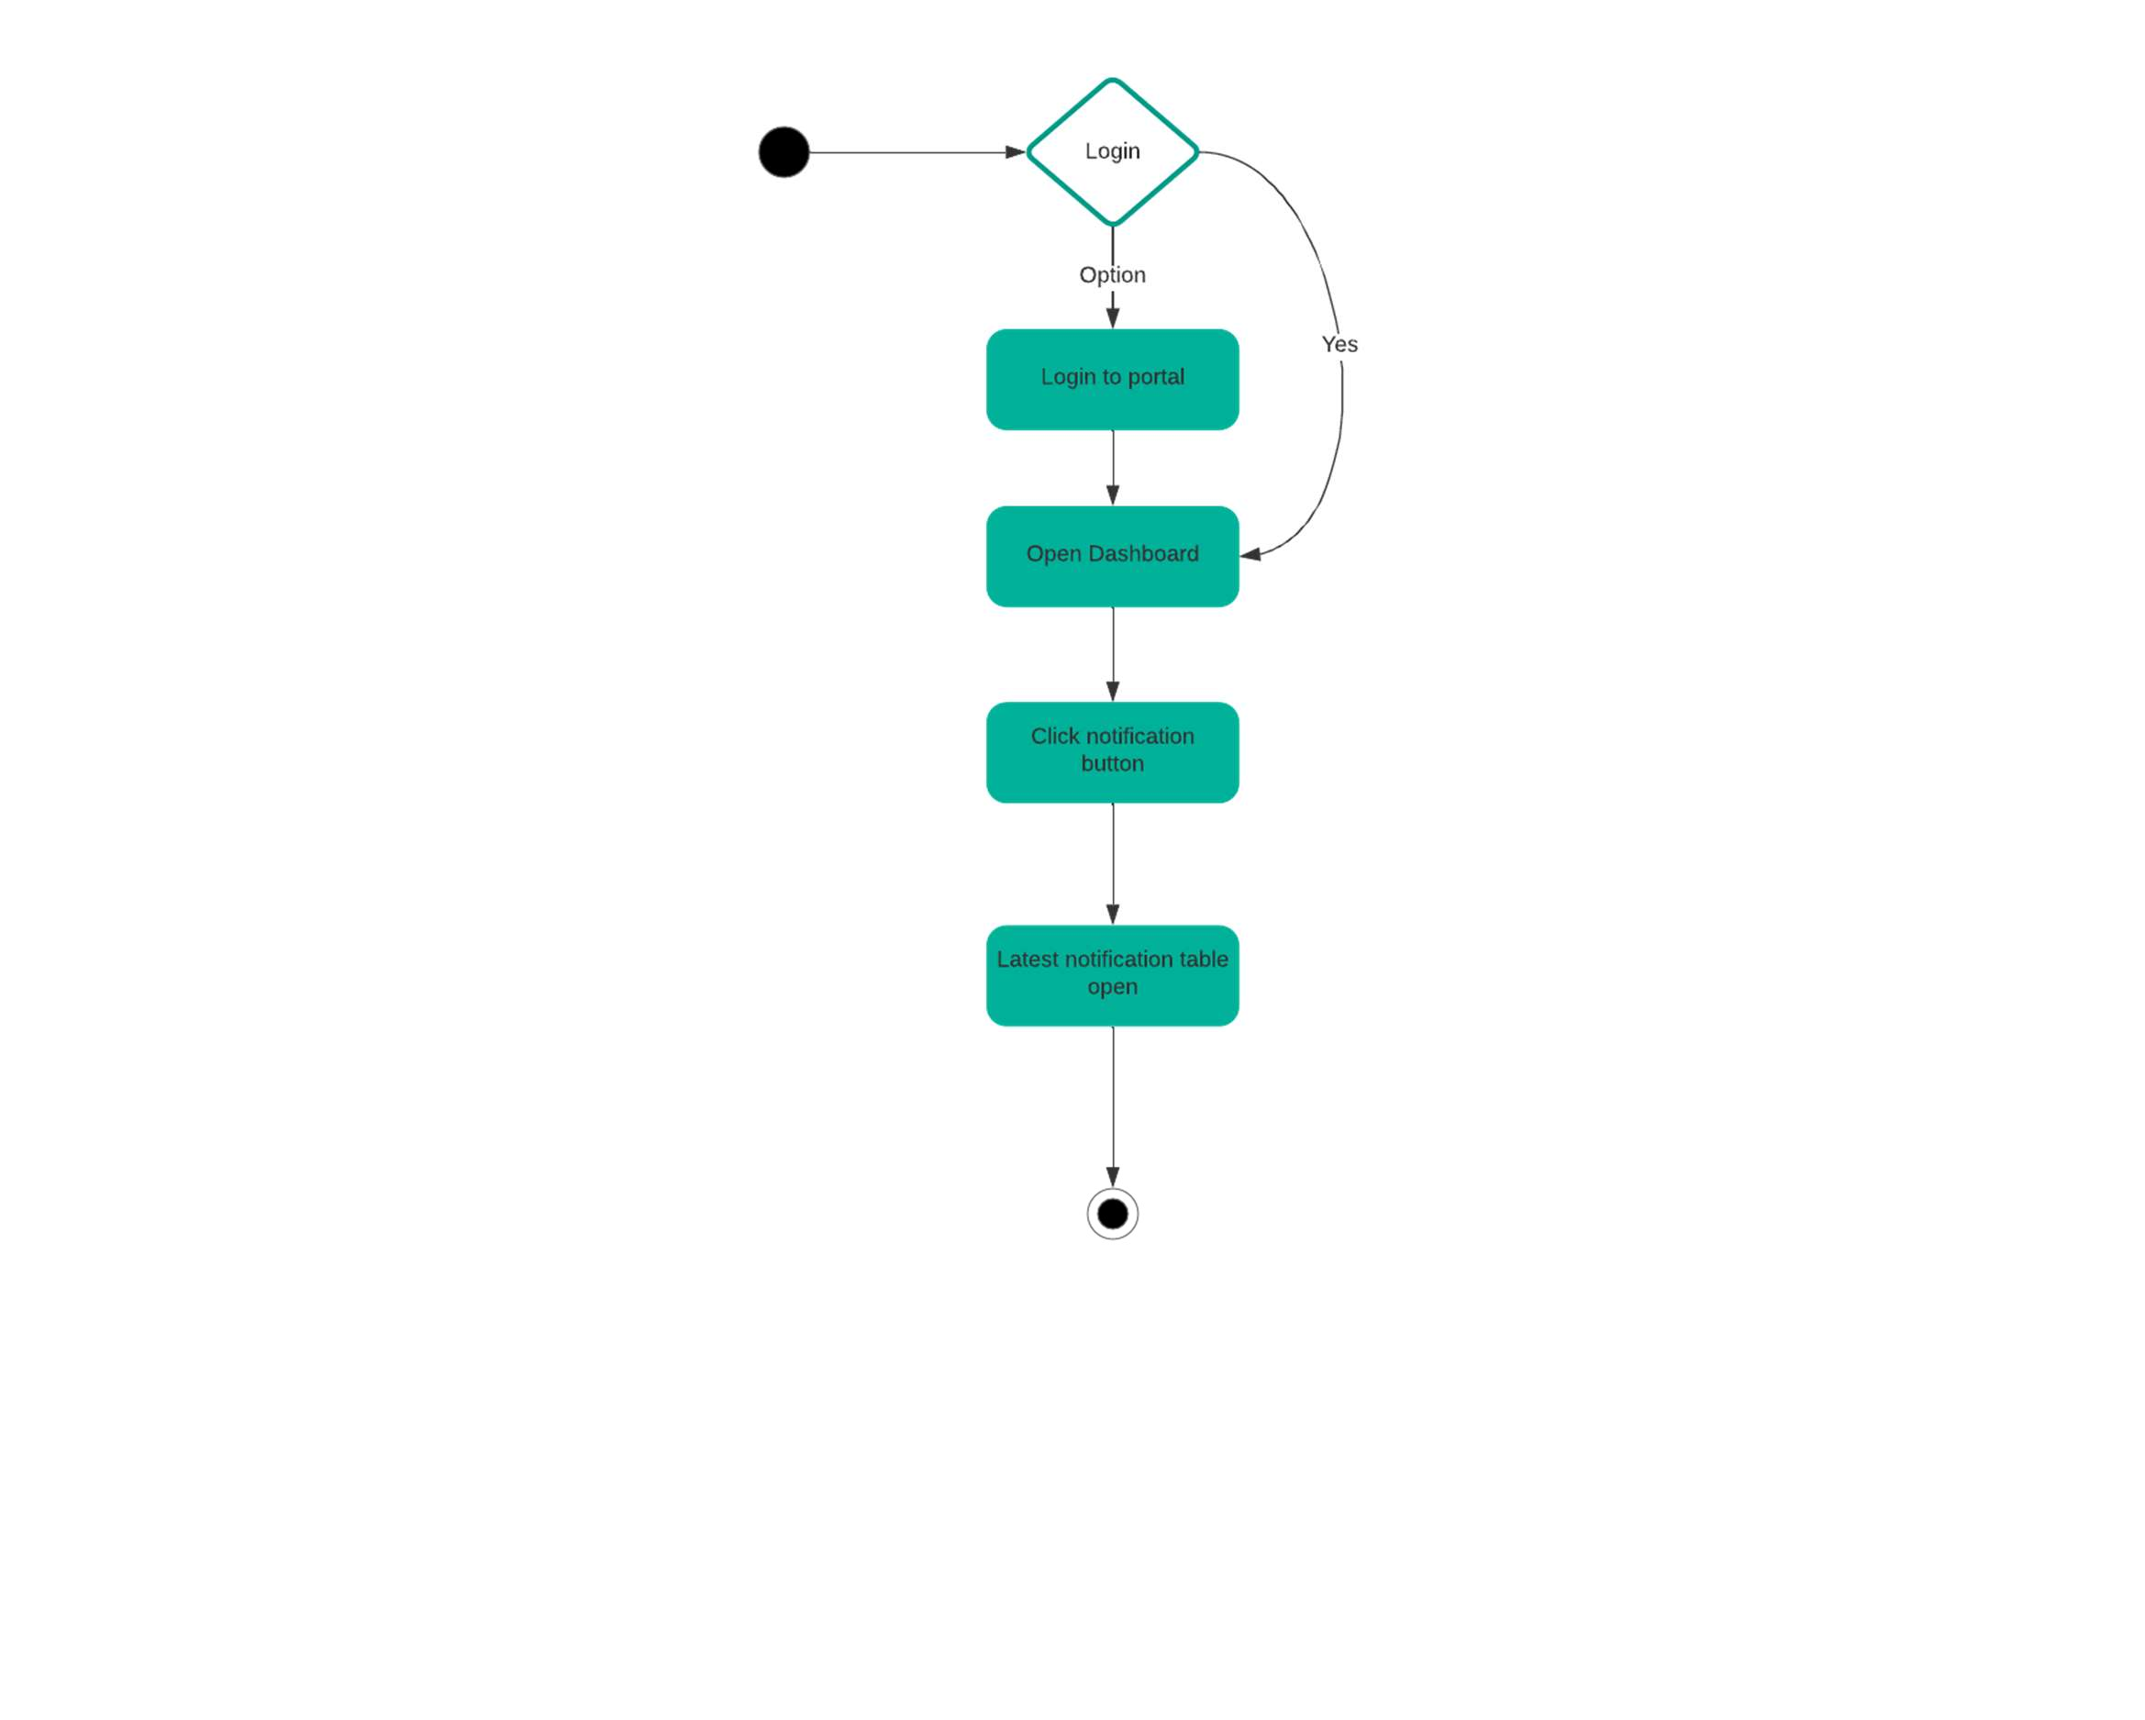

Figure 16 Activity diagram 12: Notifications

**Add teachers in list**

After logging in admin will open the side bar menu from the dashboard. Then the admin will select subject

option and then select list of teachers. Then enter the credentials of that teacher and select add option. After

this a confirmation message will appear with an option for returning to the sidebar menu. If the admin does

not select that option, then the teacher will be added and the list display will be updated.

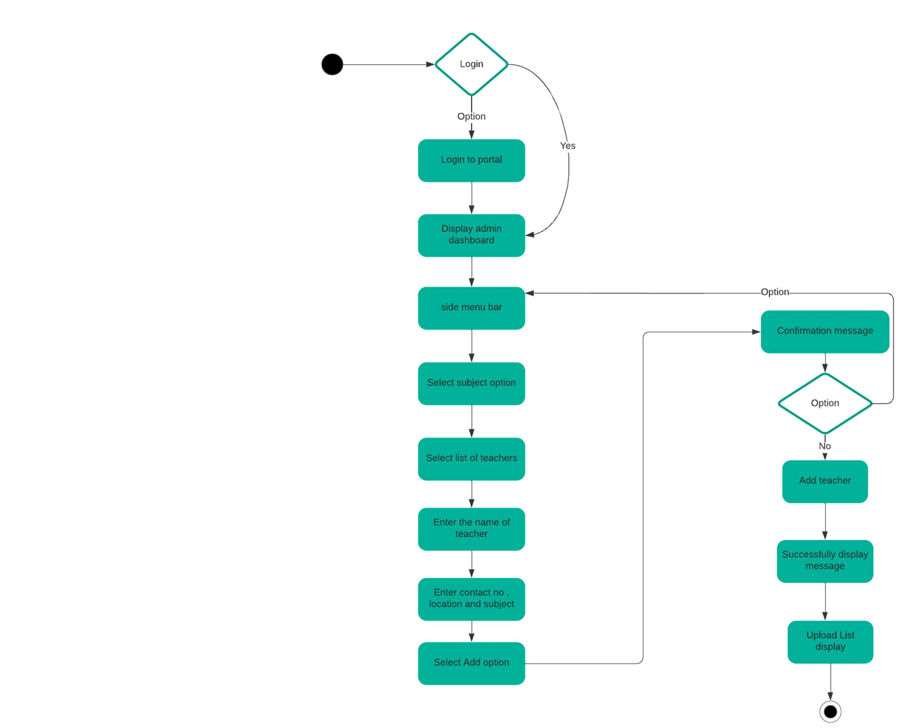

Figure 17 Activity diagram 13: Add teachers in list

**Update Teachers in list**

Admin will first login and then from the dashboard open the sidebar menu. The admin will then select list

of teachers then select the edit option then make the changes and then select the update button. The updated

list will be displayed once the user clicks the ok button.

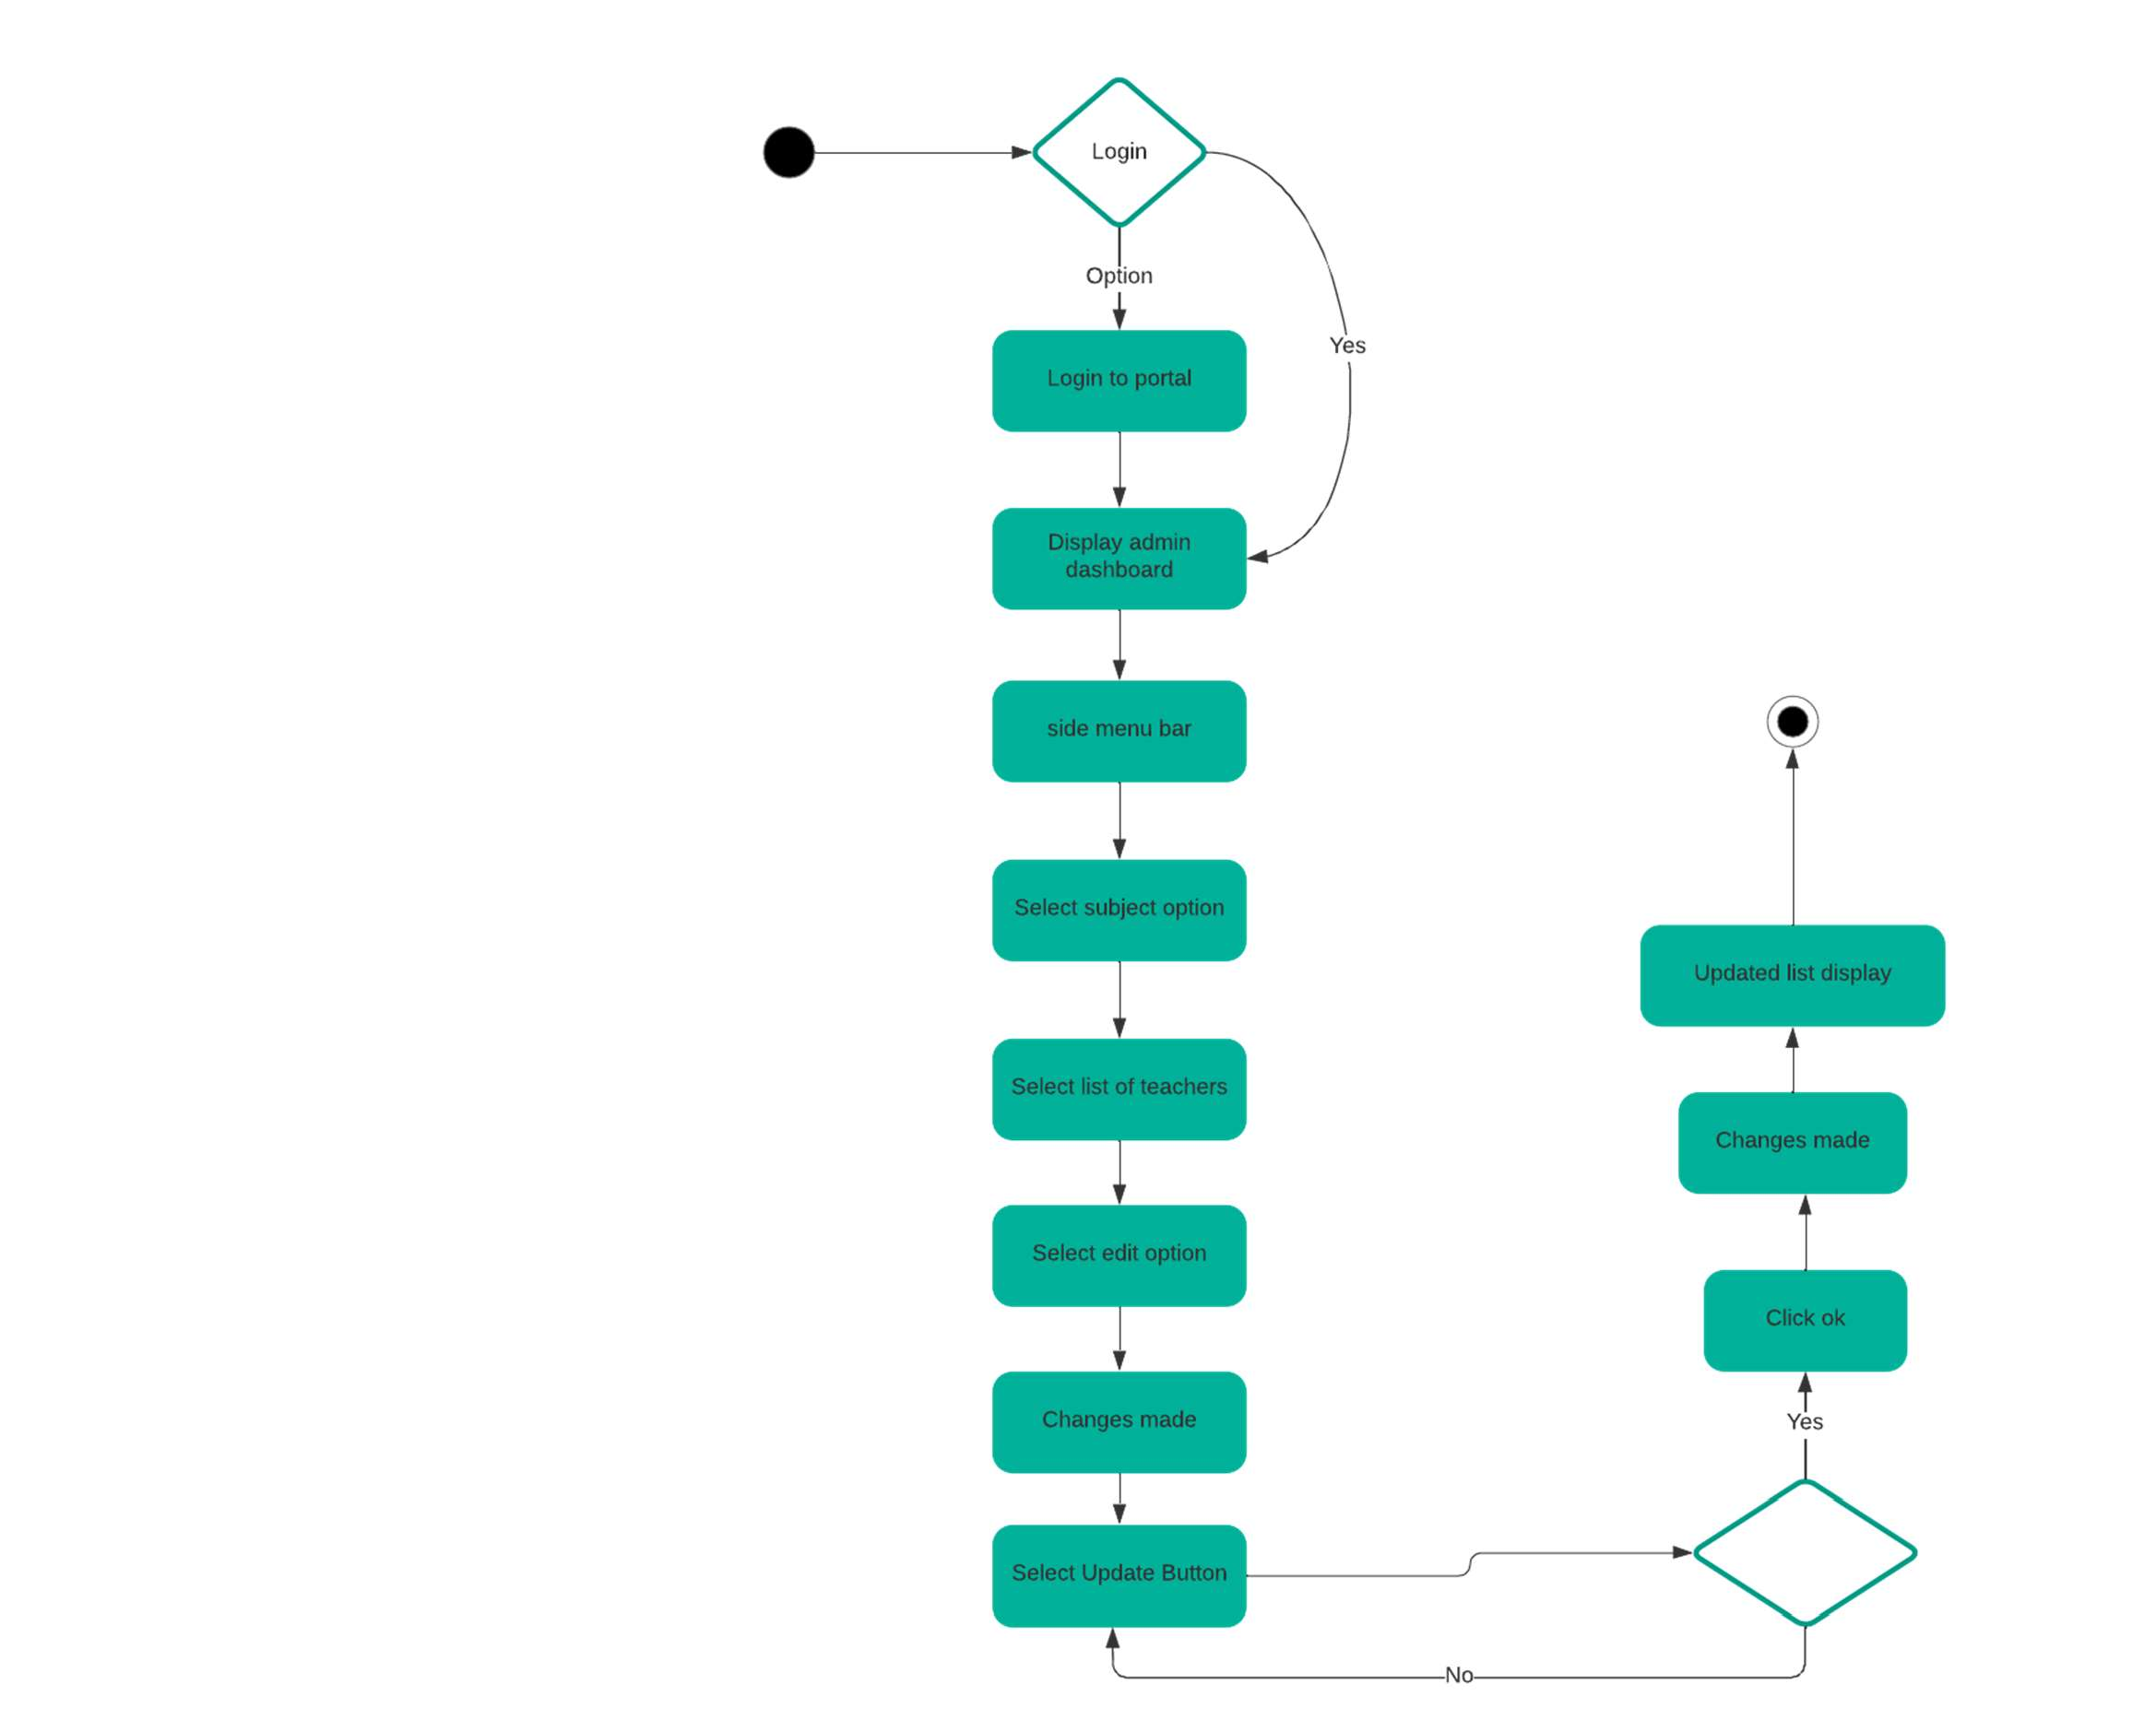

Figure 18 Activity diagram 14: Update teachers in list

**Delete Teachers in list**

Admin will first login to the portal then open the side menu bar from where he will select subject option and

then select list of teachers. After this the teacher list will display and then the admin will click on the delete

button corresponding to the teacher’s name. Admin will then receive a conformation message from which

if he will choose yes then the teacher will be successfully deleted otherwise teacher name will display again.

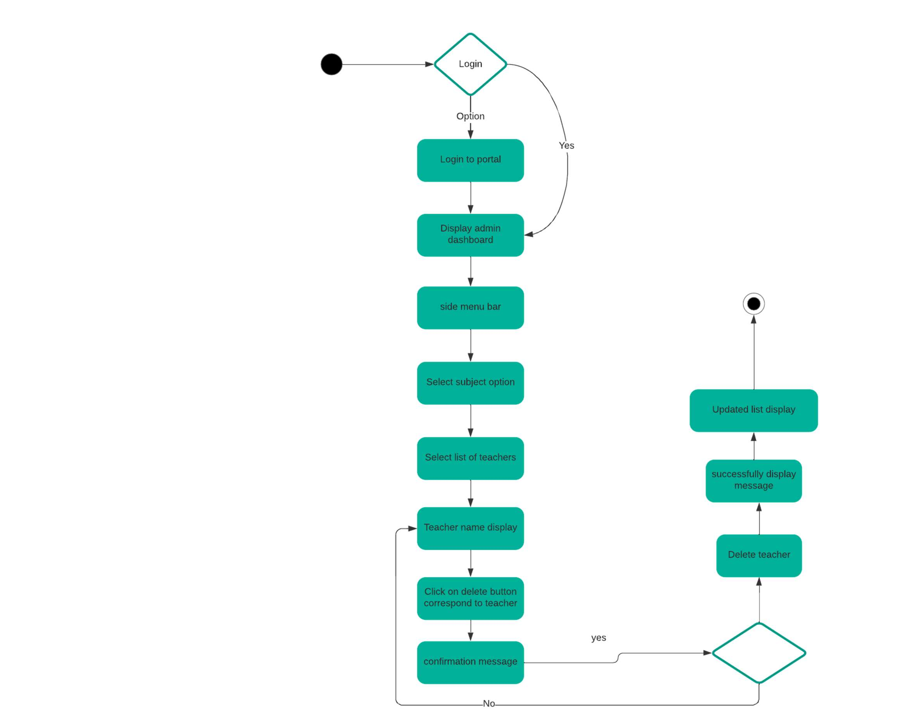

Figure 19 Activity diagram 15: Delete teachers in list

**Logout**

The already logged in user will click the option to logout from user dashboard. If the logout will be successful

then a session expired message will be displayed and user will be directed to login form. If the logout is not successful then an error message will be displayed and the user will be returned to the logout option.

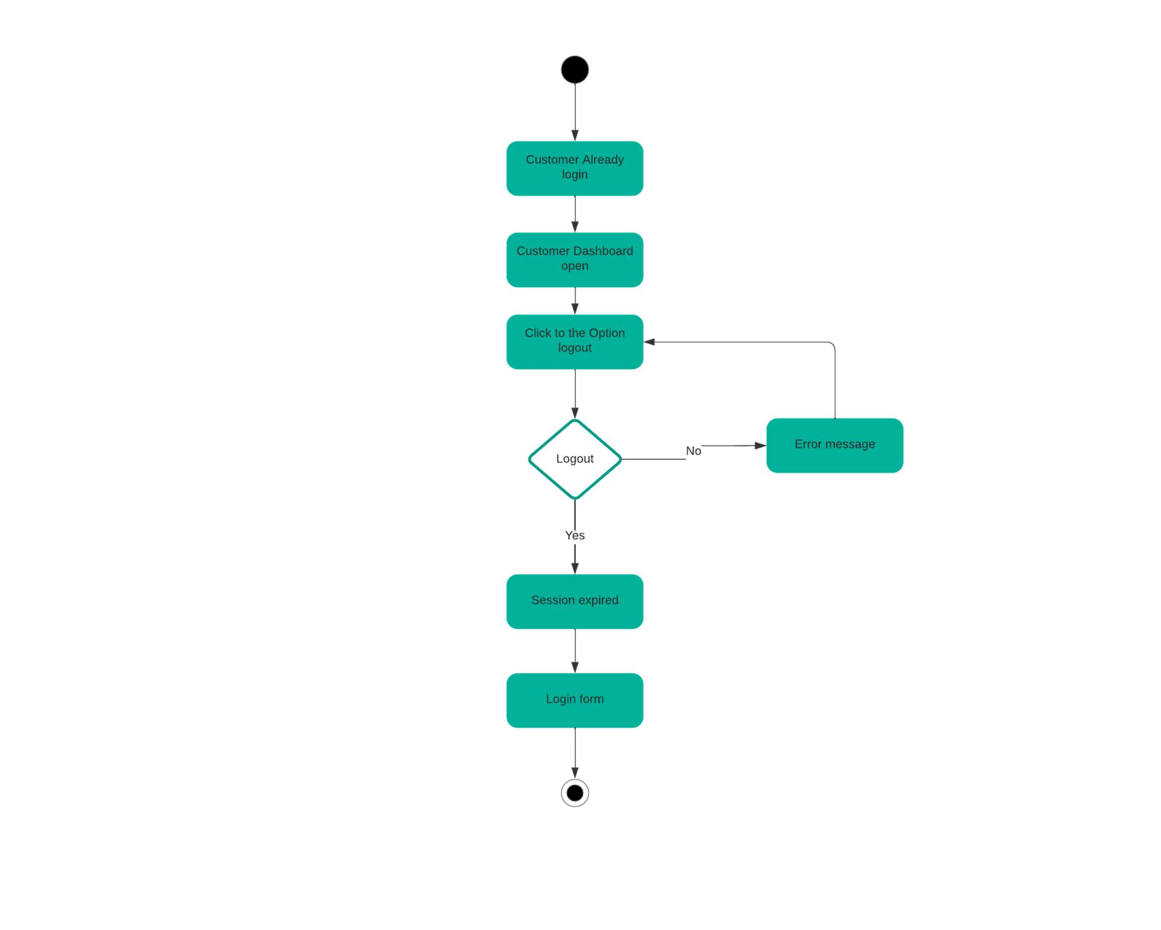

Figure 20 Activity diagram 16: Logout

##### Sequence Diagrams

**Signup**

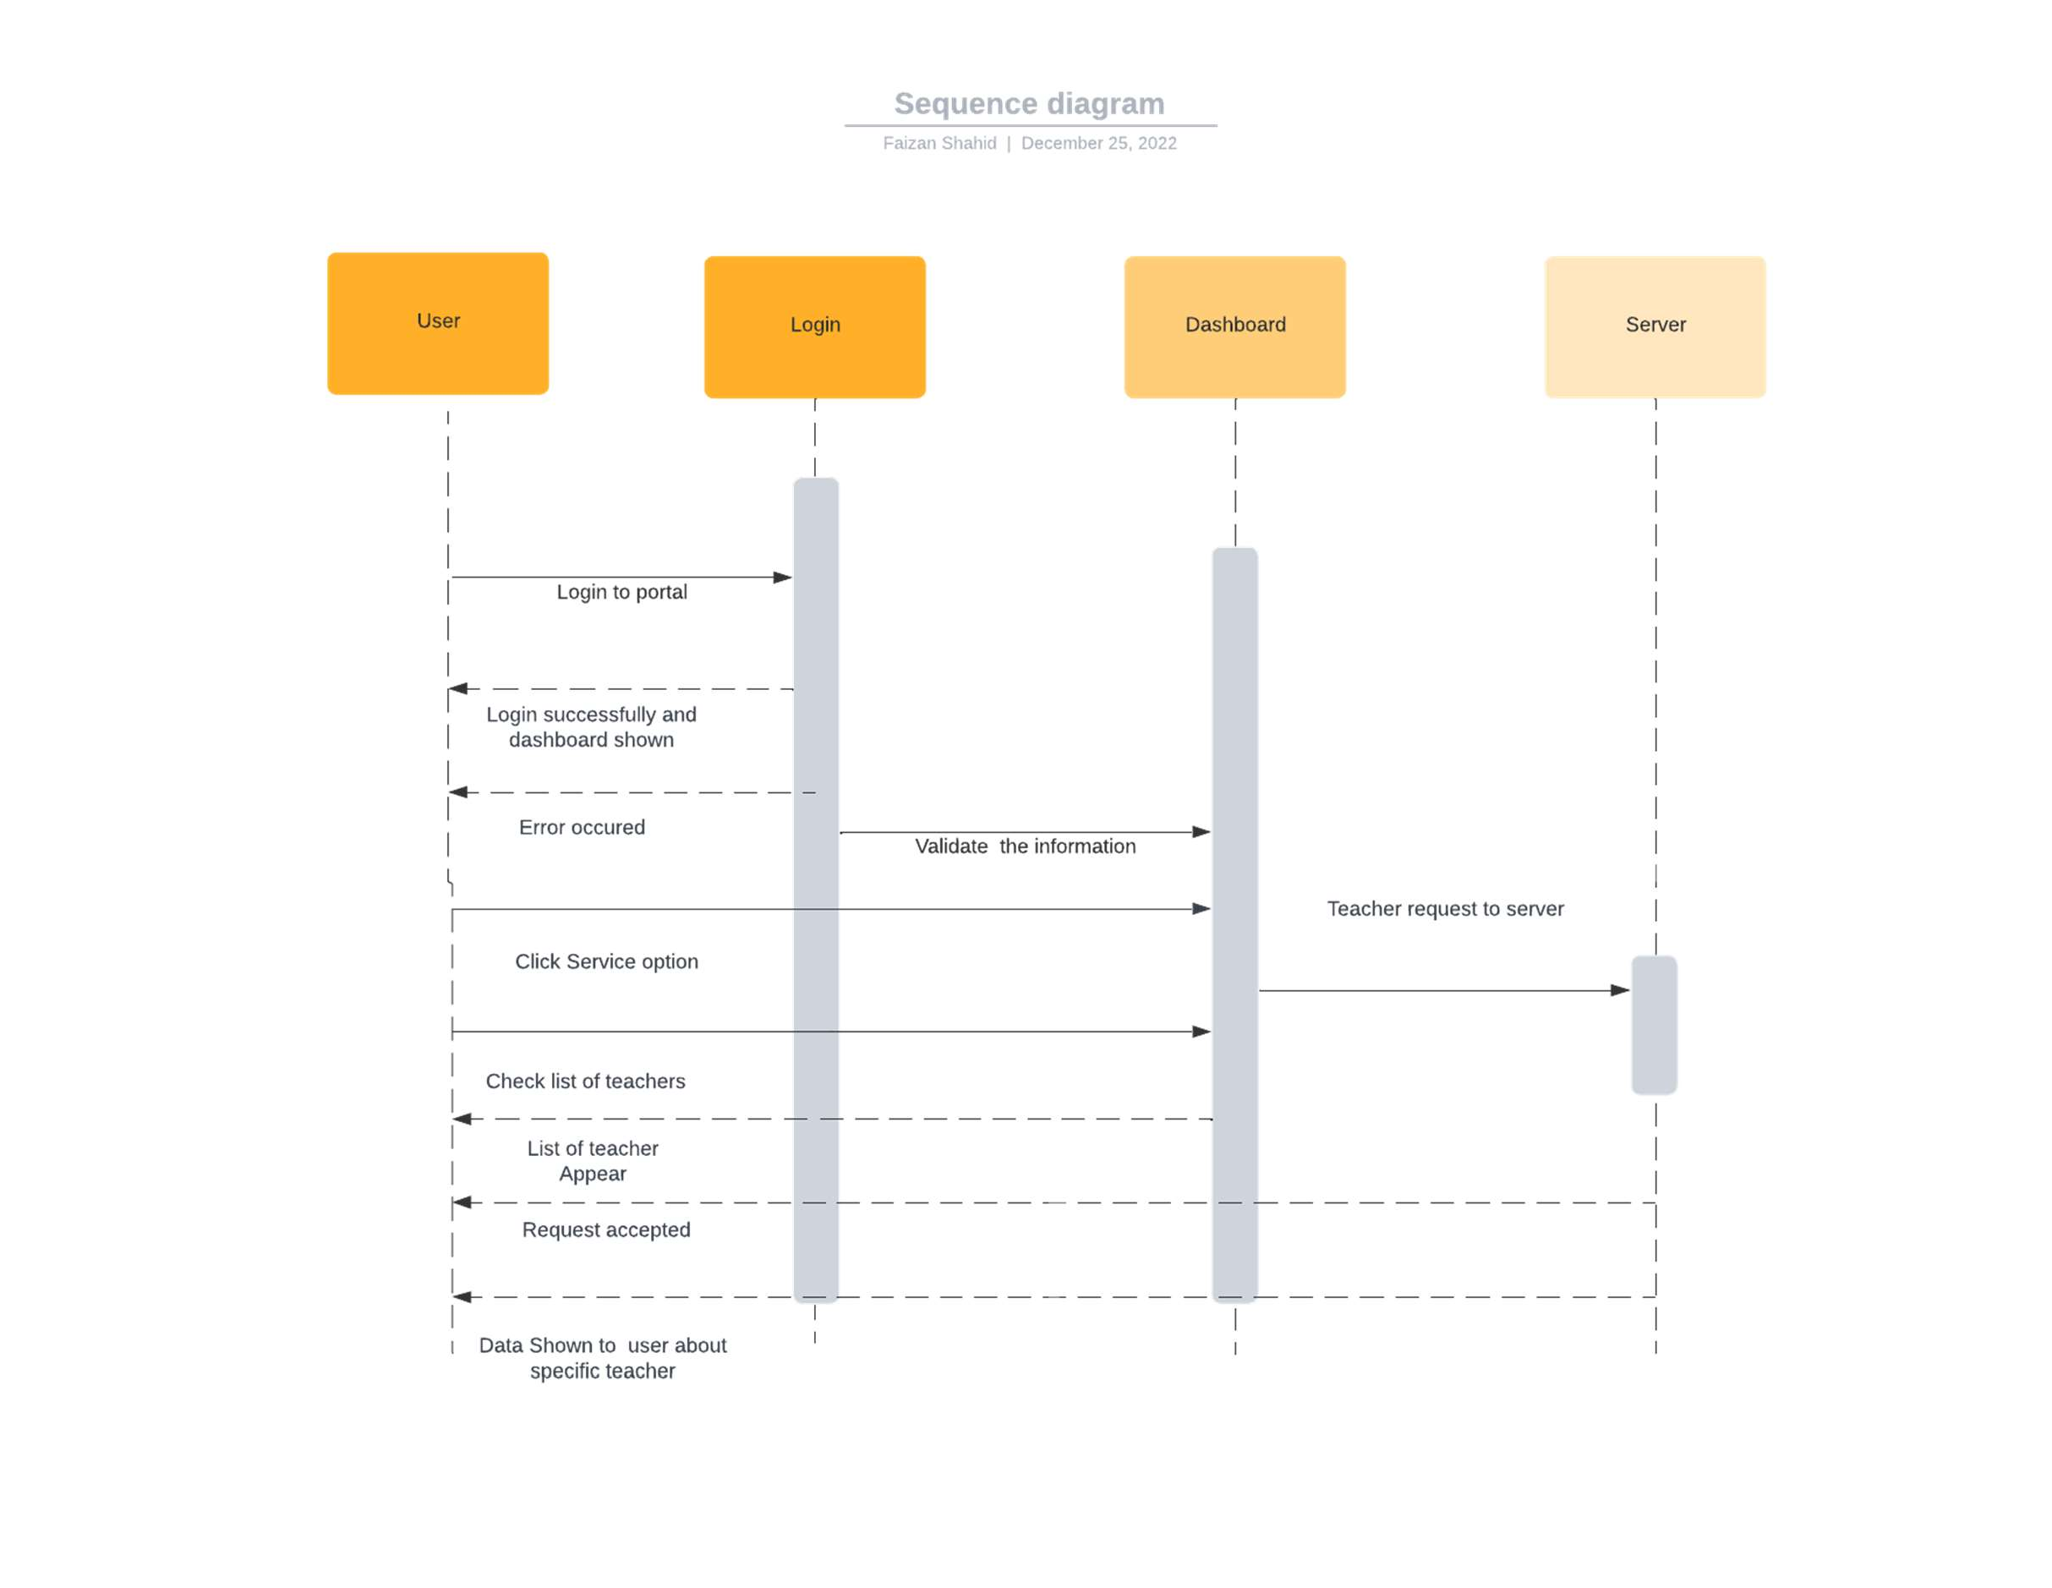

Figure 21 Sequence Diagram 1: Signup

**View list of teachers**

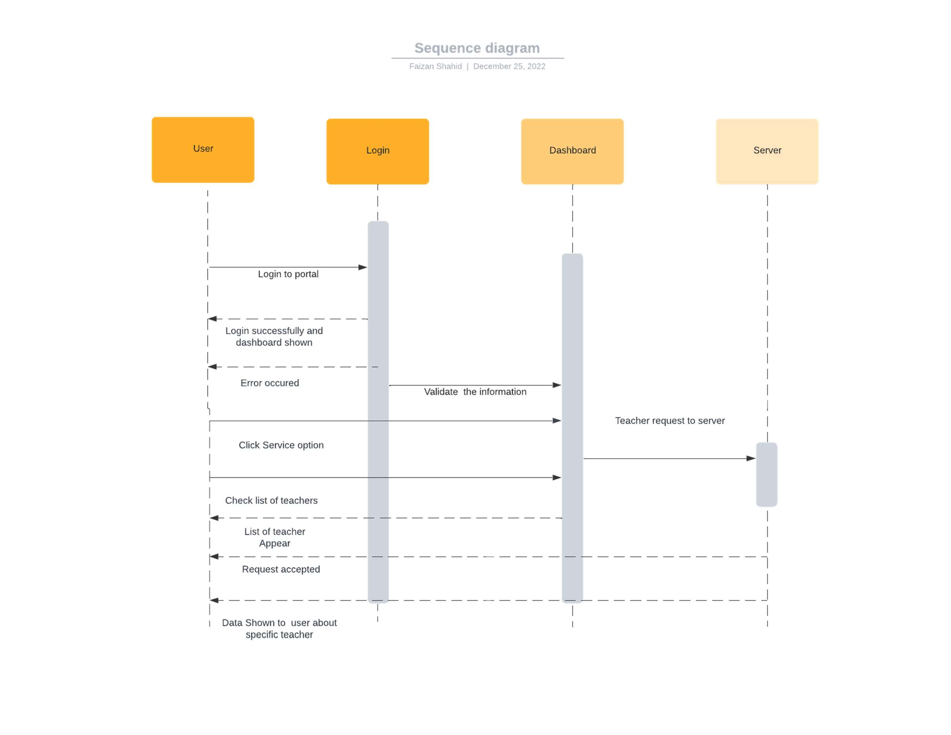

Figure 22 Sequence Diagram 2: View list of teachers

**View schedule**

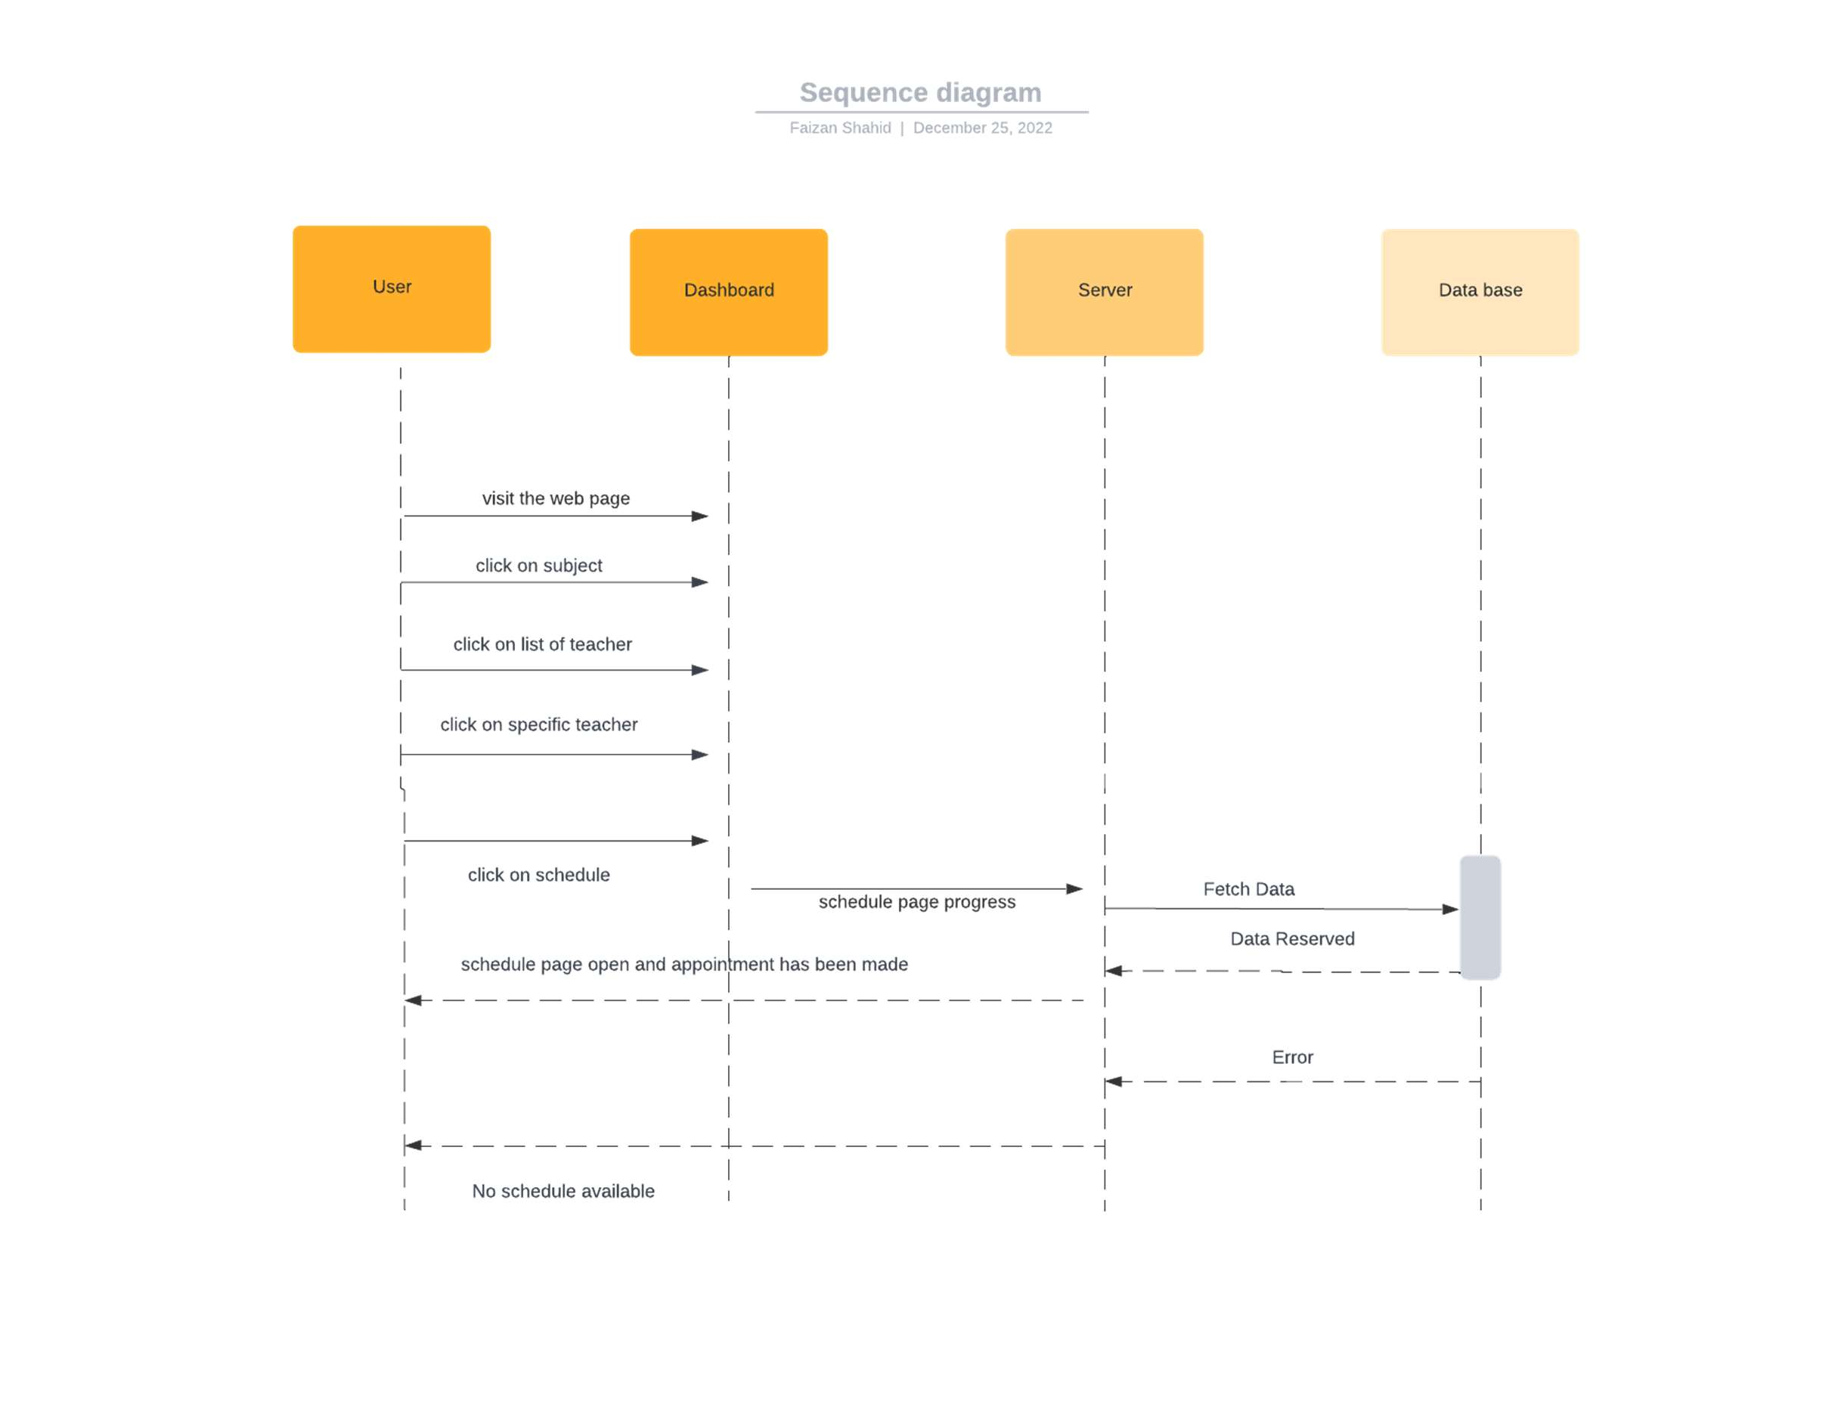

Figure 23 Sequence Diagram 3: View schedule

**Delete Appointment**

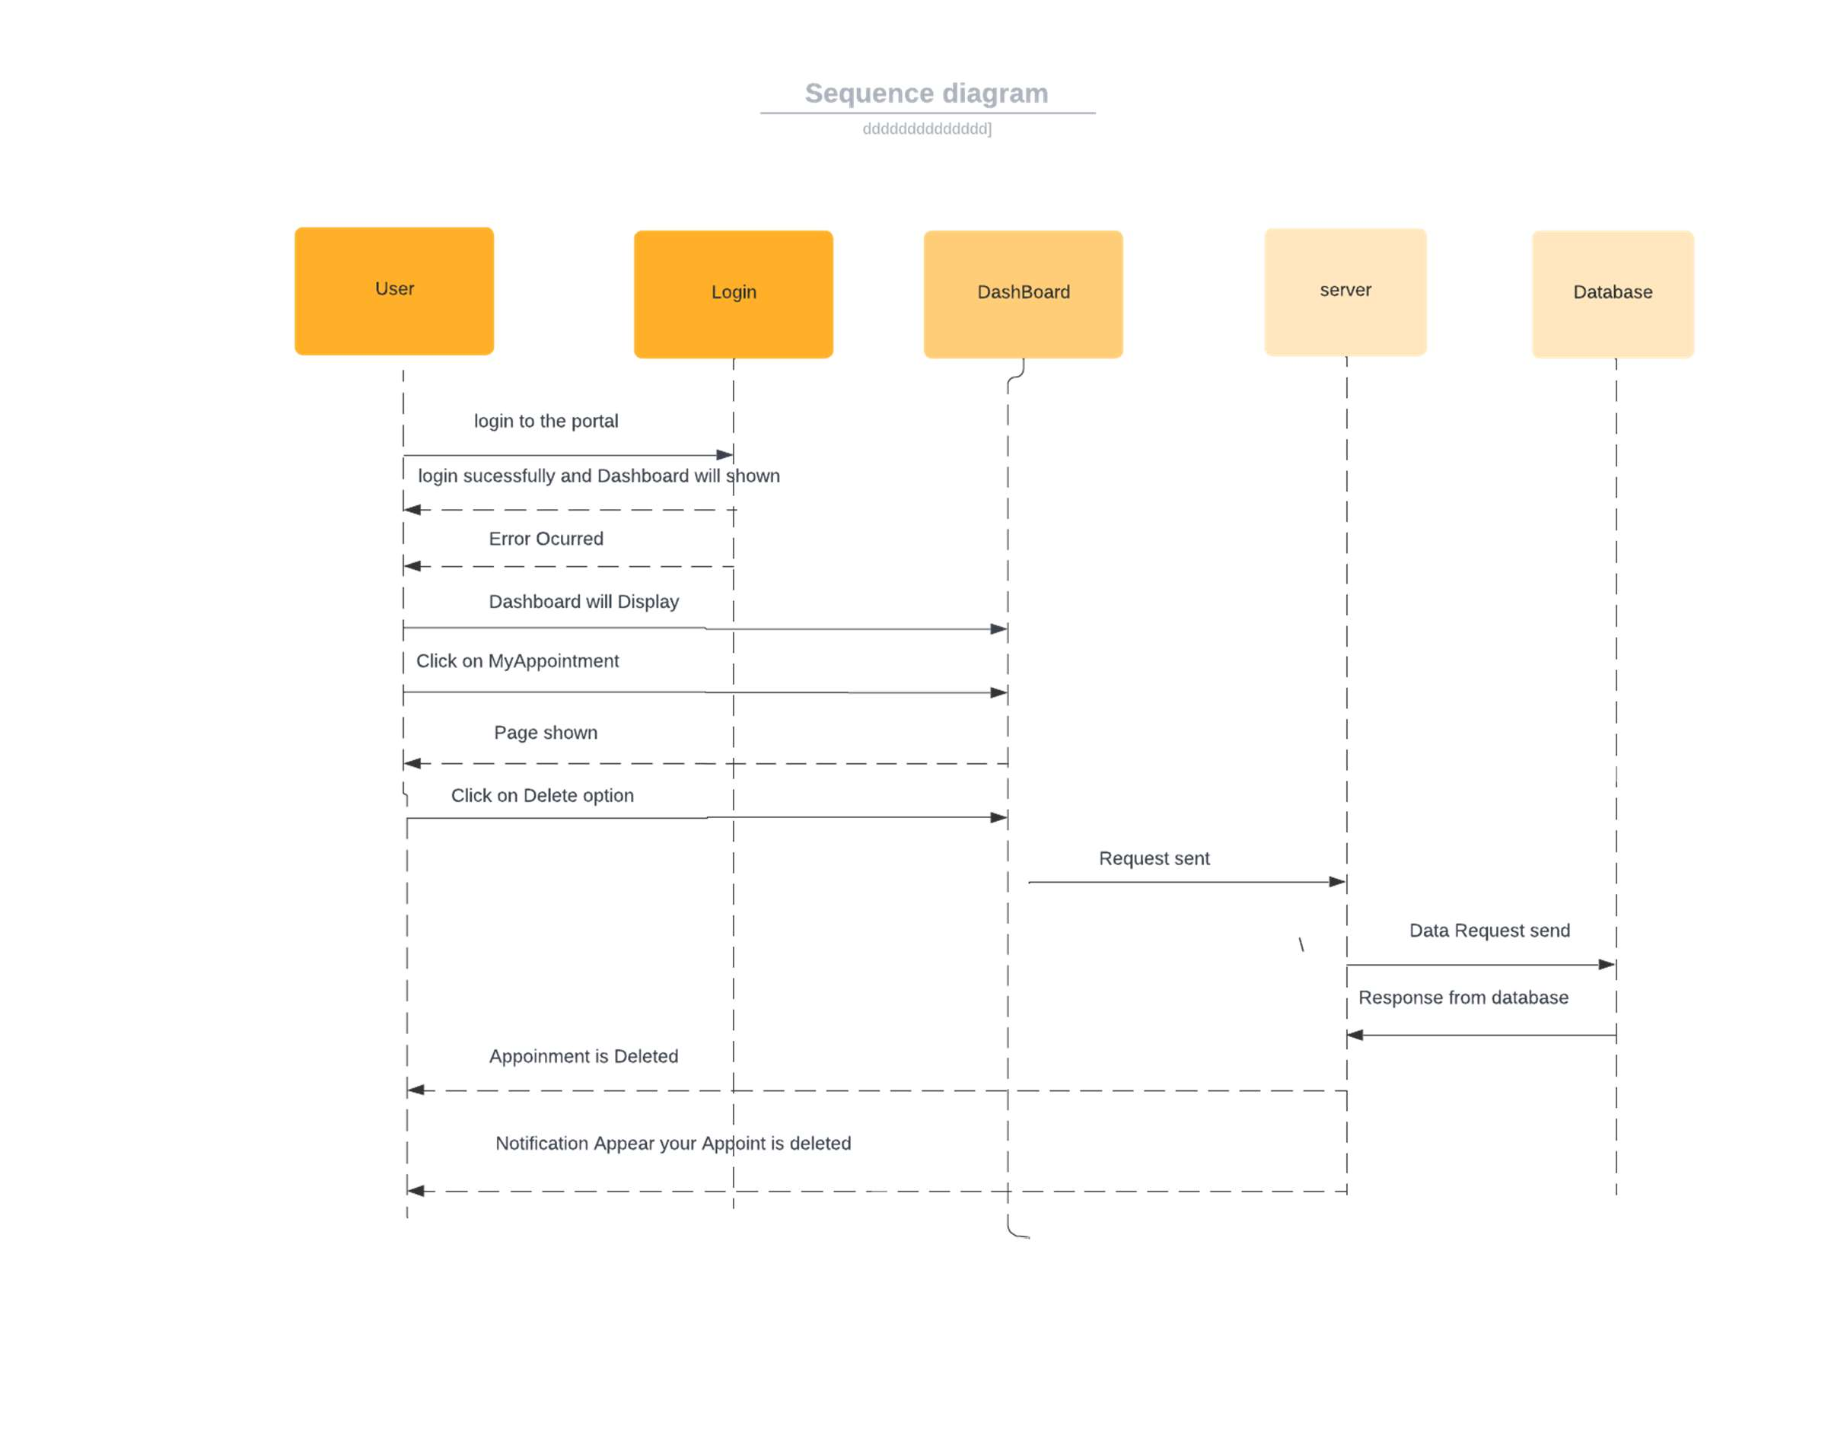

Figure 24 Sequence Diagram 4: Delete Appointment

**Delete Feedback**

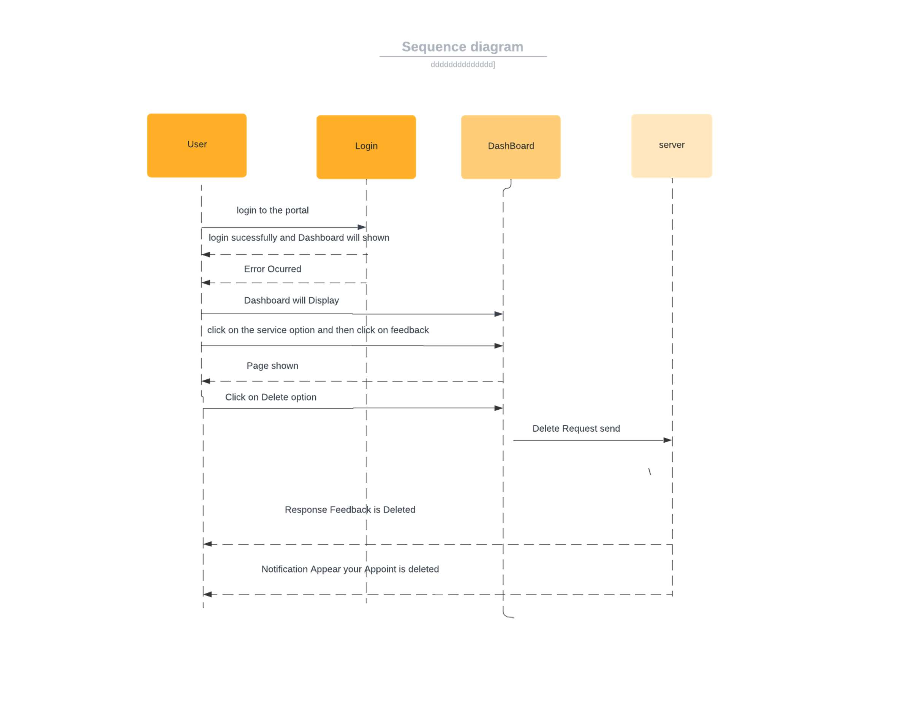

Figure 25 Sequence Diagram 5: Delete Feedback

**Update Appointment**

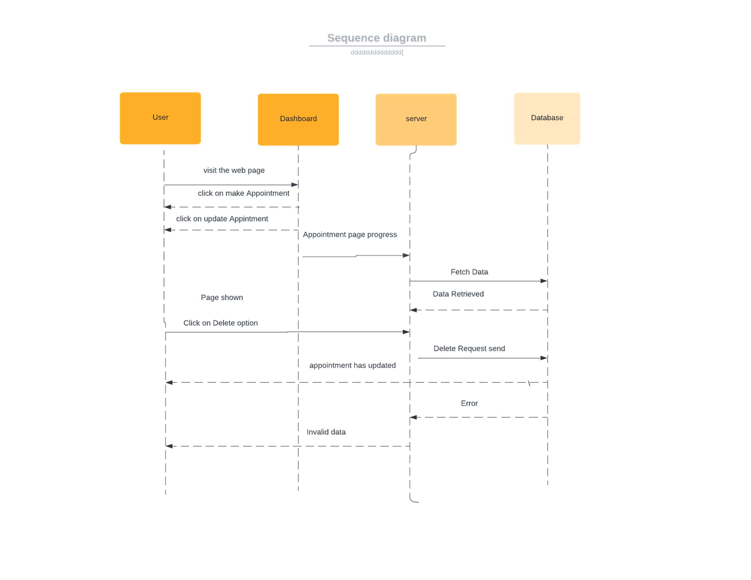

Figure 26 Sequence Diagram 6: Update Appointment

**Update Profile**

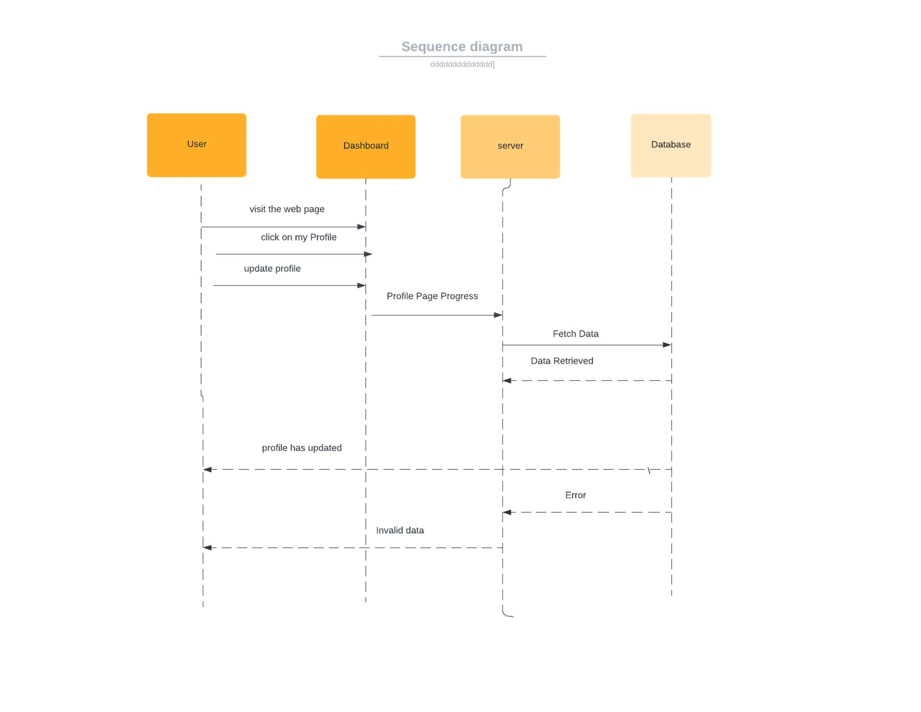

Figure 27 Sequence Diagram 7: Update Profile

**View Profile**

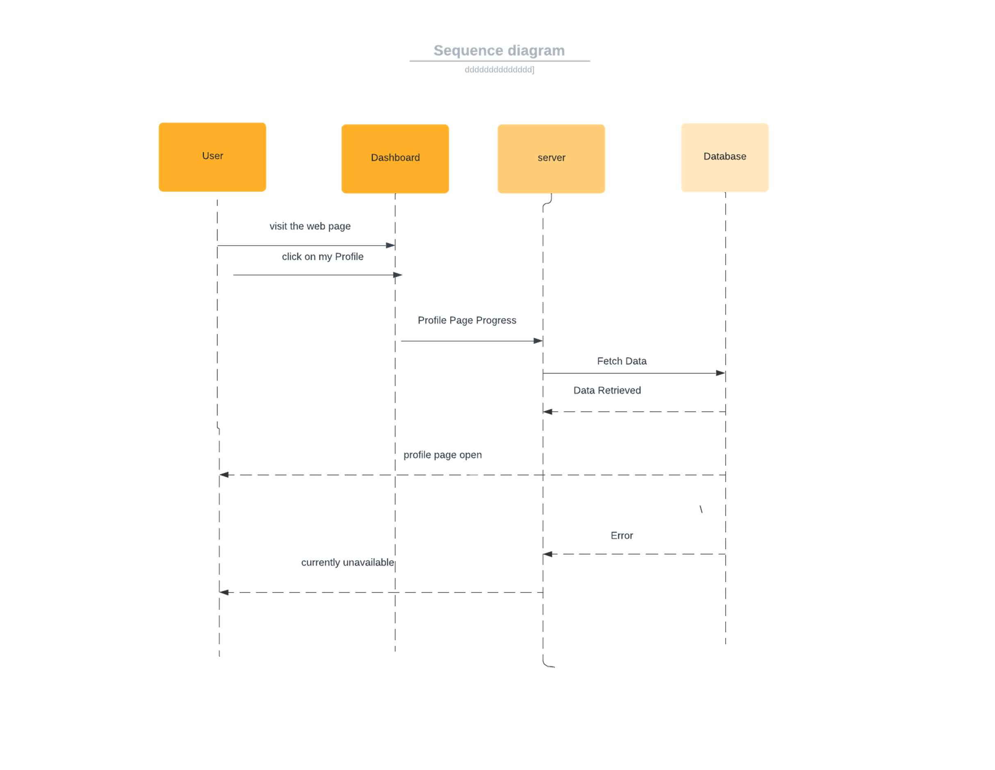

Figure 28 Sequence Diagram 8: View Profile

**Add list of Teachers**

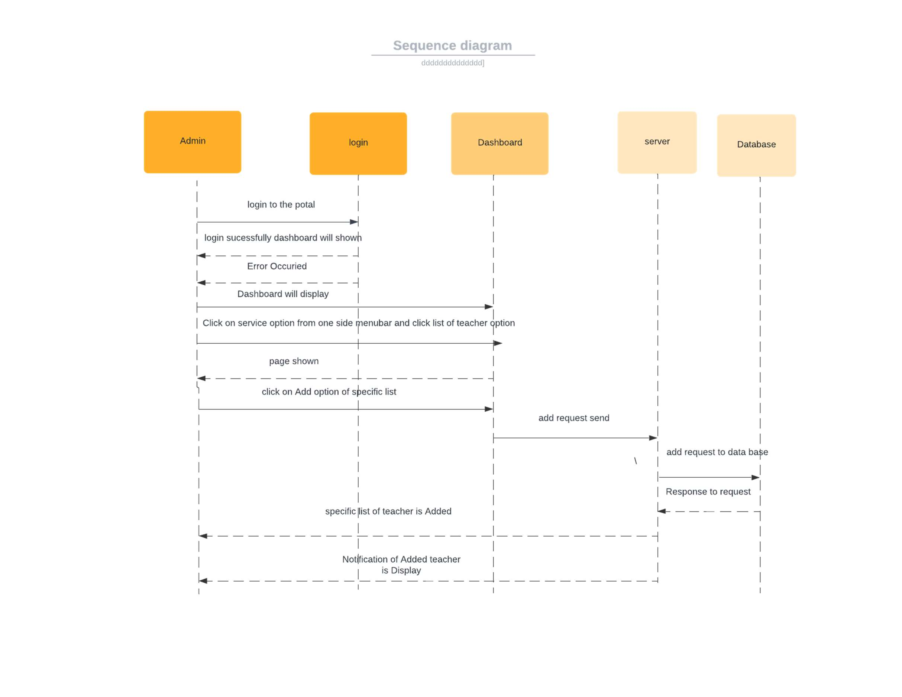

Figure 29 Sequence Diagram 9: Add list of Teachers

**Delete List of Teachers**

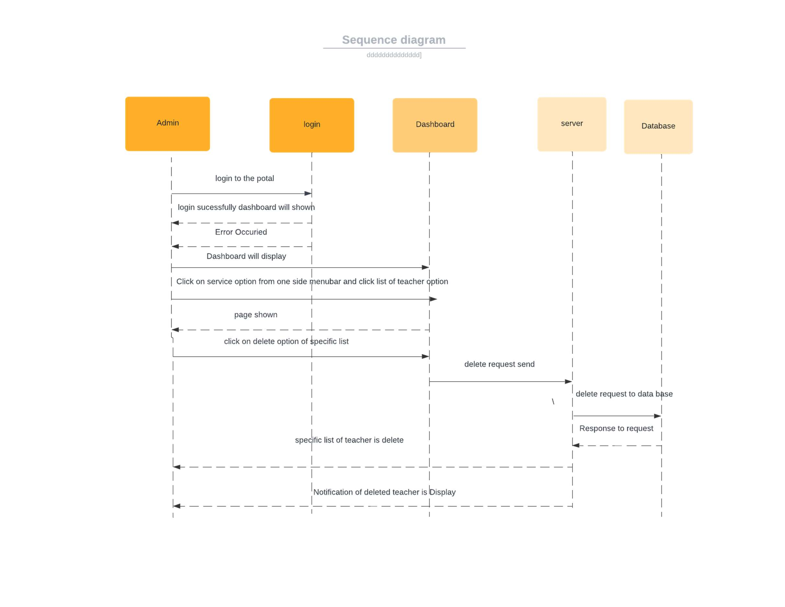

Figure 30 Sequence Diagram 10: Delete List of Teachers

**Update List of Teachers**

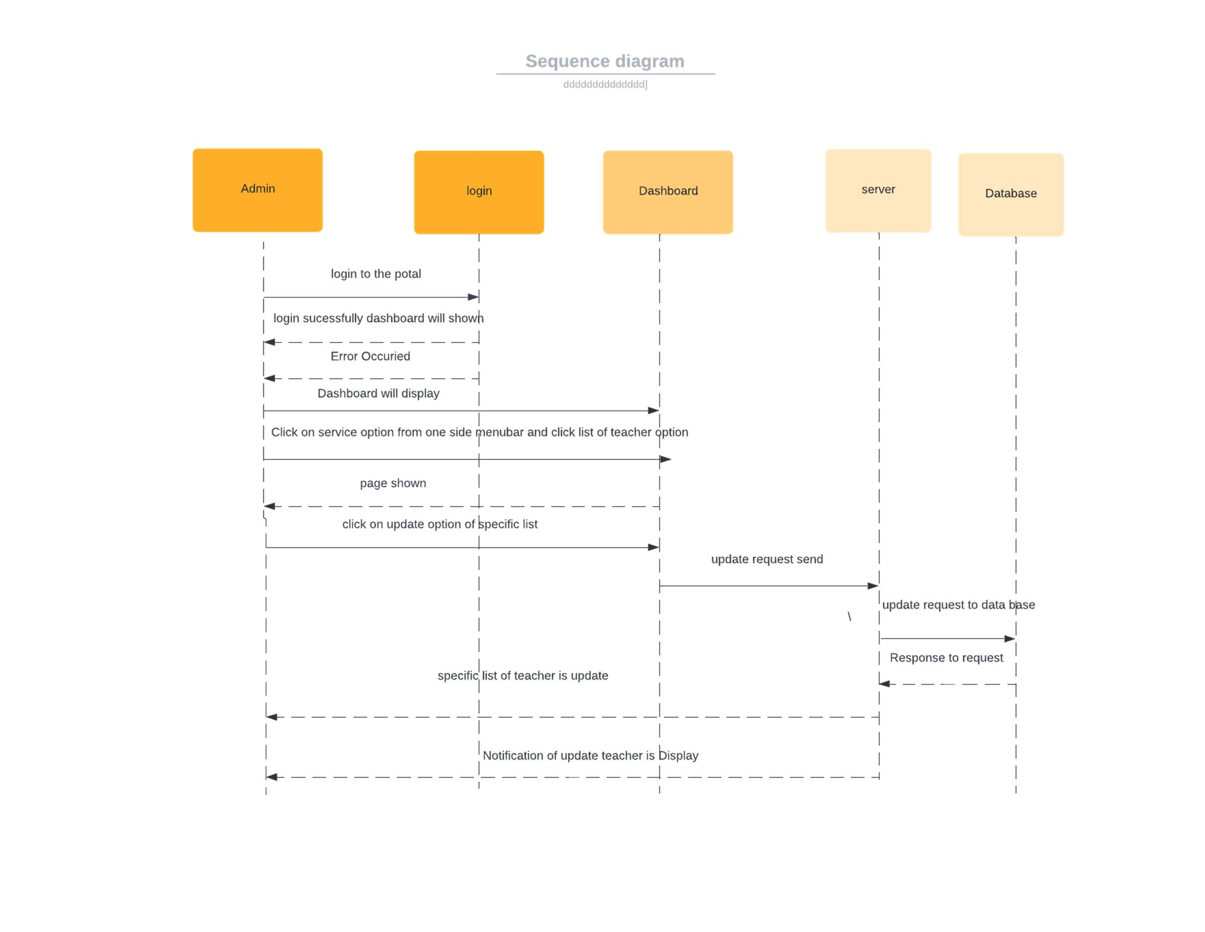

Figure 31 Sequence Diagram 11: Update list of teachers

**Logout**

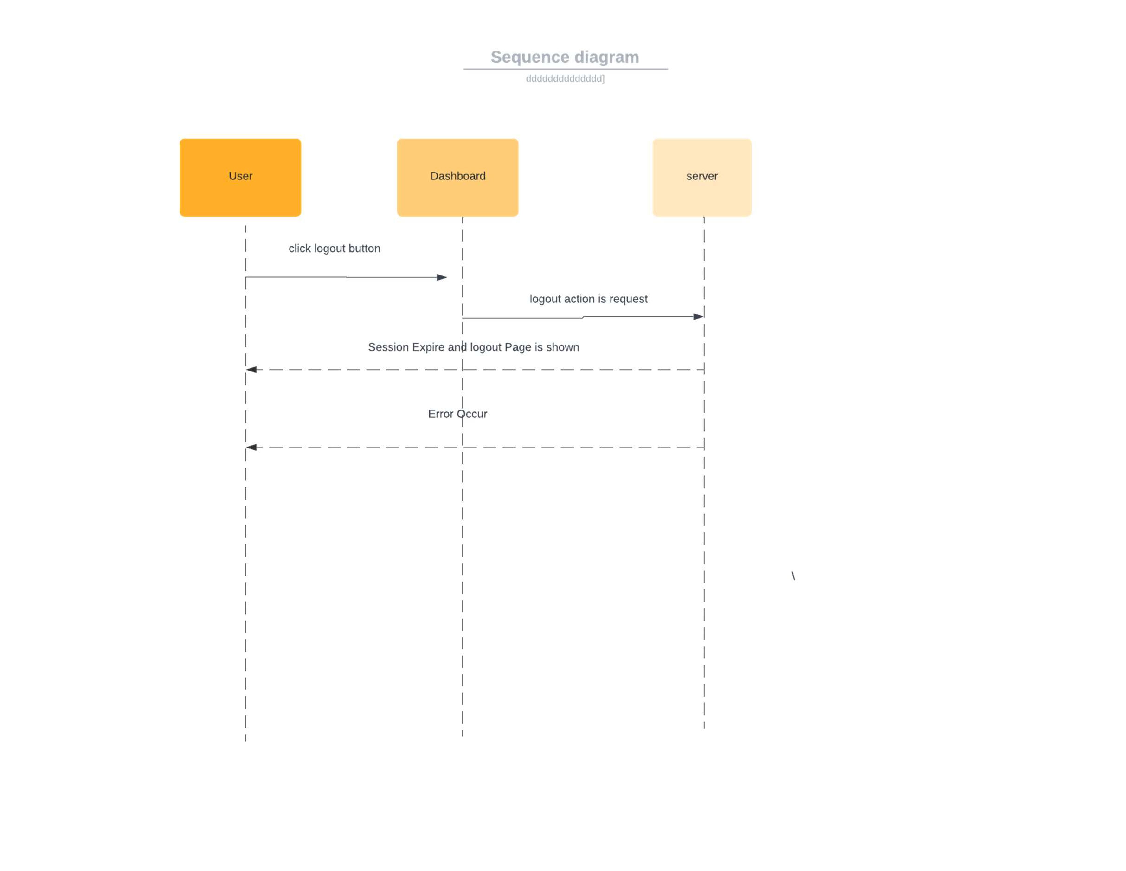

Figure 32 Sequence Diagram 12: Logout

##### Software Architecture

In our project we are using **Model View Controller** software architecture.

The **Model-View-Controller (MVC)** is an architectural pattern that separates an application into three main logical components the **model**, the view, and the controller. Each of these components are built to handle specific development aspects of an application. MVC is one of the most frequently used industry-standard web development frameworks to create scalable and extensible projects.

Following are the components of MVC −

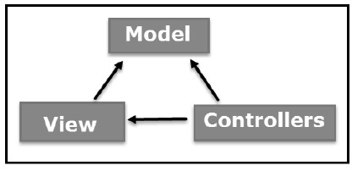

### Model

### The Model component corresponds to all the data-related logic that the user works with this can represent either the data that is being transferred between the View and Controller components or any other business logic-related data. For example, a customer object will retrieve the customer information from the database, manipulate it and update it data back to the database or use it to render than.

### View

### The View component is used for all the UI logic of the application. For example, the Customer view will include all the UI components such as text boxes, dropdowns, etc. that the final user interacts with

### Controller

### Controller act as an interface between Model and View components to process all the business logic and incoming manipulate data using the Model component and interact with the Views to render the final output.

### For-example the Customer controller will handle all the interactions and inputs from the Customer View and update the database using the Customer Model. The same controller will be used to view the Customer data.

**3.5 Class Diagram**

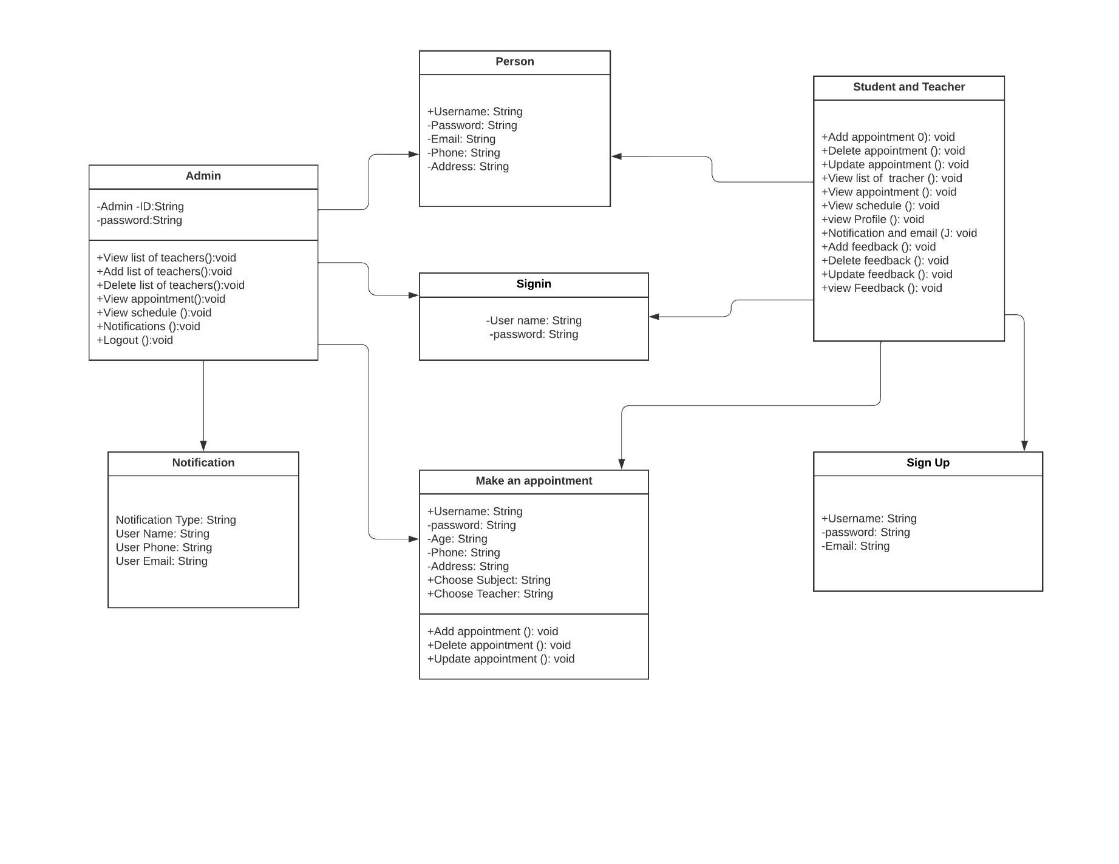

Figure 33 Class Diagram

**3.6 Gantt Chart**

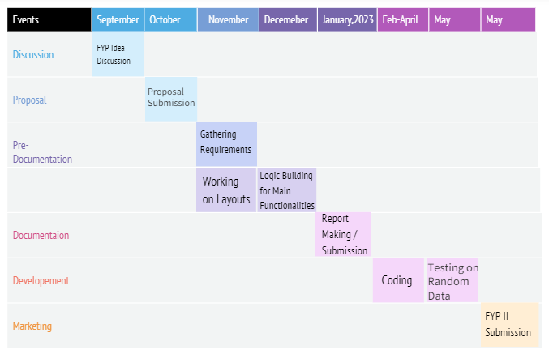

Table 20 Gantt chart

**3.7 Collaboration Diagram**

**Signup**

The user will enter the sign in credentials in the sign-up page. Those credentials will be stored and verified

in the database and the user will be signed and directed to the homepage.

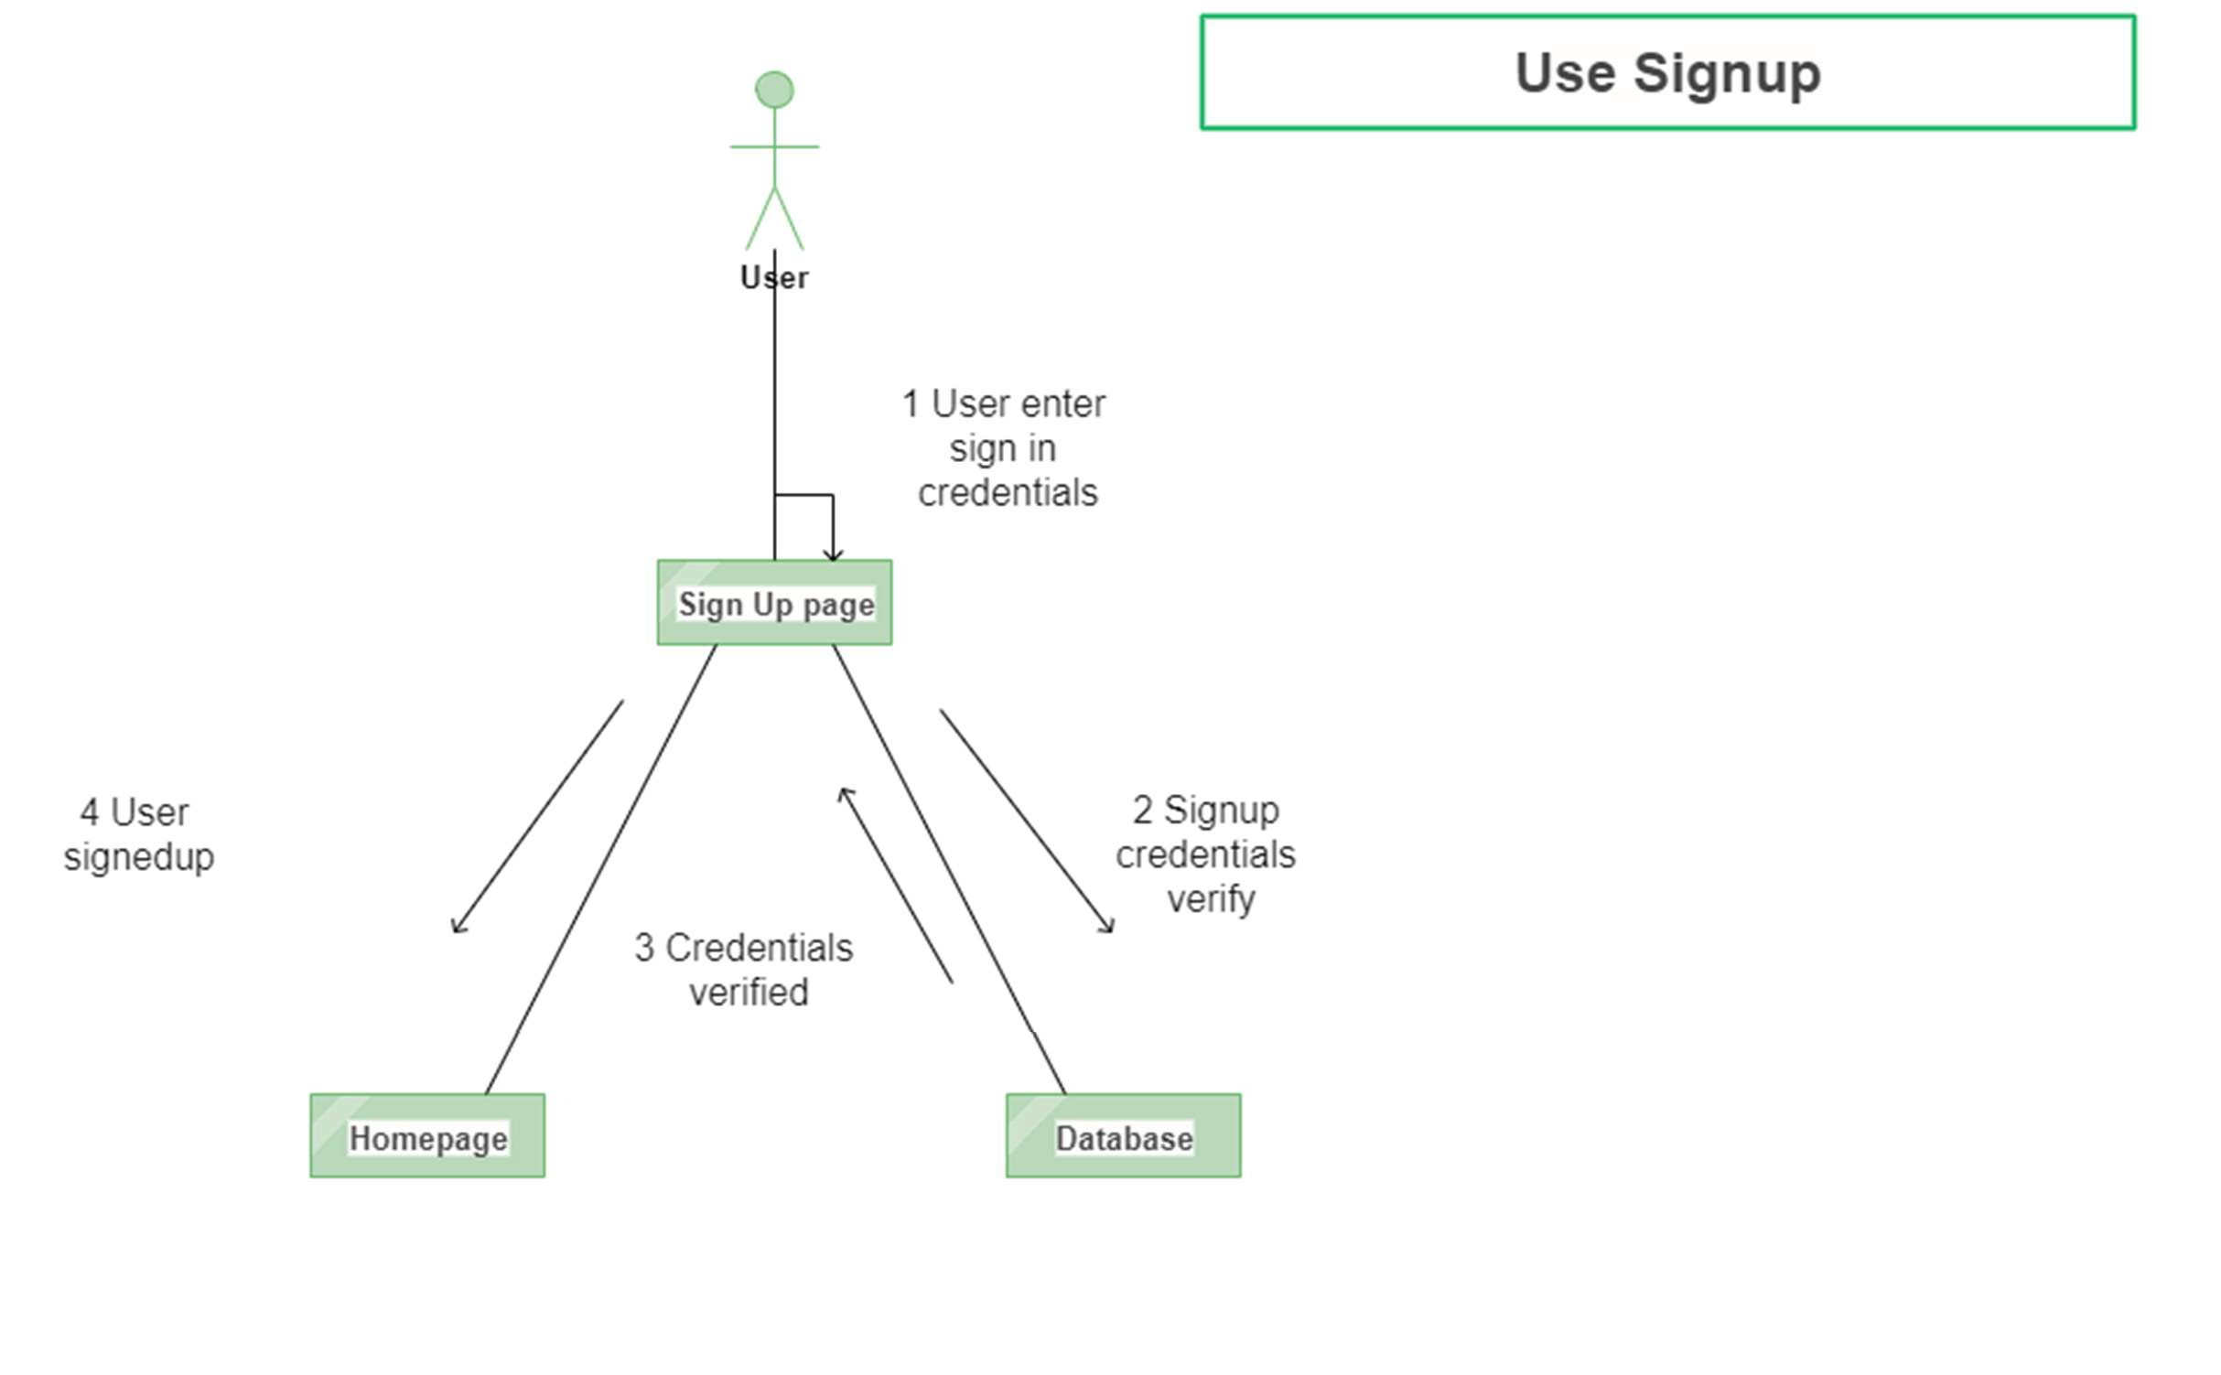

Figure 34 Collaboration Diagram 1

**Login**

User will enter login credentials and those credentials will be verified through the database. Once the

credentials are verified the user will be logged in and directed to the dashboard.

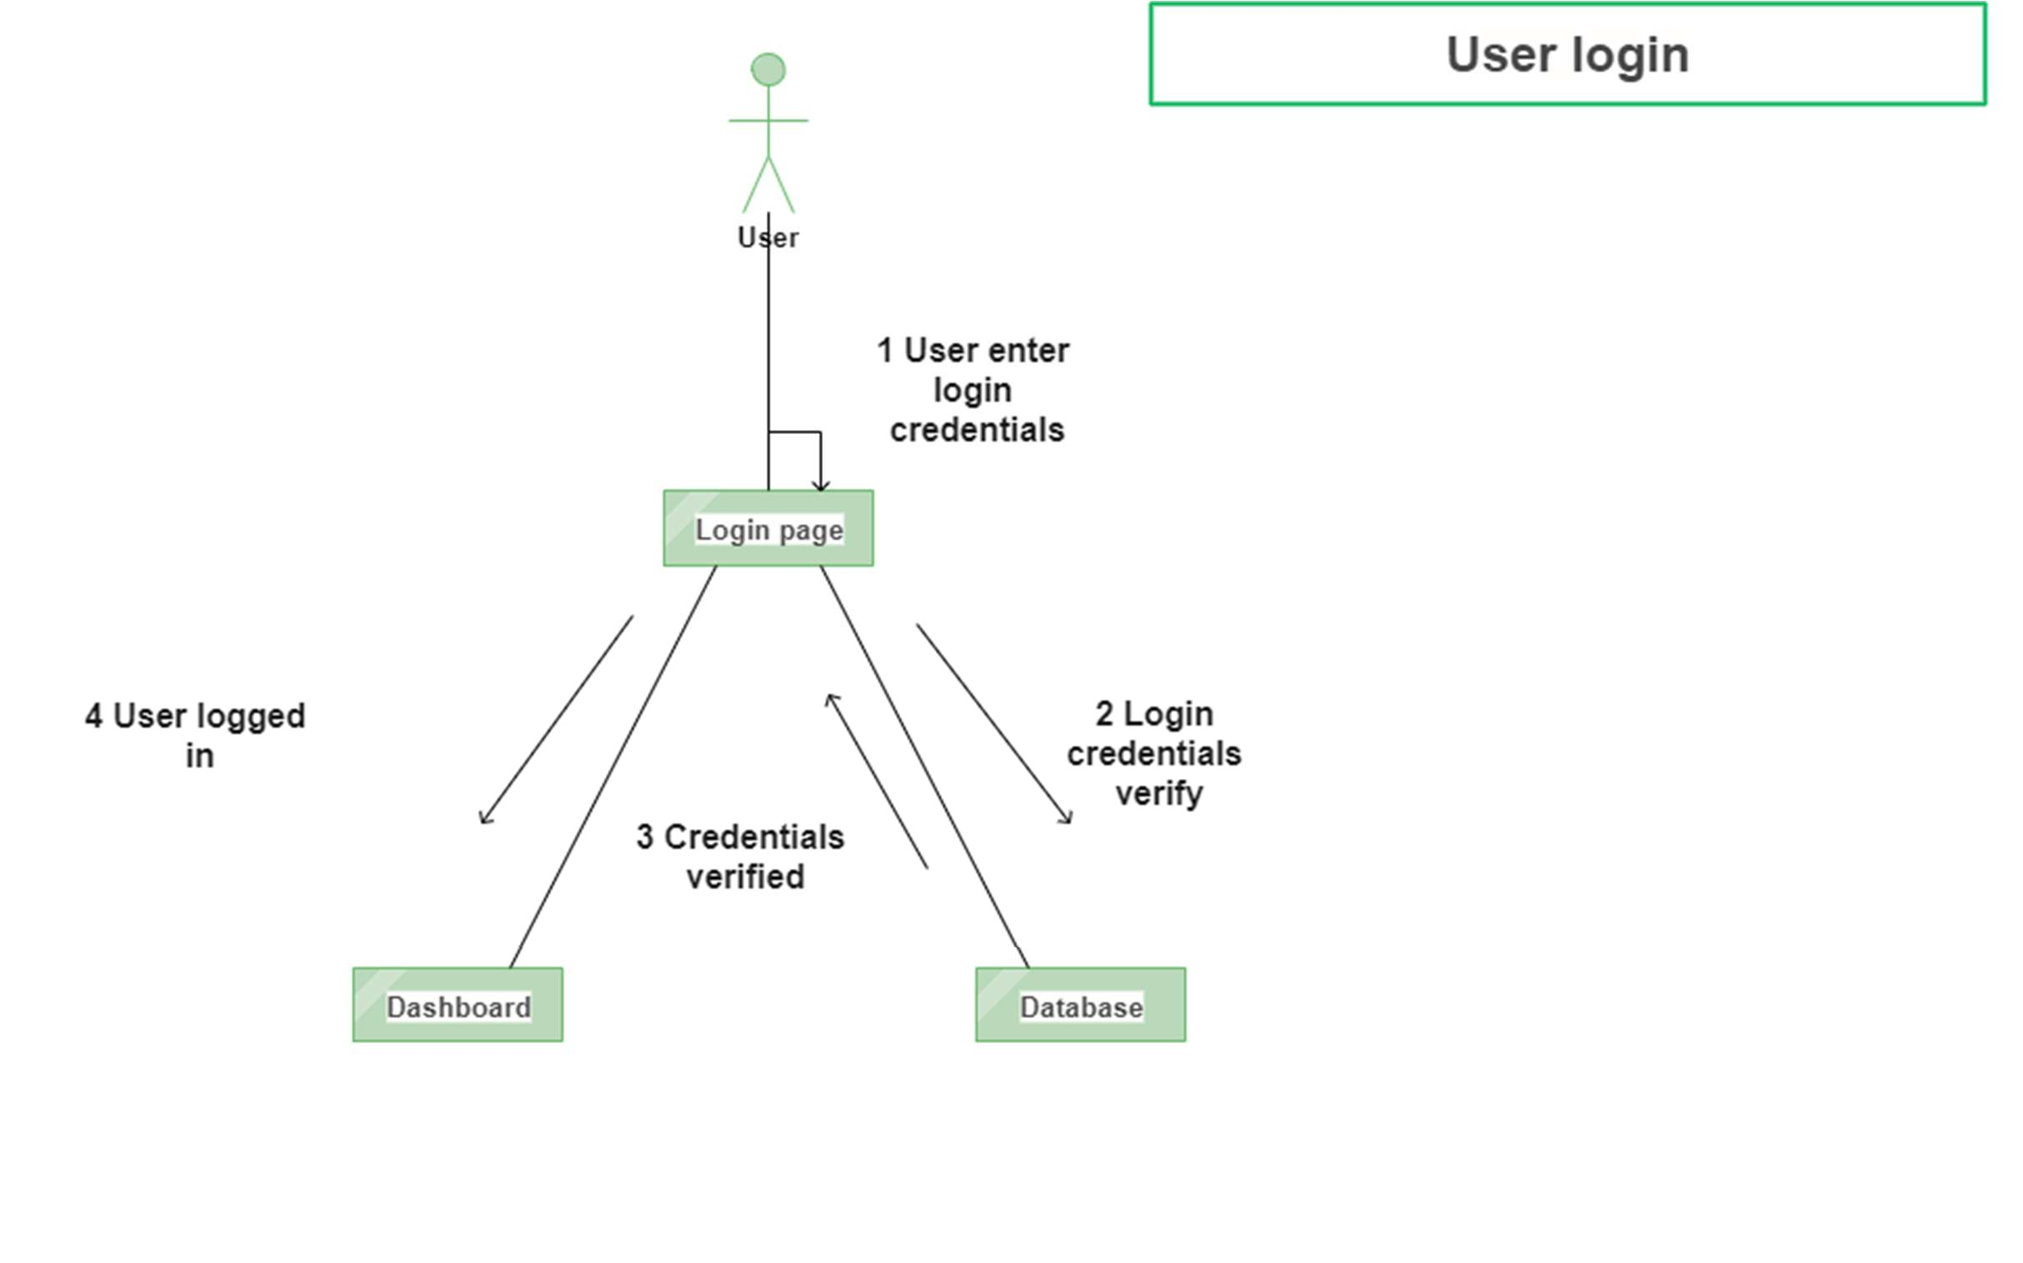

Figure 35 Collaboration Diagram 2

**View List of Teacher**

The user will login to the portal and select the list of teachers from the dashboard. The request will be

sent to the server and after the reply from server the list of teachers will be displayed.

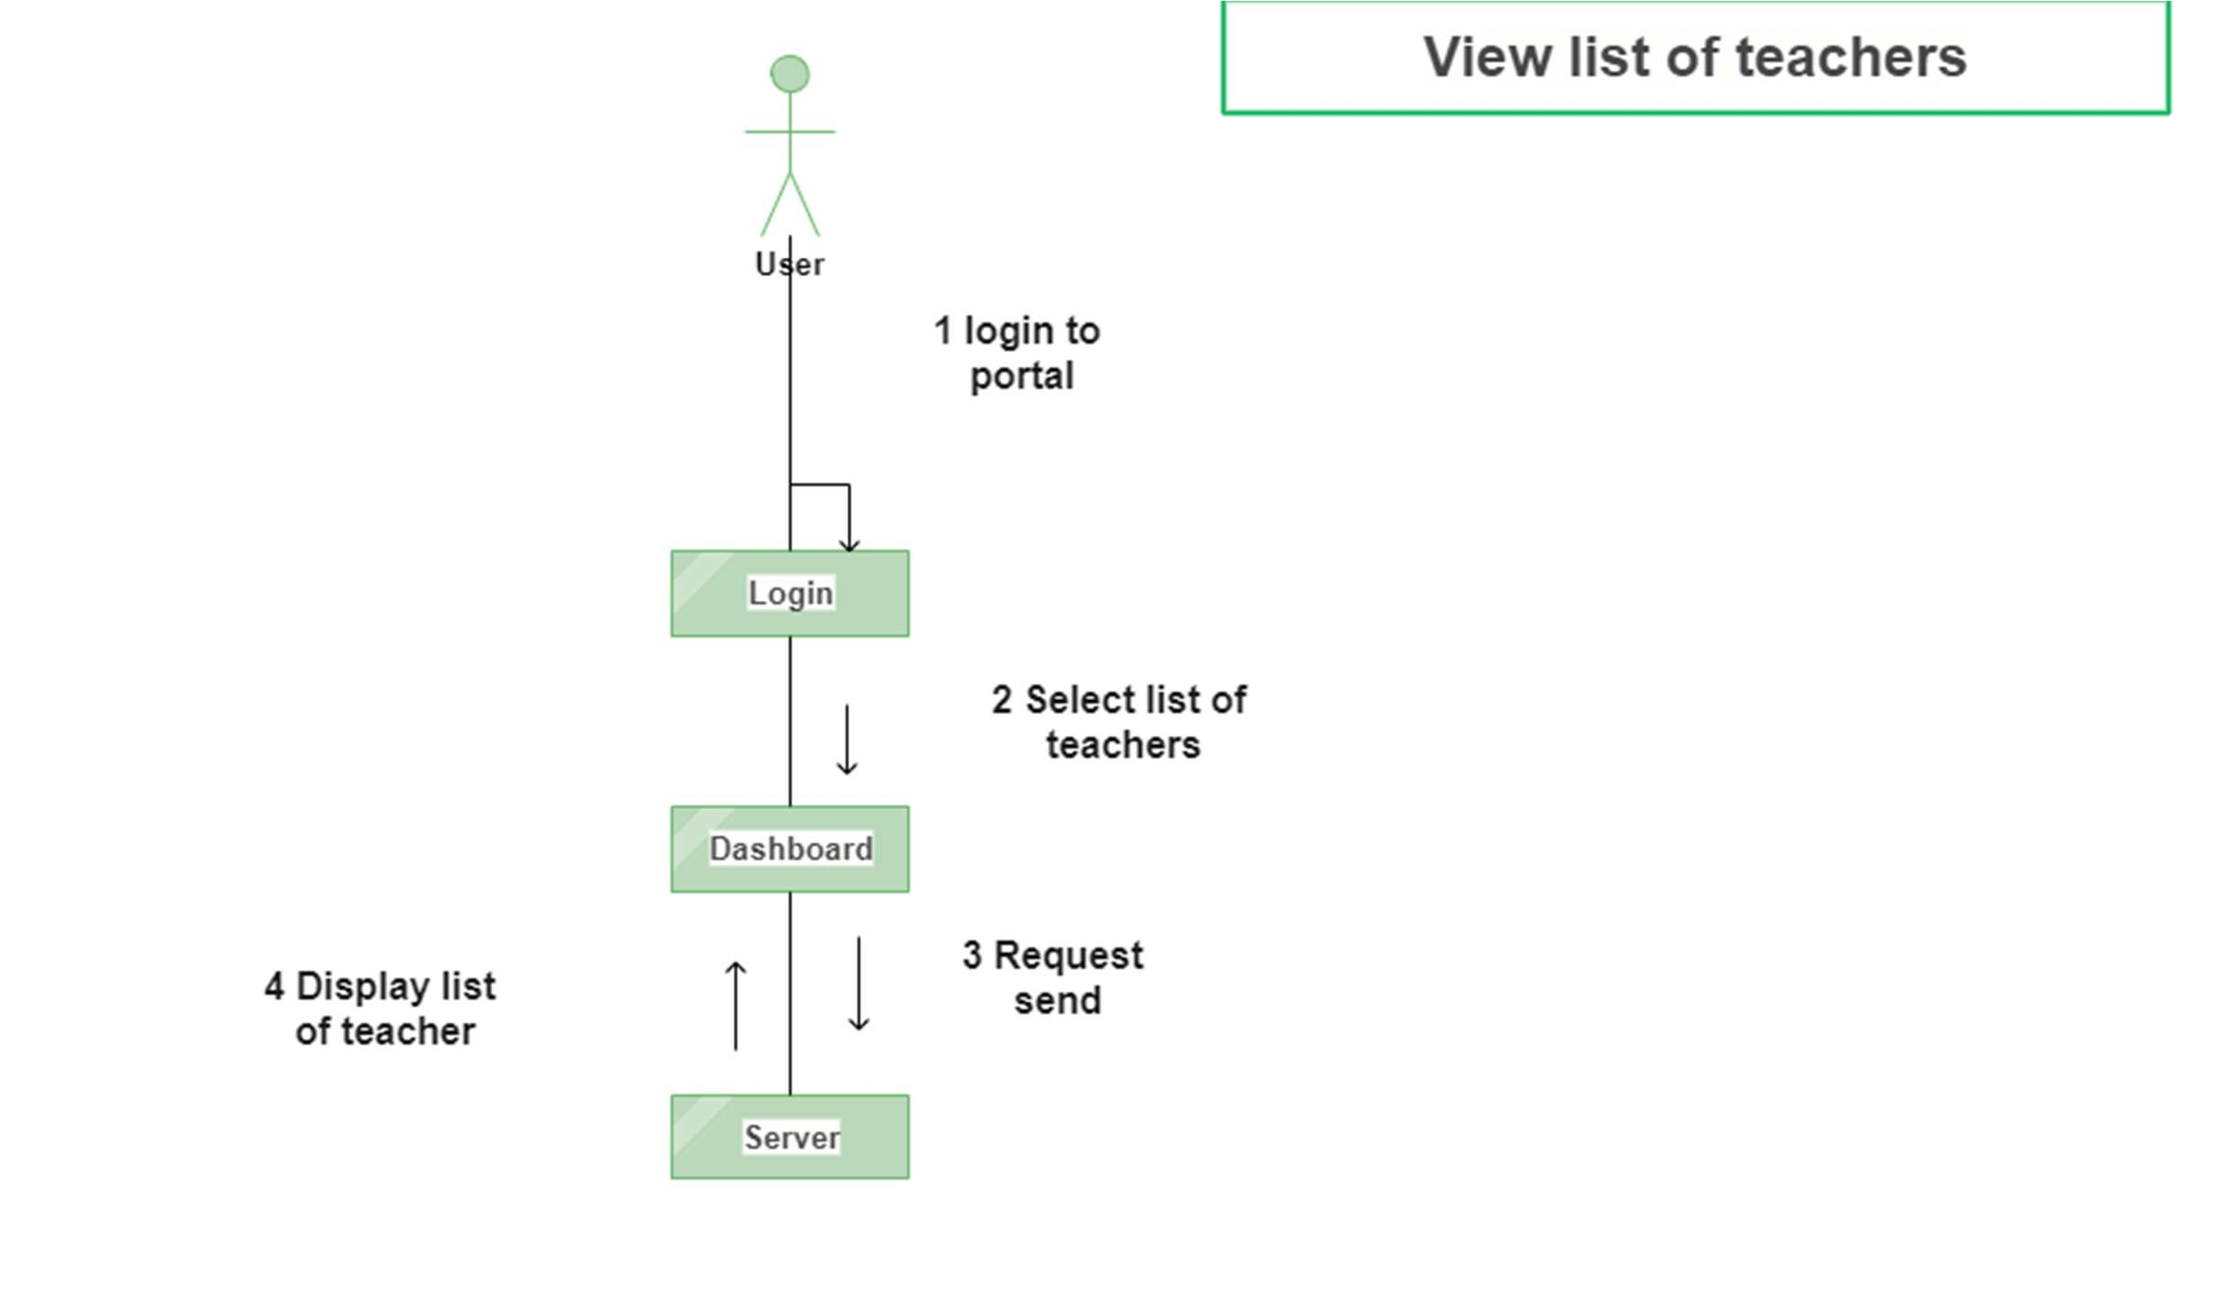

Figure 36 Collaboration Diagram 3

**View Schedule**

The user will select view schedule option from the dashboard then click on the open schedule option.

The data will be fetched from database and after that the schedule data will be displayed.

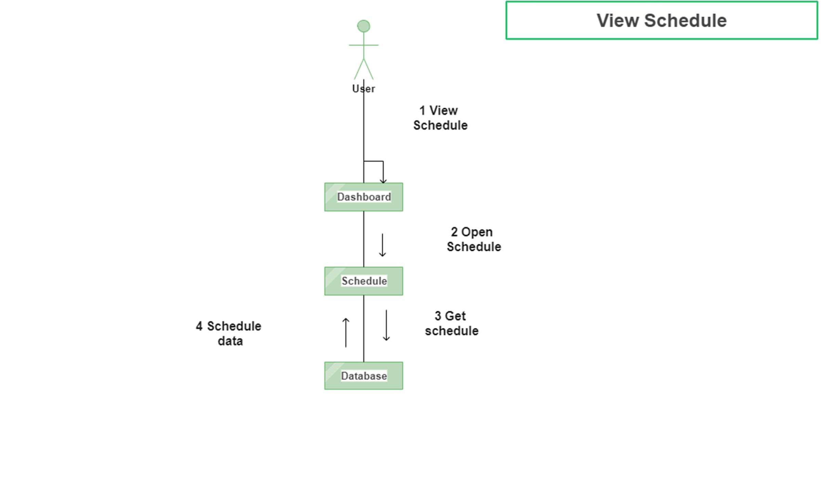

Figure 37 Collaboration Diagram 4

**Add feedback**

First user will select add feedback option from the homepage then enter the feedback. The entered feedback

data will be saved in the database and feedback will be added to the homepage.

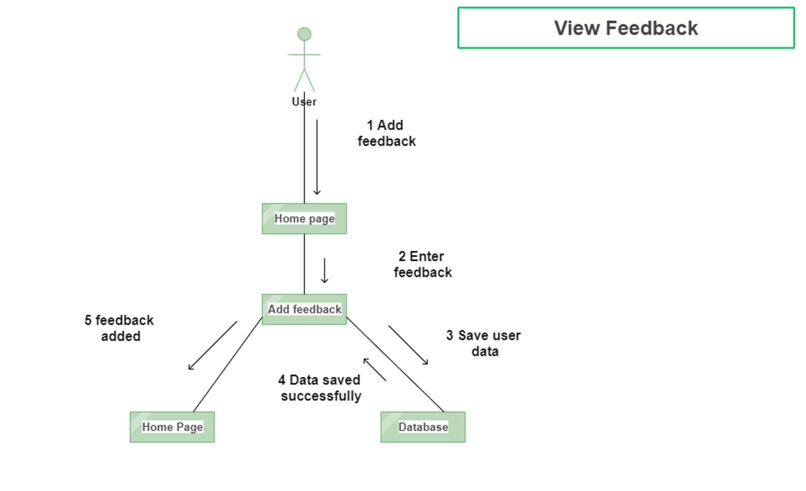

Figure 38 Collaboration Diagram 5

**Update Feedback**

User will select update feedback option and the updated feedback will be saved in the database. The feedback

will be updated which will also be shown on the homepage.

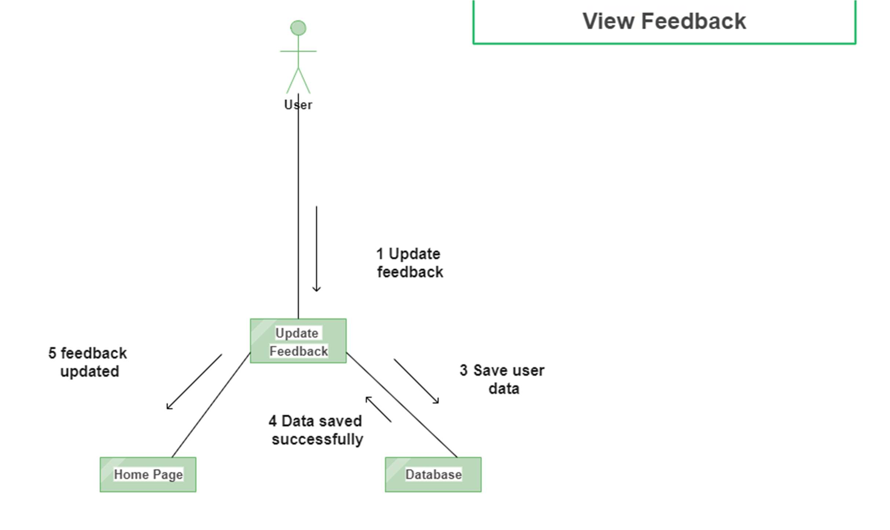

Figure 39 Collaboration Diagram 6

**Delete Feedback**

The user will login first and then from the dashboard user will select the feedback option and then delete

the feedback option. The request will be sent to server and the updated feedback list will be displayed.

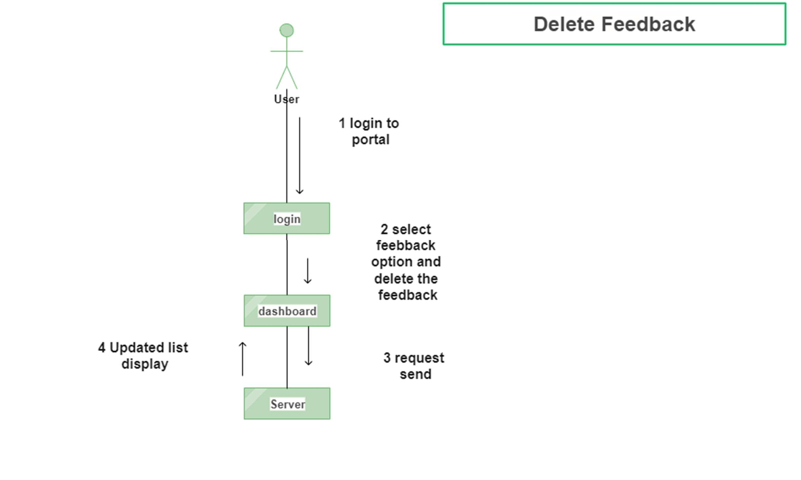

Figure 40 Collaboration Diagram 7

**View Feedback**

The user will select view feedback option from the homepage and then open the feedback. The feedback

data will be fetched from the database and then the feedback will be shown.

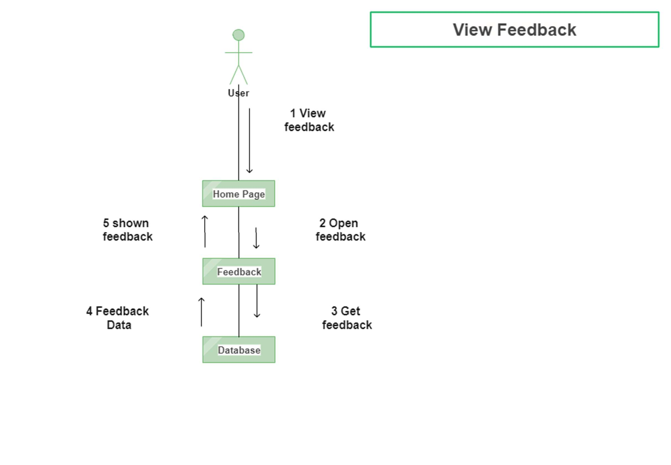

Figure 41 Collaboration Diagram 8

**Add Appointment**

User will first select appointments and then user will be directed to add appointment page. The added

appointment will be verified and after successful verification the appointment will be added.

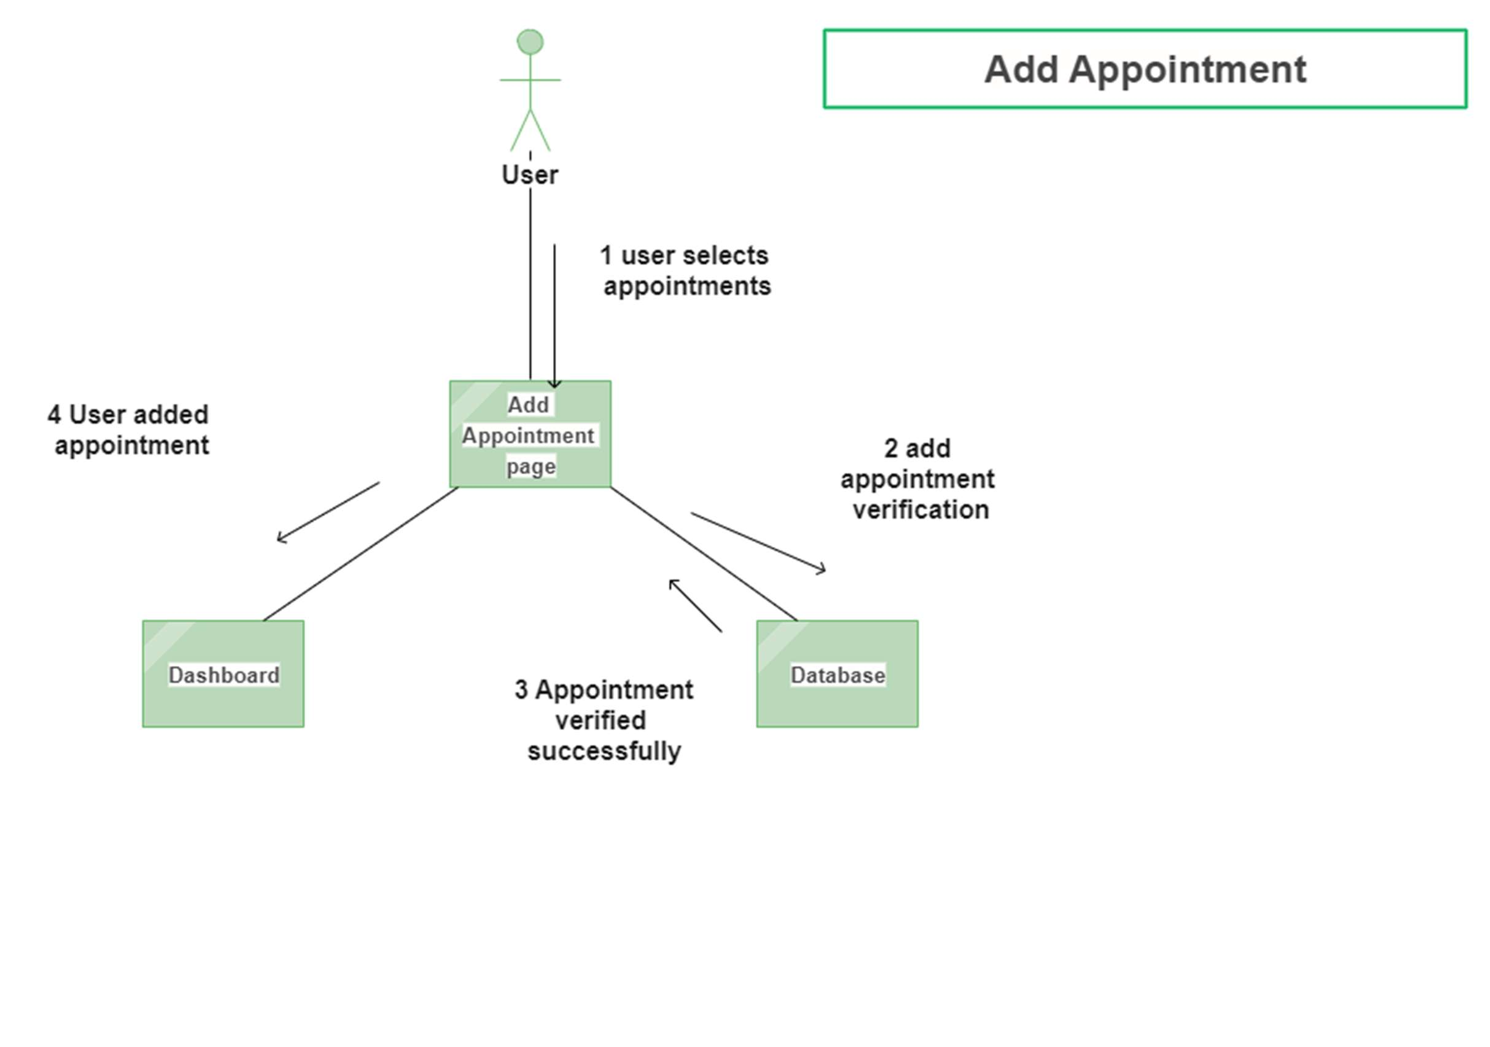

Figure 42 Collaboration Diagram 9

**Delete Appointment**

The user will first login to portal and from the dashboard my appointments option user will select delete

appointment. The request will be sent to server and after that the appointment will be deleted from the

database. After deletion of appointment from the database the updated list will be displayed.

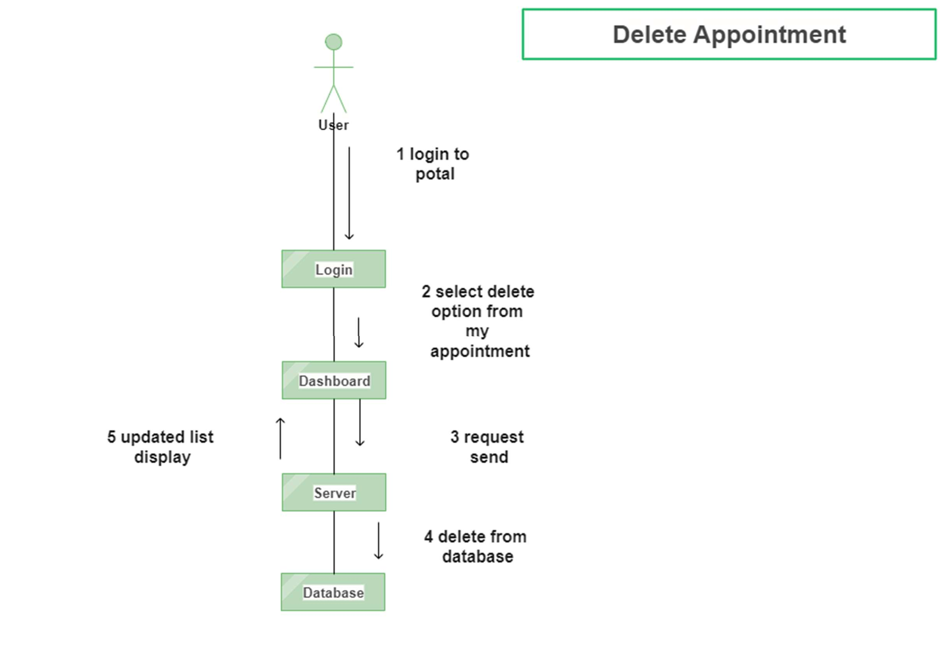

Figure 43 Collaboration Diagram 10

**View Appointment**

The user will login first and from the dashboard select my appointment option. The request to view

appointment will be sent to server and after the data is fetched from the server the appointment will

be displayed.

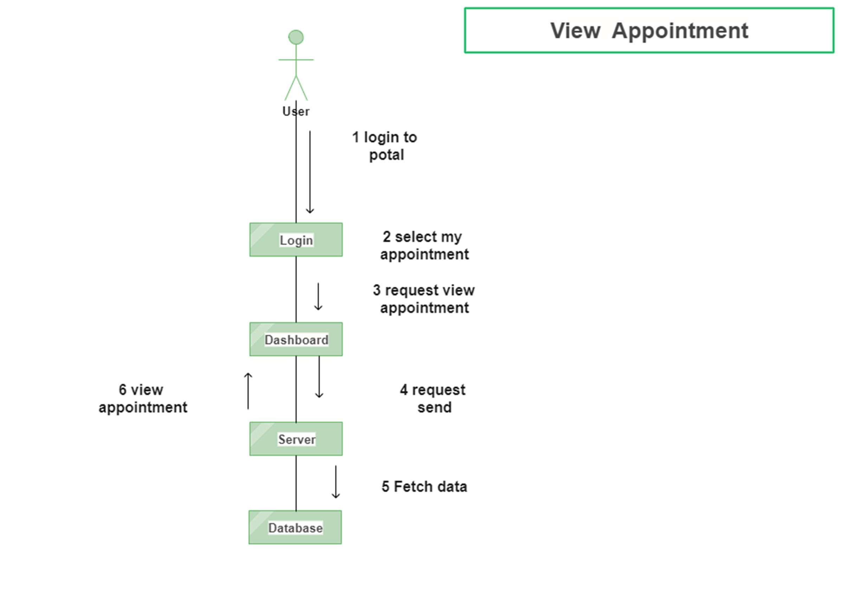

Figure 44 Collaboration Diagram 11

**View Profile**

The user will select open profile option from the homepage and then the system will fetch profile data

from database. After this the profile will be displayed to user.

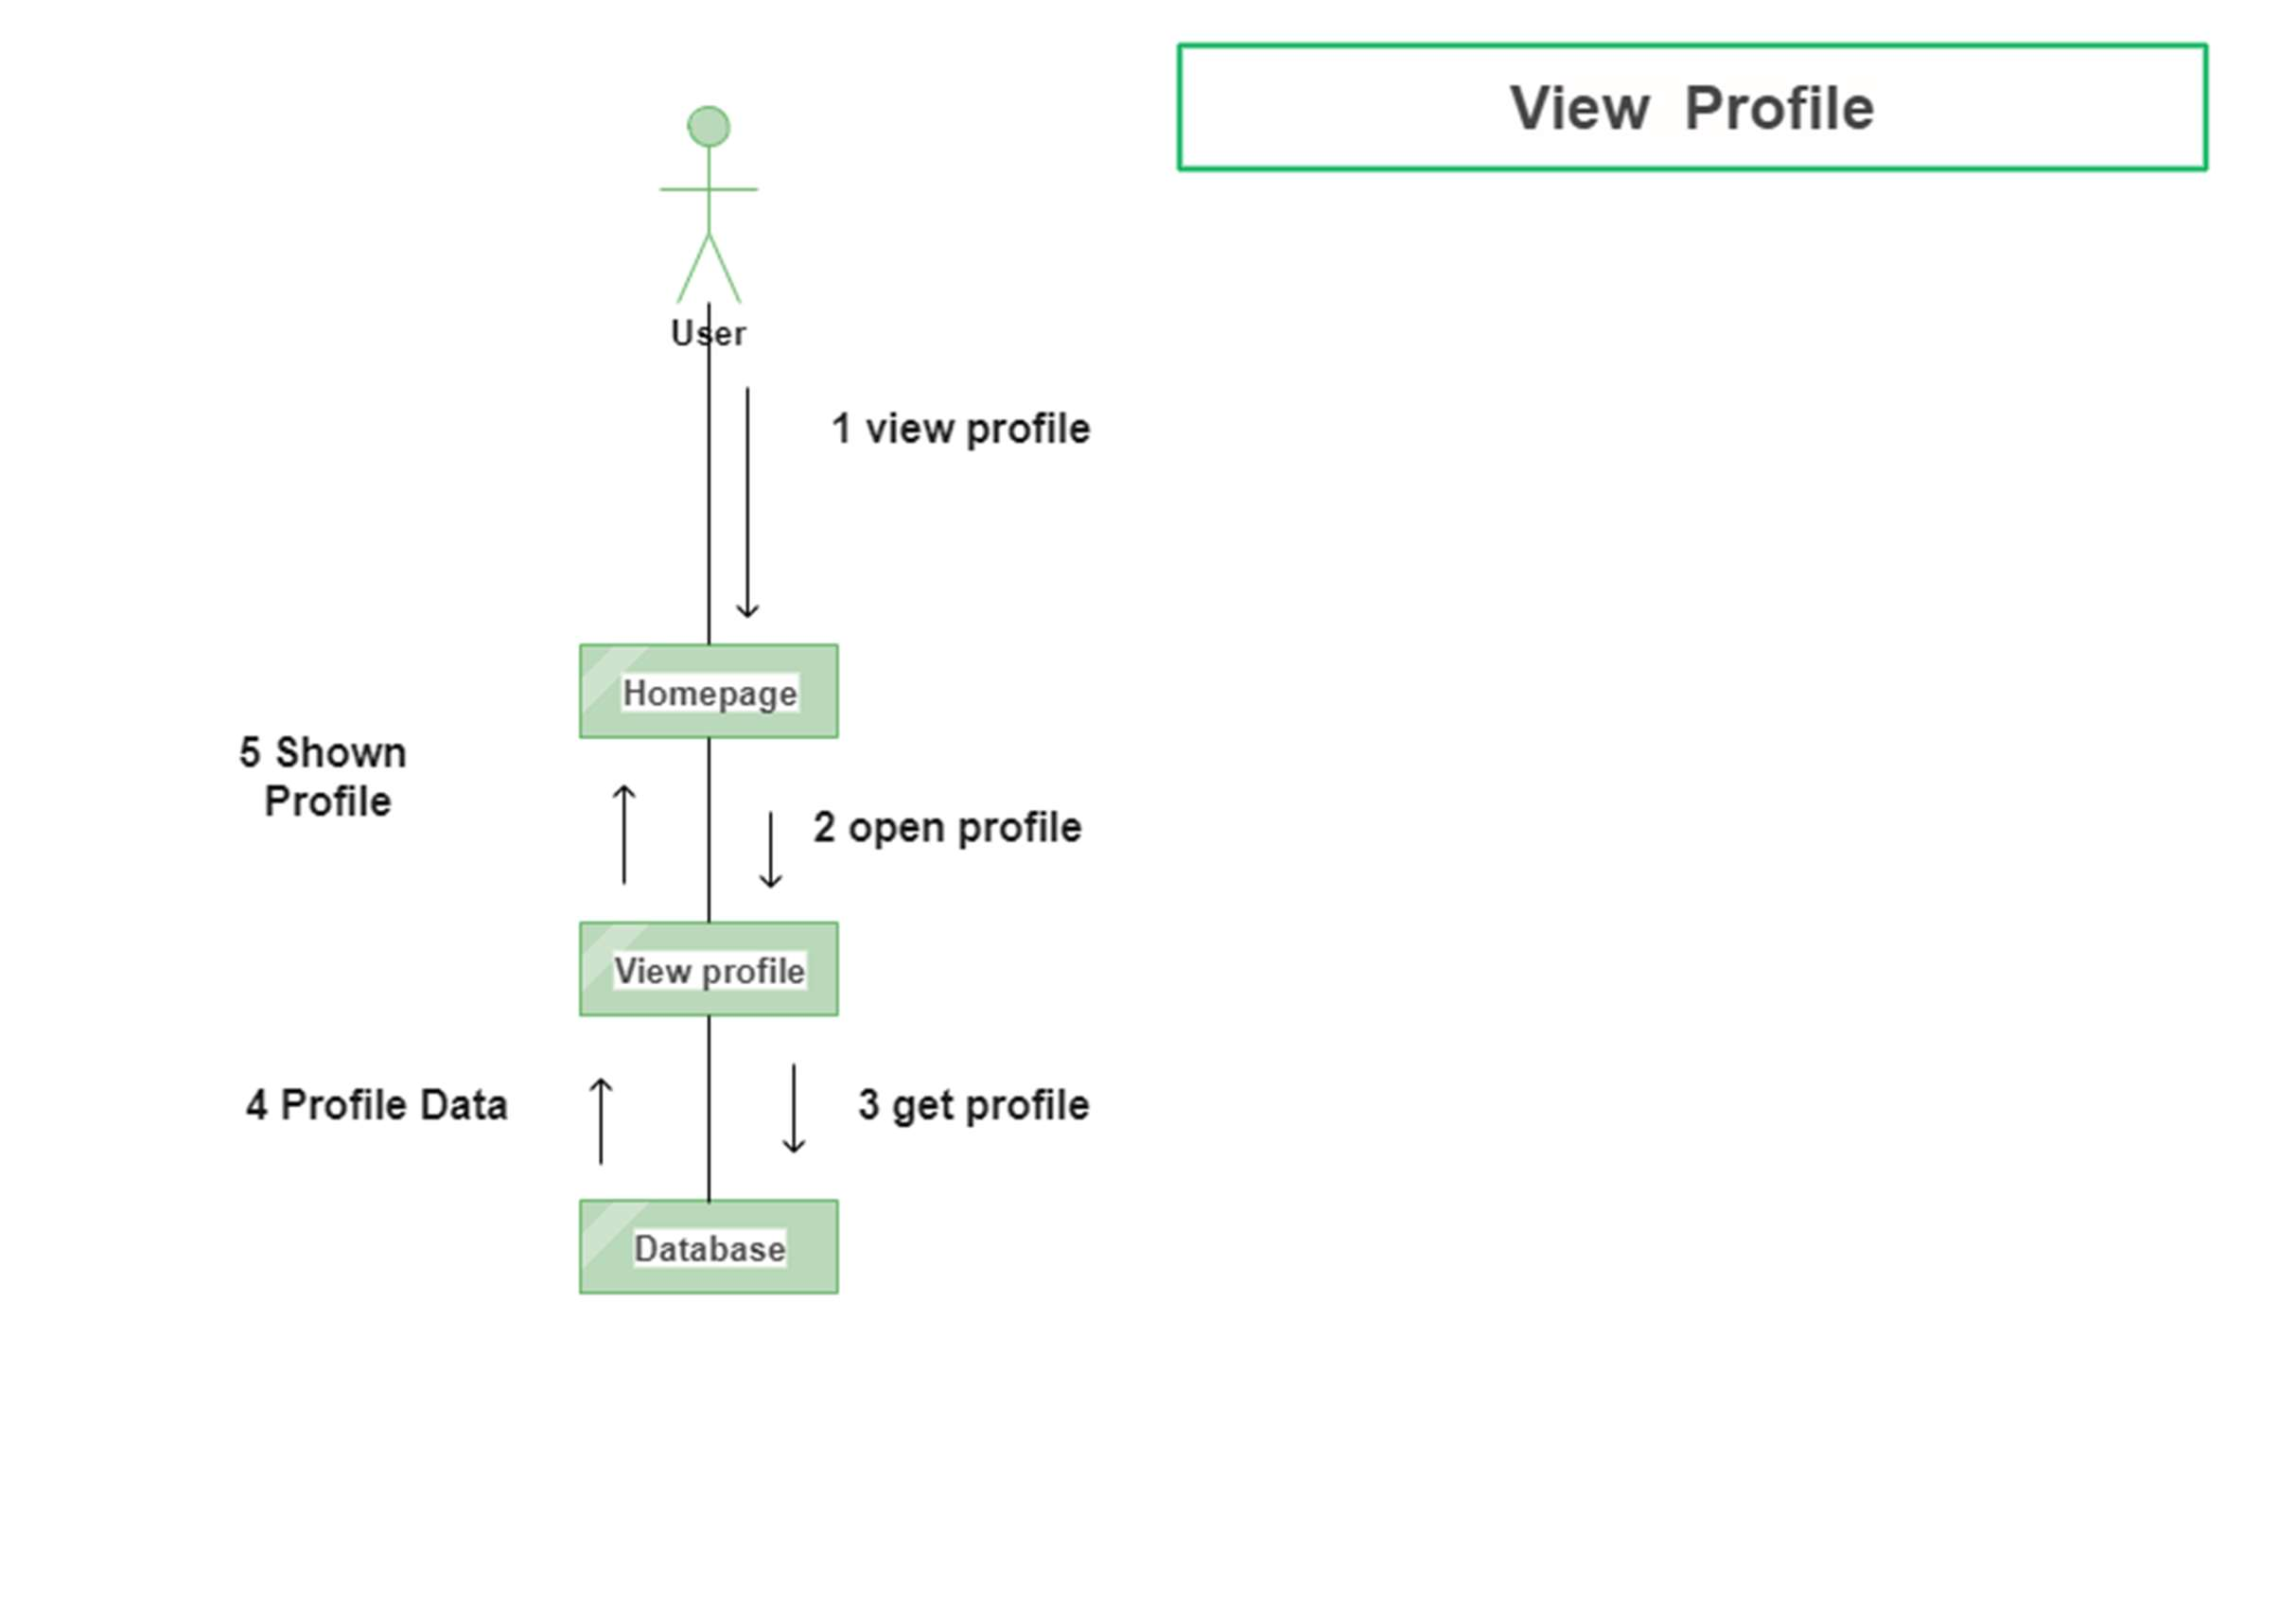

Figure 45 Collaboration Diagram 12

**Add List of Teacher**

The admin will first login to the portal and from the dashboard admin will select list of teachers from

service option. The request will be sent to server and the teacher will be added to the database.

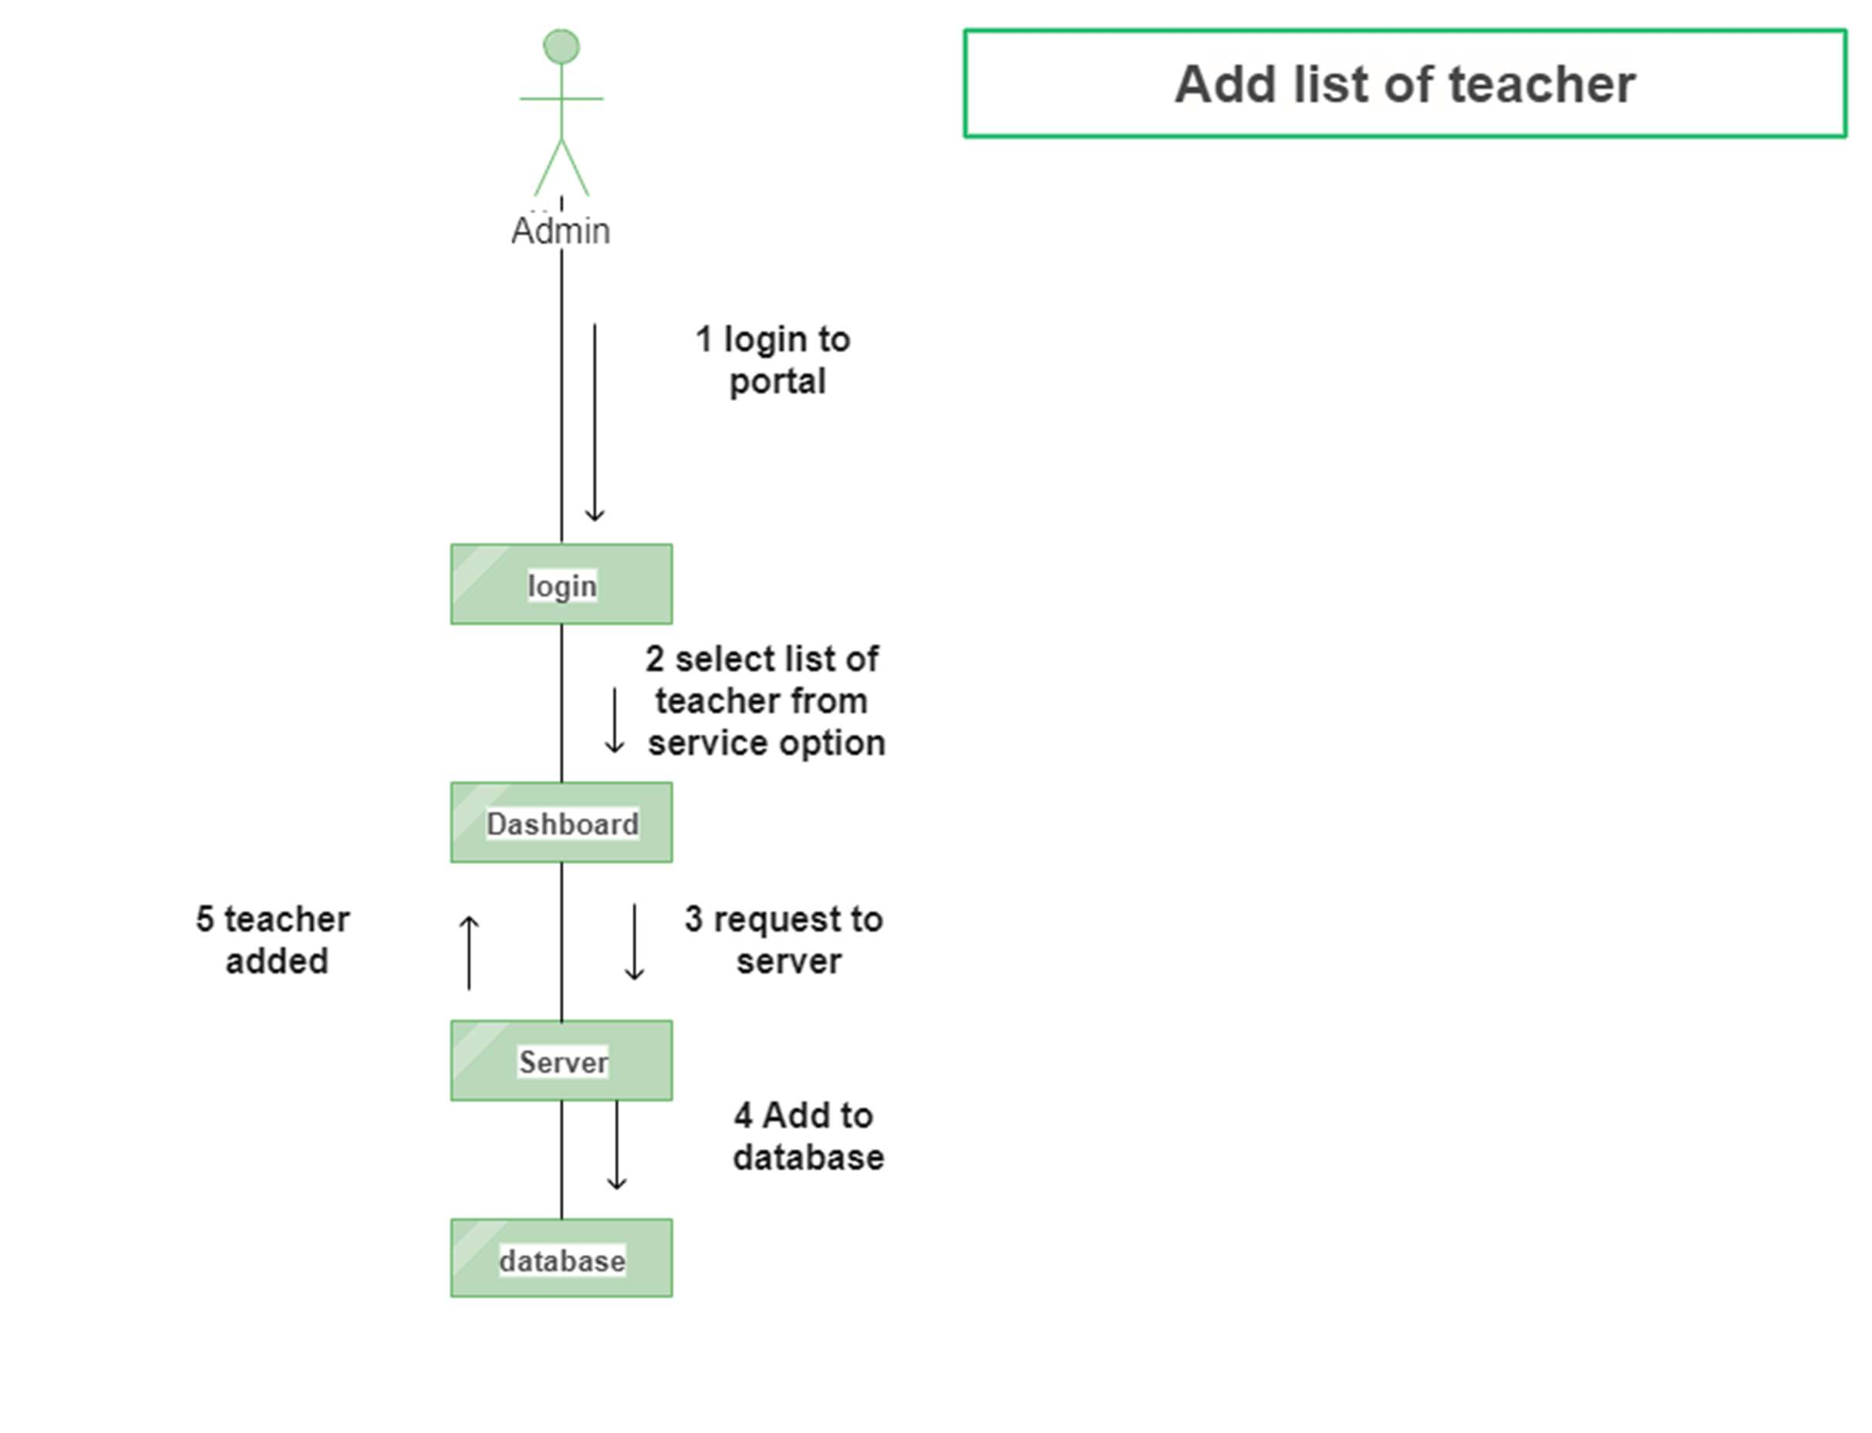

Figure 46 Collaboration Diagram 13

**Update List of Teacher**

The admin will first login to the portal and will be directed to the dashboard from where the admin will

select list of teachers from service option and make the update. The request will be sent server and the

database will be updated. After this the updated list will be displayed.

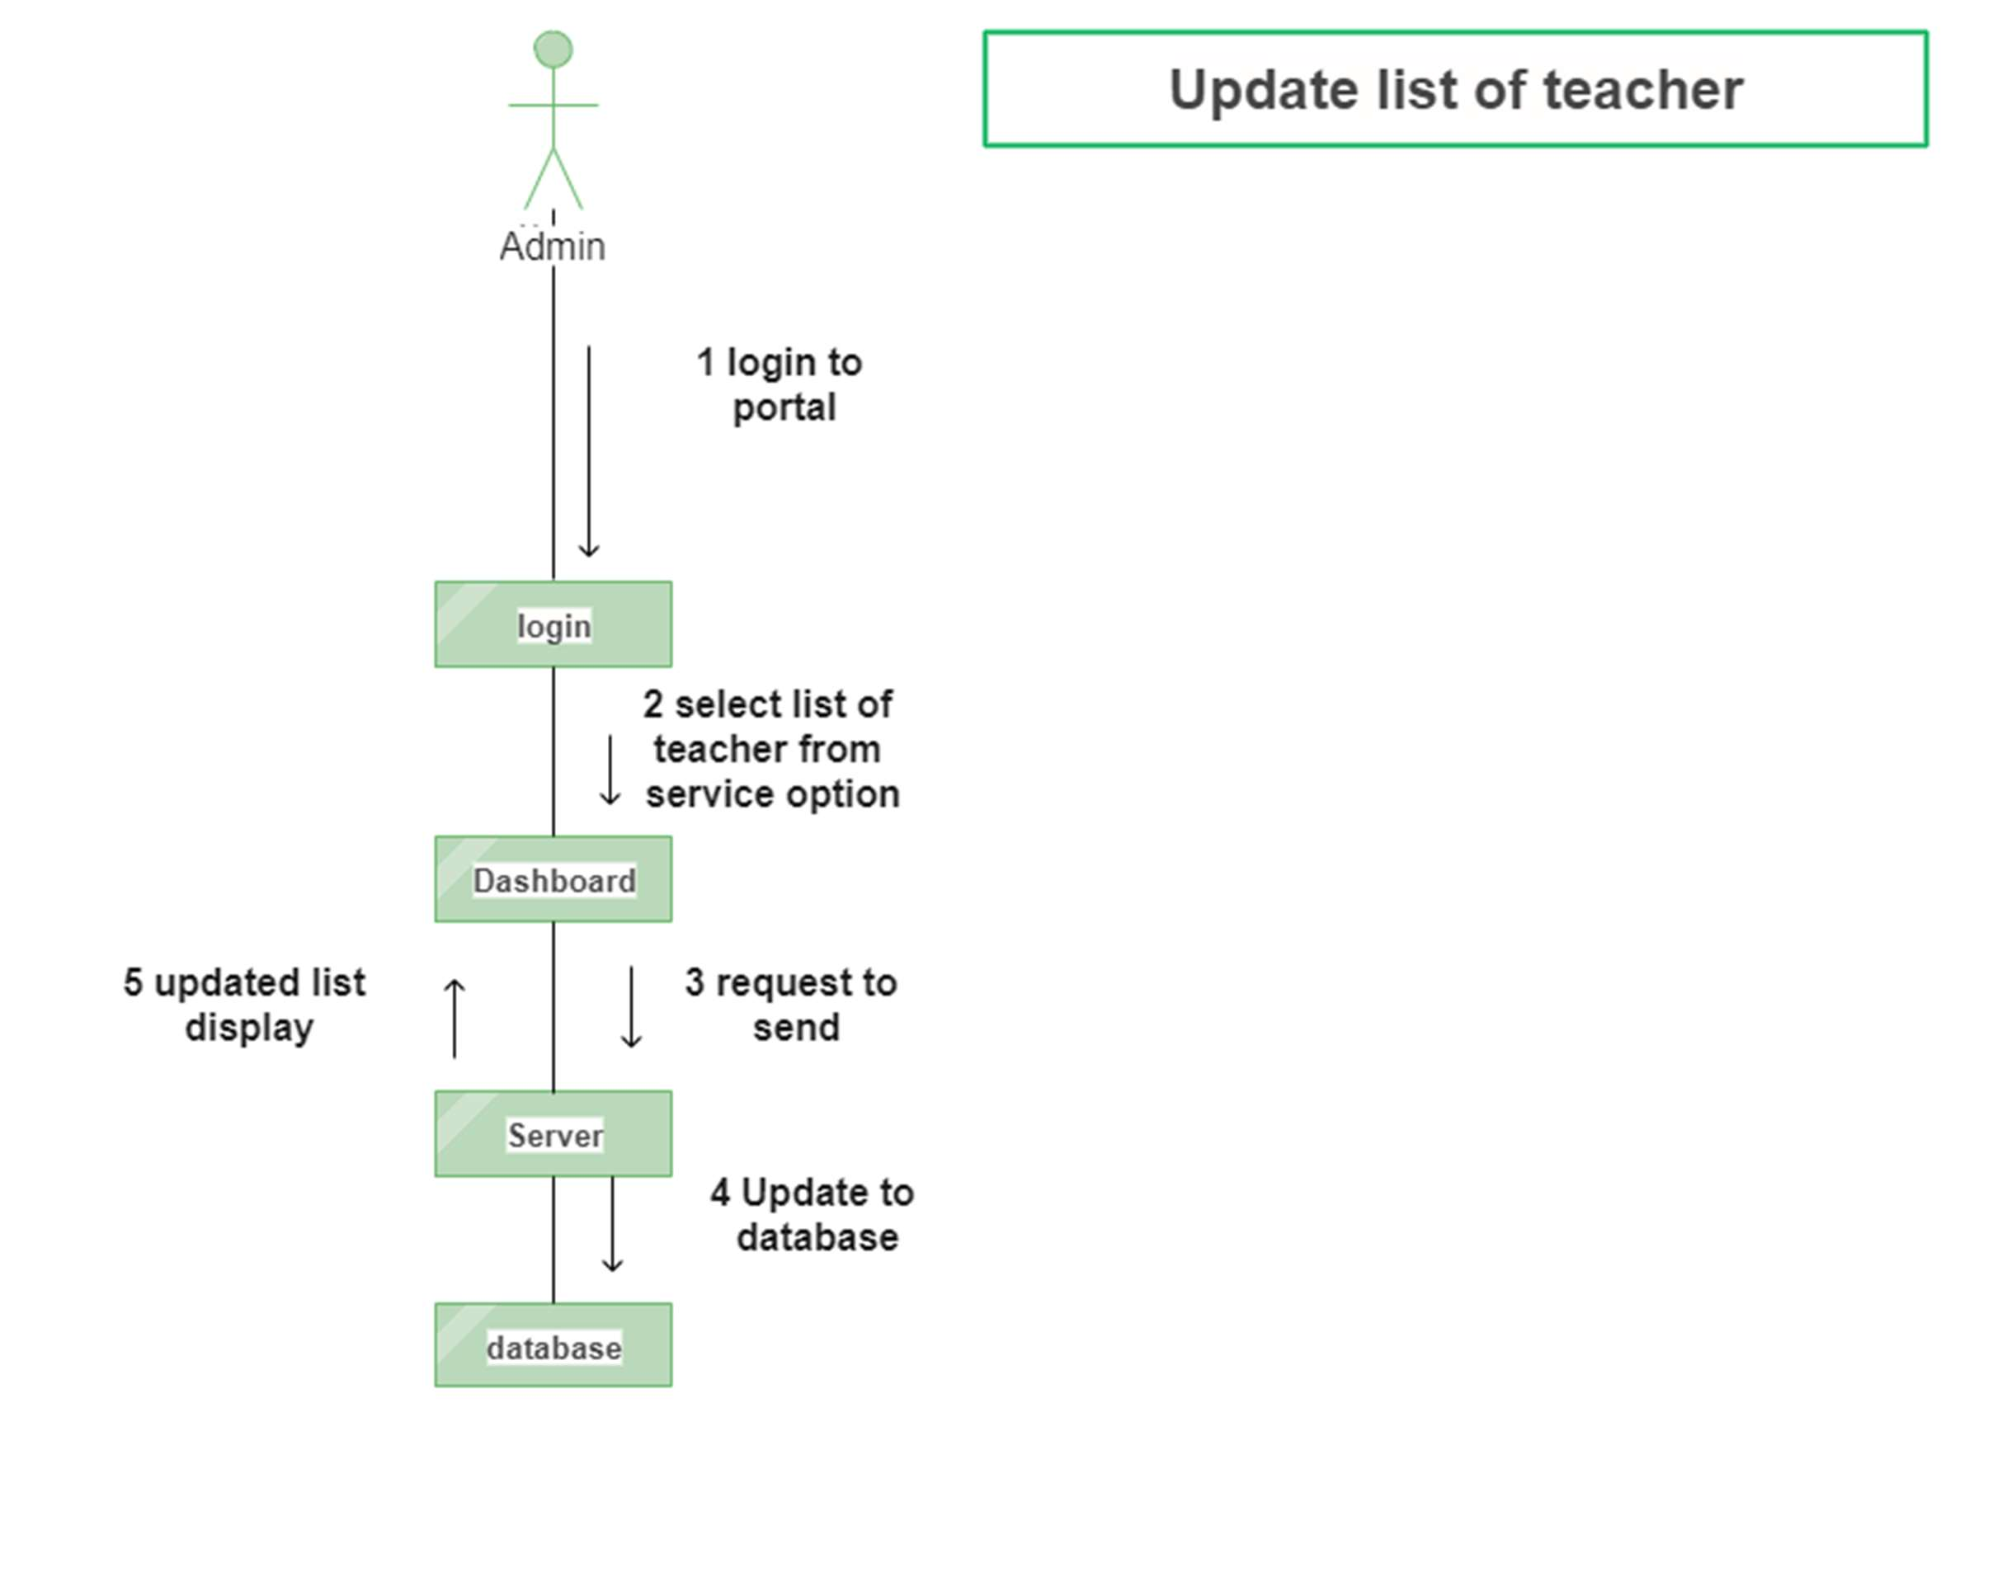

Figure 47 Collaboration Diagram 14

**Delete List of Teacher**

The admin will first login to the portal and will be directed to the dashboard from where admin will

select list of teachers from service option which is to be deleted. After this the request will be sent to

server and the teacher will be deleted from the database. The updated list will be displayed.

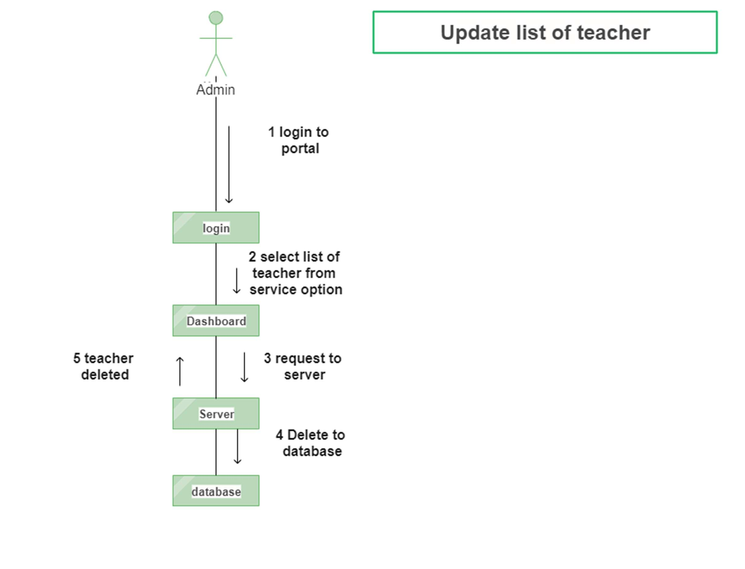

Figure 48 Collaboration Diagram 15

**Logout**

The user will login to the portal and from the dashboard user will select the logout option. The logout

request will be sent to server and then the session will be expired and user will return to login page.

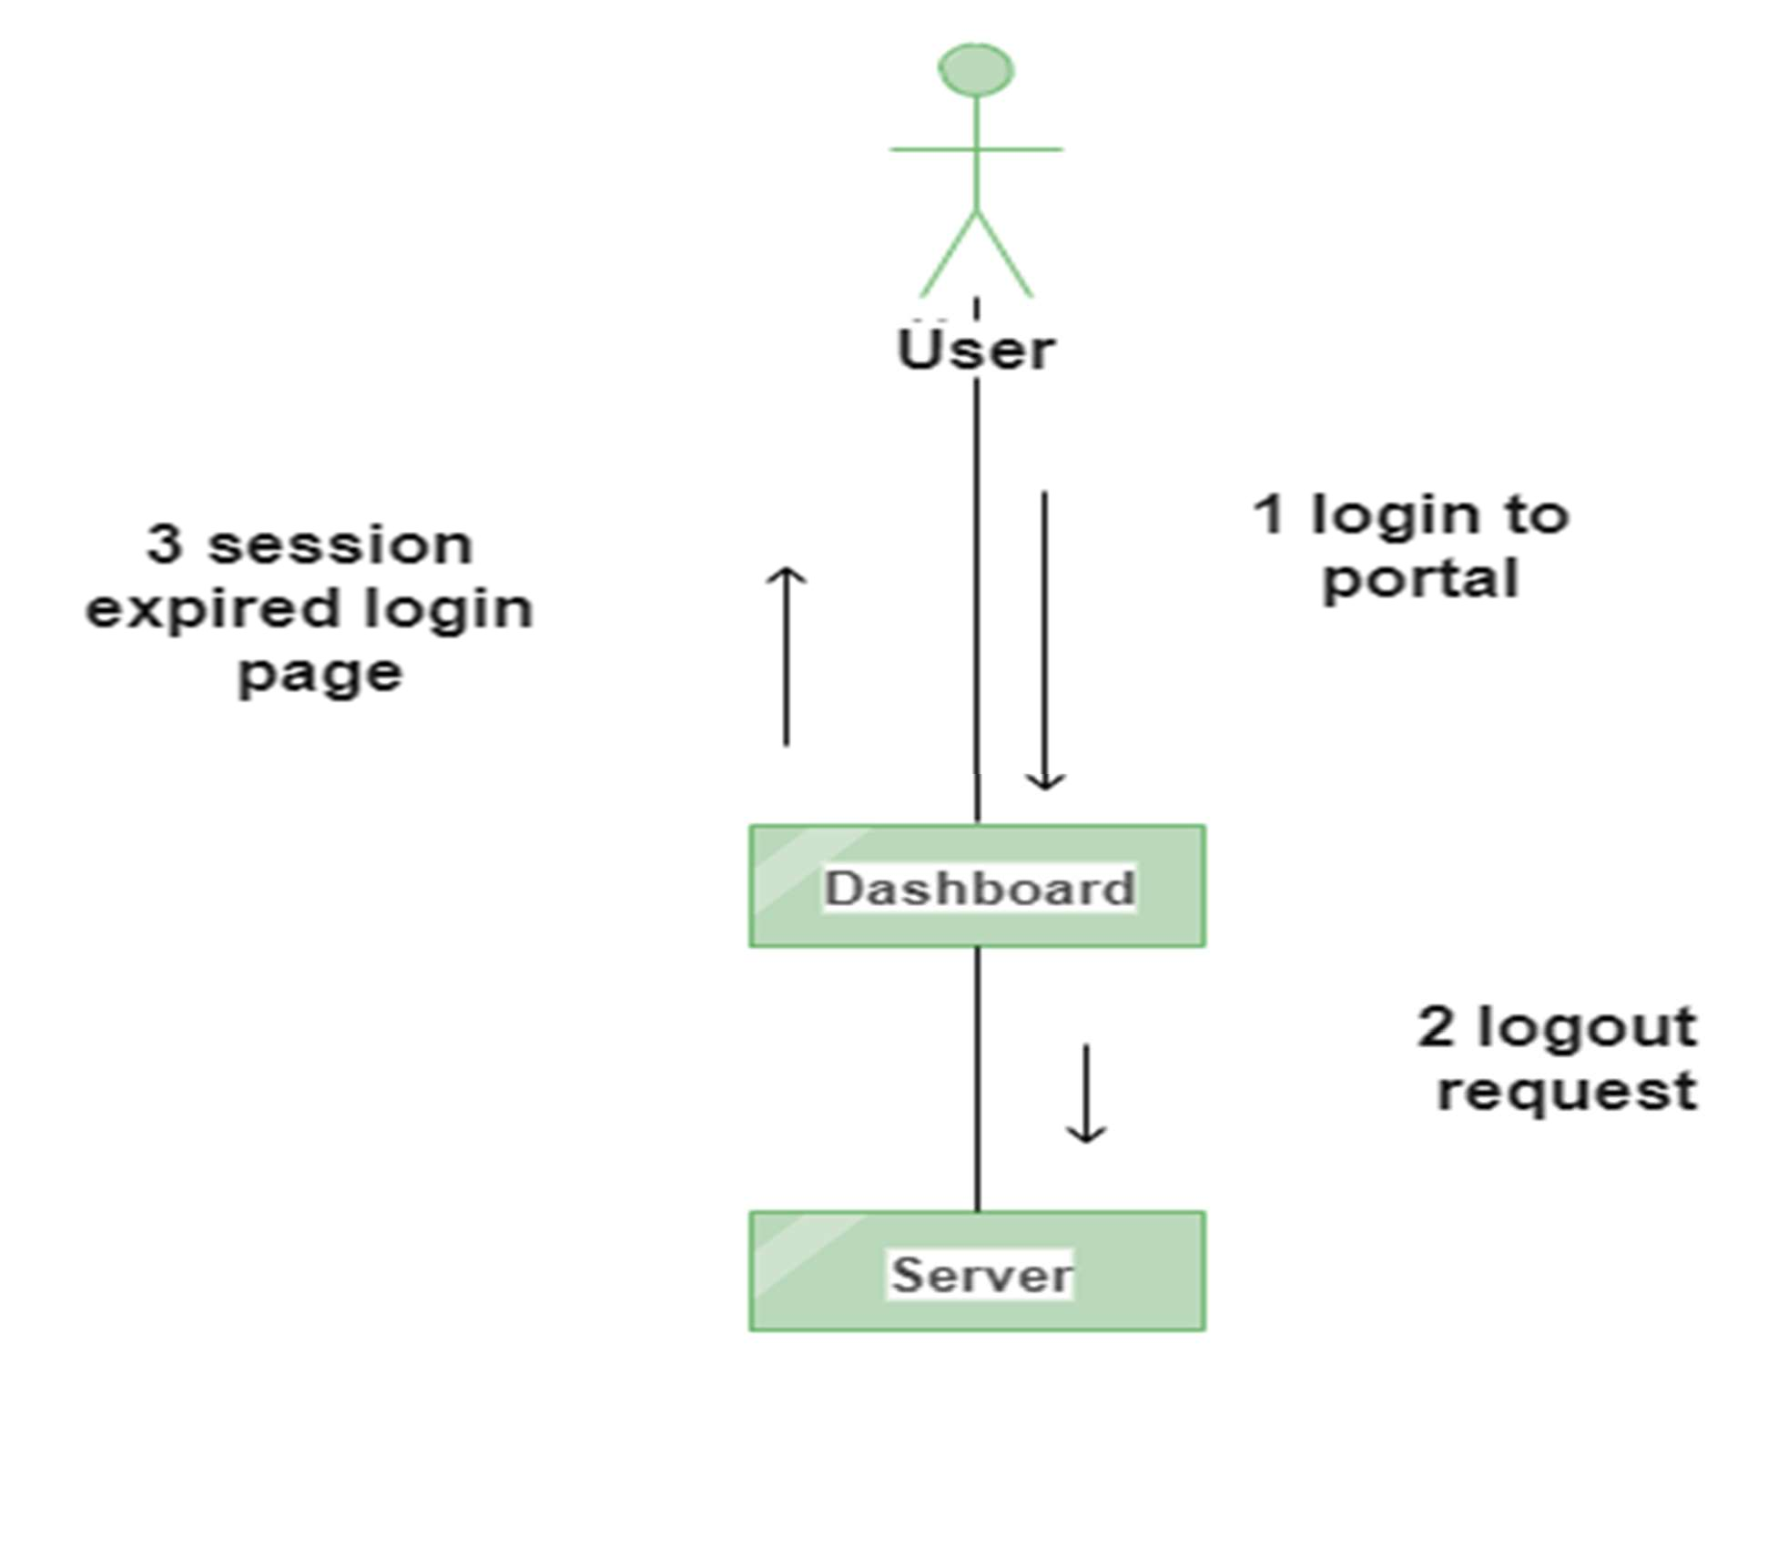

Figure 49 Collaboration Diagram 16

# CHAPTER 4 SYSTEM TESTING

#### Test Cases

**Test case #:** 1

**System:** Tutor Hub

**Designed By:** Moazzam Ali

**Executed By:**

**Test Case Name:** User Sign Up

**Subsystem:** Online Tutor System

**Design Date:** 1st December, 2022

**Execution Date:**

**Short Description:** Test that User can create an account by submitting details.

**Pre-Conditions:**

User must not be already registered

|  |  |  |  |  |
| --- | --- | --- | --- | --- |
| **Step** | **Action** | **Expected System Response** | **Pass/Fail** | **Comment** |
| 1. | The User presses sign up link. | The system displays form. | Pass | The user signups the form successfully. |
| 2. | The User enter details Name, CNIC, Contact Number, Email, Address and Password | The system validates the information entered. | Pass | The user enters all the details successfully. |
| 3. | The User submit account information. | The system stores the information in the database. | Pass | The user submits the information successfully. |

**Post-Conditions**

User account is created.

Table 20 Test case 1: User Sign Up

**Test case #:** 2

**System:** Tutor Hub

**Designed By:** Moazzam Ali

**Executed By:**

**Test Case Name:** User login

**Subsystem:** Tutor System

**Design Date:** 2 December 2022

**Execution Date:**

**Short Description:** To test that User can login after submitting details.

**Pre-Conditions:**

User should be registered.

|  |  |  |  |  |
| --- | --- | --- | --- | --- |
| **Step** | **Action** | **Expected System Response** | **Pass/Fail** | **Comment** |
| 1. | The User presses login link. | The system must have to display login form. | Pass | The user presses the login link successfully. |
| 2. | User will enter details e.g., password and username | The system will check the entered data. | Pass | The user enters all the details successfully. |
| 3. | The User submits account information. | The system has to check the data from the database. | Pass | The user submits all information successfully. |

**Post-Conditions**

User must have to login his/her account.

Table 21 Test case 2: Login User

|  |
| --- |
| **Test case #:** 3 **Test Case Name:** View List of Teacher  **System:** Tutor Hub **Subsystem:** Online Tutor System  **Designed By:** Moazzam Ali **Design Date:** 3 December 2022  **Executed By:**  **Execution Date:**  **Short Description:** Test that User can view a List of a Teacher. |
| **Pre-Conditions:** List of teachers must exist. |

|  |  |  |  |  |
| --- | --- | --- | --- | --- |
| **Step** | **Action** | **Expected System Response** | **Pass/Fail** | **Comment** |
| 1. | The User clicks on a service option. | The system must display the list inside a service option. | Pass | The user clicks on service option successfully. |
| 2. | The User clicks on the List of a Teacher. | The system must display the List of Teacher options. | Pass | The user clicks on list of teachers successfully. |
| 3. | The User clicks on a teacher | The system must display a teacher page. | Pass | The user clicks on teacher successfully. |
| 4. | The User can view teacher services, fee, timing, | The system must display accurate information about a teacher. | Pass | The user can view teacher services, fee and timing successfully. |
| **Post-Conditions:** User viewed the teacher | | | | |

Table 22 Test case 3: View List Teacher

**Test case #: 4**

**System:** Tutor Hub

**Designed By:** Muhammad Faizan

**Executed By:**

**Test Case Name:** View Profile

**Subsystem:** Online Tutor System

**Design Date:** 3 December 2022

**Execution Date:**

**Short Description:** Test that User can view his/her profile.

**Pre-Conditions:**

User must be registered

|  |  |  |  |  |
| --- | --- | --- | --- | --- |
| **Step** | **Action** | **Expected System Response** | **Pass/Fail** | **Comment** |
| 1. | The User press my profile button | The system displays my profile page | Pass | The user presses the profile button successfully. |
| 2. | The User enter the name to view profile of another User | The system displays the other User profile | Pass | The user enters the name to view profile of other user successfully. |
| 3. | The User can see all his/her information in the profile like name, city, address etc. | The system displays the information | Pass | The user can see all of the other user information successfully. |

**Post-Conditions**

The User can view his/her profile or the profile of other Users

Table 23 Test case 4: View Profile

**Test case #:** 5

**System:** Tutor Hub

**Designed By:** Muhammad Faizan

**Executed By:**

**Test Case Name:** View Schedule **Subsystem:** Online Tutor System **Design Date:** 5 December 2022

**Execution Date:**

**Short Description:** Test that User can view schedule.

**Pre-Conditions:**

User must be registered

**Post-Conditions**

The User can view the schedule

|  |  |  |  |  |
| --- | --- | --- | --- | --- |
| **Step** | **Action** | **Expected System Response** | **Pass/Fail** | **Comment** |
| 1. | The User press the service button | The system displays the list of teachers inside service option | Pass | The user presses the service button successfully. |
| 2. | The User enter the specific teacher to view schedule of that teacher | The system displays the teacher | Pass | The User enter the specific teacher to view schedule successfully |
| 3. | The User click on schedule button of the teacher | The system displays the schedule | Pass | The User click on schedule button of the teacher successfully |
| 4. | The User view schedule and fix his/her appointment | The system stores the information in the database | Pass | The User view schedule and fix his/her appointment successfully |

Table 24 Test case 5: View Schedule

|  |
| --- |
| **Test case #:** 6 **Test Case Name:** View Appointment  **System:** Tutor Hub **Subsystem:** Online Tutor System  **Designed By:** Syed Muhammad Saad **Design Date:** 5 December 2022  **Executed By:** **Execution Date:**  **Short Description:** Test that Users can view Appointments. |
| **Pre-Conditions:** Appointment must exist. |

|  |  |  |  |  |
| --- | --- | --- | --- | --- |
| **Step** | **Action** | **Expected System Response** | **Pass/Fail** | **Comment** |
| 1. | The User clicks on the My Appointment option. | The system must display the My Appointment page. | Pass | The User clicks on the My Appointment option successfully |
| 2. | The User clicks on the View option. | The system must display appointments. | Pass | The User clicks on the View option successfully |
| 3. | The User can view his/her name, teacher, service, time, etc. | The system must display accurate information. | Pass | The User can view his/her name, teacher, service successfully |
| 4. | The User can close this page after view. | The system must display My appointment page | Pass | The User can close this page after view successfully |
| **Post-Conditions:** User viewed the appointment. | | | | |

Table 25 Test case 6: View Appointment

**Test case #:** 7

**System:** Tutor Hub

**Designed By:** Syed Muhammad Saad **Executed By:**

**Test Case Name:** View Feedback **Subsystem:** Online Tutor System **Design Date:** 7 December 2022

**Execution Date:**

**Short Description:** Test that User can view feedback.

**Pre-Conditions:**

User may or may not be registered

**Post-Conditions**

The User can view the feedback page

|  |  |  |  |  |
| --- | --- | --- | --- | --- |
| **Step** | **Action** | **Expected System Response** | **Pass/Fail** | **Comment** |
| 1. | The User press the view feedback button | The system displays the feedback page. | Pass | The User press the view feedback button successfully |
| 2. | The User enter the specific teacher to view feedback of that teacher | The system displays the teacher | Pass | The User enter the specific teacher to view feedback of that teacher successfully |
| 3. | The User enter the feedback button | The system displays the feedback of that | Pass | The User enter the feedback button successfully |

Table 26 Test case 7: View Feedback

**Test case #:** 8

**System:** Tutor Hub

**Designed By:** Muhammad Faizan

**Executed By:**

**Test Case Name:** Add Feedback **Subsystem:** Online Tutor System **Design Date:** 10 December 2022

**Execution Date:**

**Short Description:** Test that User can add the feedback

**Pre-Conditions:**

User may or may not be registered

|  |  |  |  |  |
| --- | --- | --- | --- | --- |
| **Step** | **Action** | **Expected System Response** | **Pass/Fail** | **Comment** |
| 1. | The User press the service button | The system displays the feedback button inside the service button | Pass | The User press the service button successfully. |
| 2. | The User press feedback button | The system displays the feedback page | Pass | The User press feedback button successfully. |
| 3. | The User enter the feedback through comments or by rating through stars | The system displays the feedback | Pass | The User enter the feedback through comments or by rating through stars successfully |
| 4. | The User enter the submit button | The system stores the information in the database | Pass | The User enter the submit button successfully |

**Post-Conditions**

The User can add the feedback of the User

Table 27 Test case 8: Add Feedback

**Test case #:** 9 **Test Case Name:** Choose Services

**System:** Tutor Hub **Subsystem:** Online Tutor System

**Designed By:** Syed Muhammad Saad

**Executed By:**

**Design Date:** 11 December 2022

**Execution Date:**

**Short Description:** Test that User can view service chosen.

**Pre-Conditions:**

User must be logged In.

|  |  |  |  |  |
| --- | --- | --- | --- | --- |
| **Step** | **Action** | **Expected System Response** | **Pass/Fail** | **Comment** |
| 1. | The User press’s view choose services button. | The system should have to display service page. | Pass | The User press’s view choose services button successfully |
| 2. | The User can cancel the service appointment. | The system must cancel it. | Pass | The User cancel the service appointment successfully |

**Post-Conditions**

User can download the confirmation receipt.

Table 28 Test case 9: Choose service

**Test case #:** 10 **Test Case Name:** Update Appointment

**System:** Tutor Hub

**Designed By:** Moazzam Ali

**Executed By:**

**Subsystem:** Online Tutor System

**Design Date:** 15 December 2022

**Short Description:** Test that User can update his/her appointment.

**Pre-Conditions:**

User must be registered

User has already make an appointment

|  |  |  |  |  |
| --- | --- | --- | --- | --- |
| **Step** | **Action** | **Expected System Response** | **Pass/Fail** | **Comment** |
| 1. | The User press the make an appointment button | The system displays the make an appointment page | Pass | The User press the make an appointment button successfully |
| 2. | The User press the update appointment information | The system displays the appointment page | Pass | The User press the update appointment information successfully |
| 3. | The User update his/her appointment | The system displays the updated information | Pass | The system displays the updated information successfully |
| 4. | The User enter the update button | The system stores the information in the database | Pass | The User enter the update button successfully |

**Post-Conditions**

The User can update his/her appointment

Table 29 Test case 10: Update Appointment

**Test case #:** 11 **Test Case Name:** Update Feedback

**System:** Tutor Hub

**Designed By:** Moazzam Ali

**Executed By:**

**Subsystem:** Tutor System

**Design Date:** 17 December 2022

**Execution Date:**

**Short Description:** Test that Student can view his/her synopsis progress.

**Pre-Conditions:**

User must be logged In.

|  |  |  |  |  |
| --- | --- | --- | --- | --- |
| **Step** | **Action** | **Expected System Response** | **Pass/Fail** | **Comment** |
| 1. | The User presses update feedback button. | The system displays updated feedback page. | Pass | The User presses update feedback button successfully |
| 2. | The User can edit the feedback. | The system must edit it. | Pass | The User can edit the feedback successfully |
| 3. | The User can view edited feedback. | The edited feedback must be viewed. | Pass | The User can view edited feedback successfully. |

**Post-Conditions**

User can view updated feedback.

Table 30 Test case 11: Update Feedback

**Test case #:** 12

**System:** Tutor Hub

**Designed By:** Syed Muhammad Saad

**Executed By:**

**Test Case Name:** Notification and email

**Subsystem:** Online Tutor System

**Design Date:** 18 December 2022

**Execution Date:**

**Short Description:** Test that User get email of current status.

**Pre-Conditions:**

User must be registered.

|  |  |  |  |  |
| --- | --- | --- | --- | --- |
| **Step** | **Action** | **Expected System Response** | **Pass/Fail** | **Comment** |
| 1. | The User presses notification link/icon. | The system must display notification page. | Pass | The User presses notification link/icon successfully. |
| 2. | The User can also get notification via an email. | The system must send the email on User provided email address. | Pass | The User can also get notification via an email successfully |

**Post-Conditions**

User can view the notification and email.

Table 31 Test case 12: Notification and Email

|  |
| --- |
| **Test case #:** 13 **Test Case Name:** Logout User  **System:** Tutor Hub **Subsystem:** Online Tutor System  **Designed By:** Muhammad Faizan **Design Date:** 20 December 2022  **Executed By:**  **Execution Date:**  **Short Description:** Test that User can Logout. |
| **Pre-Conditions:** User must Login to the system |

|  |  |  |  |  |
| --- | --- | --- | --- | --- |
| **Step** | **Action** | **Expected System Response** | **Pass/Fail** | **Comment** |
| 1. | User presses on the Logout button. | The system must display a Confirmation message | Pass | User presses on the Logout button successfully |
| 2. | User presses on the Ok option and Logout the system | The system must display a Log-In form | Pass | User presses on the Ok option and Logout the system successfully |
| **Post-Conditions:** User is Logout | | | | |

Table 32 Test case 13: Logout User

**CHAPTER 5**

**CONCLUSION**

### Problem faced and lesson learned

We faced different problems while writing this report and finalizing requirements for our project. The main problem we faced was during requirement gathering and adding functionalities in our product i.e., which functionality will be beneficial and attractive for the stakeholders and will also be practical. Also, those functionalities which will make our product different and better from our competitors.

We also faced difficulty while using different online tools like lucid chart to make use case diagrams and Figma for making prototypes for the satisfaction of stakeholders. For learning how to use these tools we had to watch different tutorials as well as to seek help from our supervisor and teachers.

At last, from this project, we learned how to work in a team and how to gather requirements which will satisfy all stakeholders and these things will also help us a lot in our future endeavors and professional life.

### Summary of Project

Our platform which is a web application will provide students an opportunity to select a tutor of their own choice available nearby their location. Students and tutors will register themselves on the system and a list of tutors available in the area will be displayed to students from which they can hire one or more tutors based on their area of interest and expertise of tutors. Students will also have the facility to make a timetable with the tutor they have hired. Tutors will be able to take online quizzes and assignments as well. Parents will also have access to the platform and they will be able to check their child’s performance as well as his grades in quizzes and assignments. Parents will also have the facility to arrange a meeting with the tutor to discuss their child’s situation.

To facilitate the hiring process the platform will also provide a chat box and online meeting option so both parents/students and tutors will be able to know more about each other before they start working together. This system will also provide ease of work for tutors as they will only be suggested to those students who are nearby their location. In this way their travel expense and time will be saved. The built-in functionalities in the system like chat box and online meeting option, online quizzes and assignments, timetable management and ease to connect with parents will prove to be very helpful for both parties i.e., tutors and parents/students.

### Future Work

1. May add more functionalities for the ease and benefit of stakeholders.
2. May expand the services of our application and launch it in different markets.
3. May also develop an android and iOS app for the users.

##### 6 References

1. https://[www.khanacademy.org](http://www.khanacademy.org/)
2. https://[www.udemy.com/?utm_source=adwords-brand&utm_medium=udemyads&utm_campaign=Brand-](http://www.udemy.com/?utm_source=adwords-brand&utm_medium=udemyads&utm_campaign=Brand-) Udemy_la.EN_cc.ROW&utm_term=_._ag_80315195513_._ad_535757779892_._de_c_._dm ._pl ._ti_kwd- 310556426868_._li_9076951_._pd ._&utm_term=_._pd ._kw_udemy_._&matchtype=e
3. https://[www.wyzant.com/tutors/web-applications](http://www.wyzant.com/tutors/web-applications)
4. https://[www.linkedin.com/learning/](http://www.linkedin.com/learning/)
5. https://[www.coursera.org/](http://www.coursera.org/)
6. https://[www.masterclass.com/](http://www.masterclass.com/)
7. https://myfik.unisza.edu.my/www/fyp/fyp18sem2/report/43112.pdf
8. https://myfik.unisza.edu.my/www/fyp/fyp18sem2/report/43112.pdf
9. https://myfik.unisza.edu.my/www/fyp/fyp18sem2/report/43112.pdf
10. https://t4tutorials.com/find-my-tutor-mobile-android-application-project/
11. <https://files.eric.ed.gov/fulltext/EJ1127269.pdf>

# **Turnitin** Originality Report

* Processed on: 03-Jan-2023 12:35 PKT
* ID: 1988148779
* Word Count: 8781
* Submitted: 1

## **Tutor Hub** By Muhammad Faizan Shahid

Similarity Index

18%

**Similarity by Source**

Internet Sources:

7%

Publications:

0%

Student Papers:

16%

5% match (student papers from 16-Jun-2022)

[Submitted to Higher Education Commission Pakistan on 2022-06-16](javascript:openDSC(2341457556,1,'0'))

1% match (student papers from 04-Jan-2022)

[Submitted to Higher Education Commission Pakistan on 2022-01-04](javascript:openDSC(2210427311,1,'0'))

1% match (student papers from 15-May-2018)

[Submitted to Higher Education Commission Pakistan on 2018-05-15](javascript:openDSC(964022242,1,'0'))

1% match (student papers from 10-Jun-2021)

[Submitted to Higher Education Commission Pakistan on 2021-06-10](javascript:openDSC(2065609280,1,'0'))

1% match (Internet from 27-Sep-2021)

<https://www.guru99.com/dbms-architecture.html/>

1% match (student papers from 07-Aug-2020)

[Submitted to Coventry University on 2020-08-07](javascript:openDSC(634251327,2,'0'))

1% match (Internet from 08-Jun-2020)

<https://raisemymarks.com/2020/01/03/pros-and-cons-of-online-tutoring/>

1% match (student papers from 23-May-2018)

[Submitted to Colorado Technical University Online on 2018-05-23](javascript:openDSC(967655905,1,'0'))

< 1% match (student papers from 28-Jun-2022)

[Submitted to Higher Education Commission Pakistan on 2022-06-28](javascript:openDSC(2348614774,1,'0'))

< 1% match (student papers from 05-Aug-2020)

[Submitted to Higher Education Commission Pakistan on 2020-08-05](javascript:openDSC(1809949367,1,'0'))

< 1% match (student papers from 28-Jun-2022)

[Submitted to Higher Education Commission Pakistan on 2022-06-28](javascript:openDSC(2348616440,1,'0'))

< 1% match (student papers from 02-Jan-2023)

[Submitted to Higher Education Commission Pakistan on 2023-01-02](javascript:openDSC(2487456073,1,'0'))

< 1% match (student papers from 20-Jun-2022)

[Submitted to Higher Education Commission Pakistan on 2022-06-20](javascript:openDSC(2344163182,1,'0'))

< 1% match (student papers from 01-Jan-2016)

[Submitted to Higher Education Commission Pakistan on 2016-01-01](javascript:openDSC(618035540,1,'0'))

< 1% match (student papers from 08-Jun-2021)

[Submitted to Higher Education Commission Pakistan on 2021-06-08](javascript:openDSC(2064305956,1,'0'))

< 1% match (student papers from 01-Jun-2017)

[Submitted to Higher Education Commission Pakistan on 2017-06-01](javascript:openDSC(820907595,1,'0'))

< 1% match (student papers from 03-Oct-2022)

[Submitted to Higher Education Commission Pakistan on 2022-10-03](javascript:openDSC(2406262691,1,'0'))

< 1% match (student papers from 22-Dec-2016)

[Submitted to Higher Education Commission Pakistan on 2016-12-22](javascript:openDSC(755646504,1,'0'))

< 1% match (student papers from 09-Jan-2018)

[Submitted to Higher Education Commission Pakistan on 2018-01-09](javascript:openDSC(901246713,1,'0'))

< 1% match (student papers from 30-Jul-2020)

[Submitted to Higher Education Commission Pakistan on 2020-07-30](javascript:openDSC(1807713625,1,'0'))

< 1% match (student papers from 06-Aug-2020)

[Submitted to Higher Education Commission Pakistan on 2020-08-06](javascript:openDSC(1810427516,1,'0'))

< 1% match (student papers from 21-Dec-2016)

[Submitted to Higher Education Commission Pakistan on 2016-12-21](javascript:openDSC(755470992,1,'0'))

< 1% match (student papers from 26-May-2016)

[Submitted to Higher Education Commission Pakistan on 2016-05-26](javascript:openDSC(678587347,1,'0'))

< 1% match (student papers from 15-May-2018)

[Submitted to Higher Education Commission Pakistan on 2018-05-15](javascript:openDSC(964039719,1,'0'))

< 1% match (student papers from 04-Jan-2022)

[Submitted to Higher Education Commission Pakistan on 2022-01-04](javascript:openDSC(2210606380,1,'0'))

< 1% match (student papers from 09-Jun-2015)

[Submitted to Higher Education Commission Pakistan on 2015-06-09](javascript:openDSC(549245247,1,'0'))

< 1% match (Internet from 06-Oct-2022)

<https://www.coursehero.com/file/69749060/CS35-E-TUTORdocx/>

< 1% match (Internet from 16-Apr-2022)

<https://www.coursehero.com/file/121733986/Reportpdf/>

< 1% match (Internet from 19-Dec-2021)

<https://www.coursehero.com/file/99943676/Bilaldocx/>

< 1% match (Internet from 17-Apr-2022)

<https://www.coursehero.com/file/95445758/Comsats-Hubdocx/>

< 1% match (Internet from 15-Jul-2020)

<https://edtechmxblog.wordpress.com/an-apple-a-week/the-danger-of-a-single-story/>

< 1% match (student papers from 08-Jan-2018)

[Submitted to Universiti Teknologi Petronas on 2018-01-08](javascript:openDSC(900873268,1,'0'))

< 1% match (student papers from 31-Jul-2017)

[Submitted to Asia Pacific University College of Technology and Innovation (UCTI) on 2017-07-31](javascript:openDSC(833878737,1,'0'))

< 1% match (student papers from 26-Feb-2018)

[Submitted to Asia Pacific University College of Technology and Innovation (UCTI) on 2018-02-26](javascript:openDSC(921585601,1,'0'))

< 1% match (student papers from 04-Aug-2014)

[Submitted to HELP UNIVERSITY on 2014-08-04](javascript:openDSC(442688669,1,'0'))

< 1% match (Internet from 09-Feb-2020)

<https://krex.k-state.edu/dspace/bitstream/handle/2097/12436/TejaswiBattula2011.pdf>

< 1% match (Internet from 19-Aug-2022)

<https://crapplet8080.blogspot.com/2021/10/dbmsnotes-roadmap-by-love-babbar.html>

< 1% match (student papers from 15-Oct-2016)

[Submitted to Ghana Technology University College on 2016-10-15](javascript:openDSC(721188478,1,'0'))

< 1% match (student papers from 21-Feb-2020)

[Submitted to colorado-technical-university on 2020-02-21](javascript:openDSC(22905564,6374,'0'))

< 1% match (Internet from 08-Dec-2022)

<https://www.scribd.com/document/395105759/Salam>

< 1% match (student papers from 25-Apr-2012)

[Submitted to University of Bradford on 2012-04-25](javascript:openDSC(16508067,2,'0'))

< 1% match (Internet from 26-Dec-2022)

<https://economicforall.com/library/lecture/read/628556-how-are-software-distributed-in-client-server-model>

< 1% match (Internet from 13-Jul-2020)

<https://training.fws.gov/resources/course-resources/pesticides/Aquatic%20Effects/pyrethroids_white_paper_final.pdf>

< 1% match (student papers from 28-Mar-2019)

[Submitted to Kingston University on 2019-03-28](javascript:openDSC(596677941,2,'0'))

< 1% match (student papers from 25-Dec-2017)

[Submitted to University of Bahrain on 2017-12-25](javascript:openDSC(899345494,1,'0'))

< 1% match (student papers from 10-Dec-2014)

[Submitted to Arab Open University on 2014-12-10](javascript:openDSC(488646744,1,'0'))

< 1% match (Internet from 12-Dec-2022)

<https://123dok.com/article/case-mengelola-event-analisis-kebutuhan-aplikasi-sosial-dengan.zww9ge7z>

< 1% match (Internet from 25-Oct-2022)

<http://irigs.iiu.edu.pk:64447/gsdl/collect/00electron/import/T06084E2008CSMCS.PDF>

< 1% match (Internet from 12-Dec-2022)

<http://repository.cuilahore.edu.pk/xmlui/bitstream/handle/123456789/3275/7503..pdf?isAllowed=y&sequence=1>